### Introduction

Apache kafka is used to decouple your systems and act as an interface for communication between the systems

* Scales horizontally
* 100s brokers per second
* 1 million messages exchanged per second
* Low latency with less than 10ms seconds in realtime
* Kafka is just a messaging bridge between systems - Decouples the multiple systems.

### Topics, Partitions and Offsets

Topic:

1. A particular stream of data
2. Similar to a table in a database without any constraints
3. You can have as many topics as you want
4. Each topic is identified by its name

Partitions:

1. Each topic is split into partitions
2. Each partition is ordered
3. Each message in a partition gets an incremental Id called offset

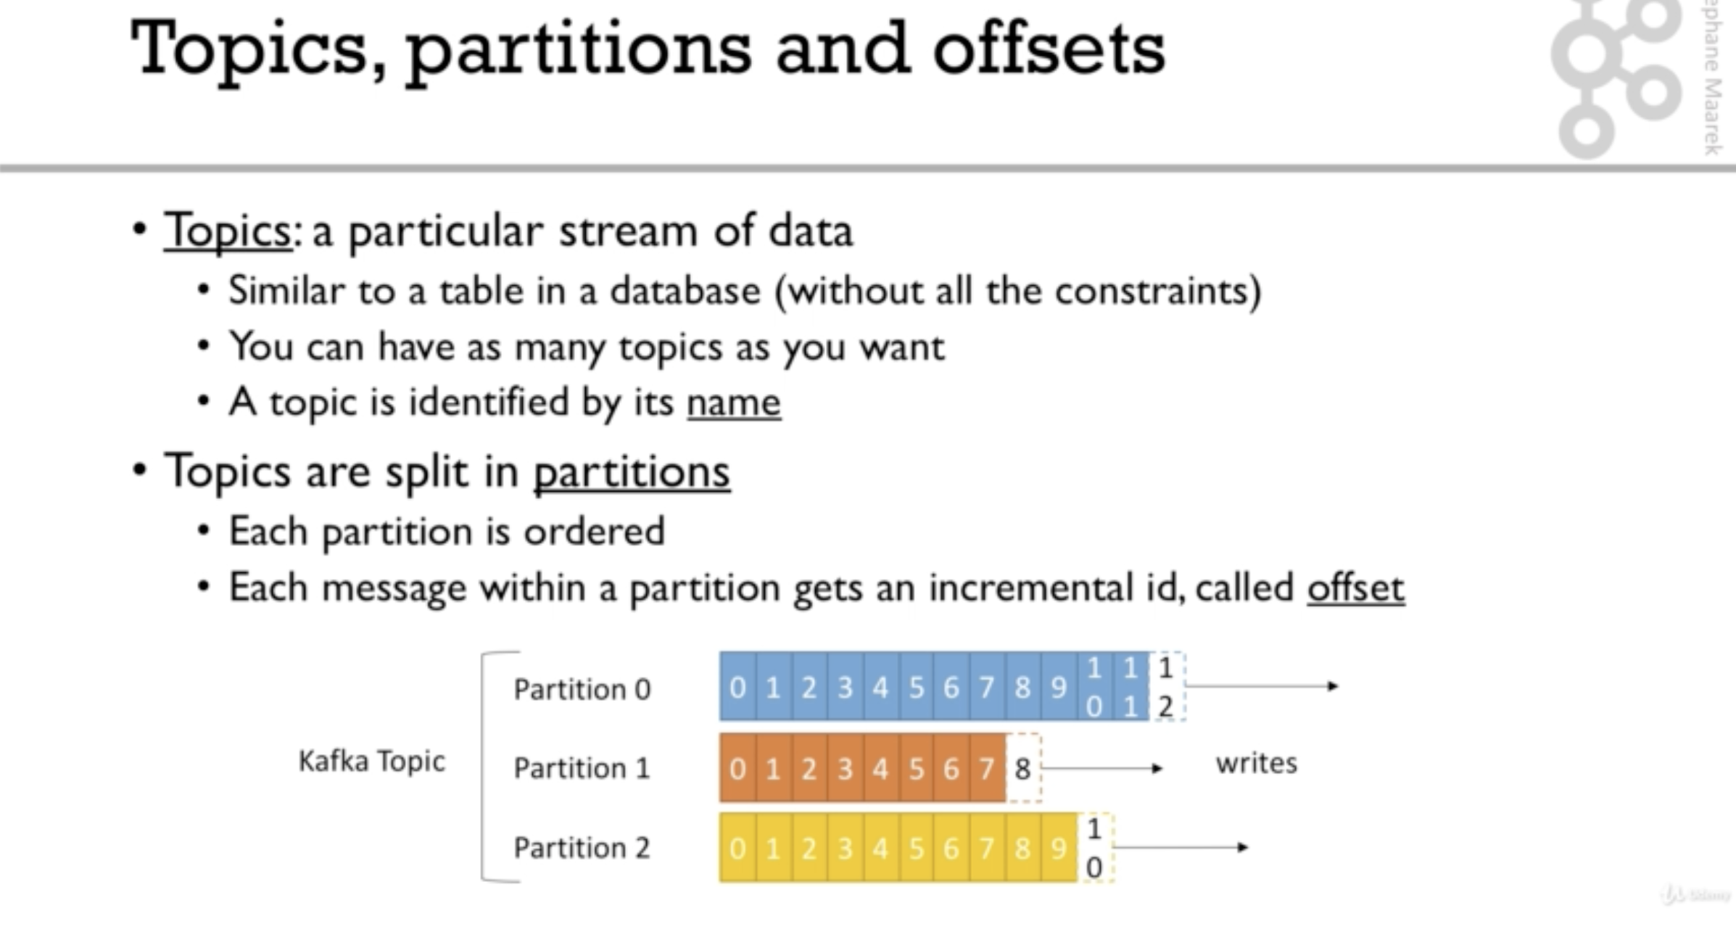

Example

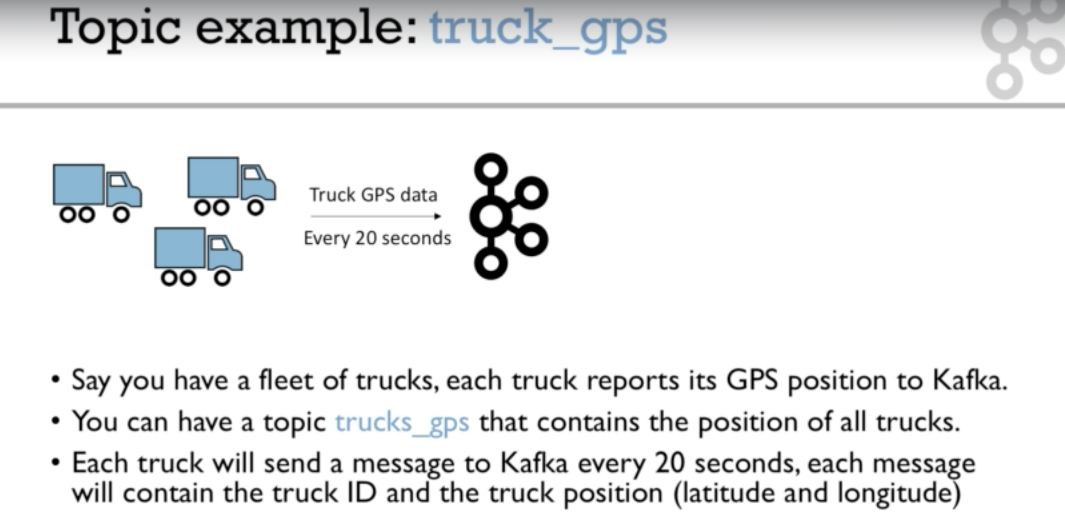

* Offset has meaning only within a partition
* Order is guaranteed only inside a partition
* Data is kept only for a limited time, default is 7 days
* Once a data is written into a partition, it cant be changed - Immutability
* Data is assigned randomly to a partition unless an Id is provided

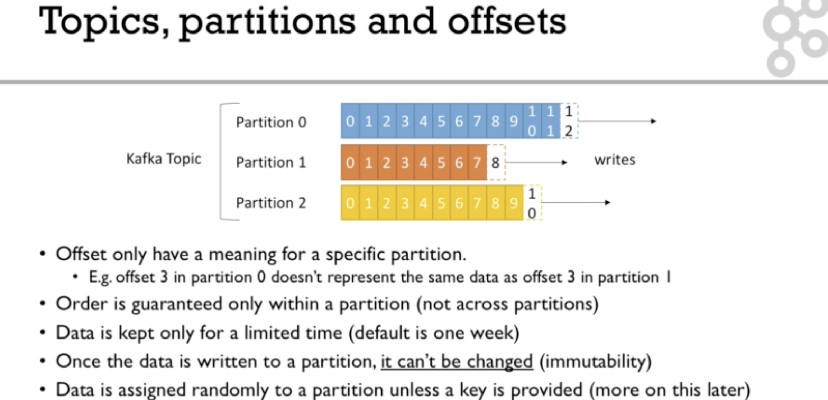

### **Brokers**

1. A Kafka cluster is composed of multiple brokers, Broker = Server
2. Each broker is identified with an Id
3. Each broker consists of only certain topic partitions, not all
4. After connecting to any broker (Bootstrap broker), you will be connected to entire broker cluster
5. A good number to start is 3, but a big cluster can have over 100 brokers

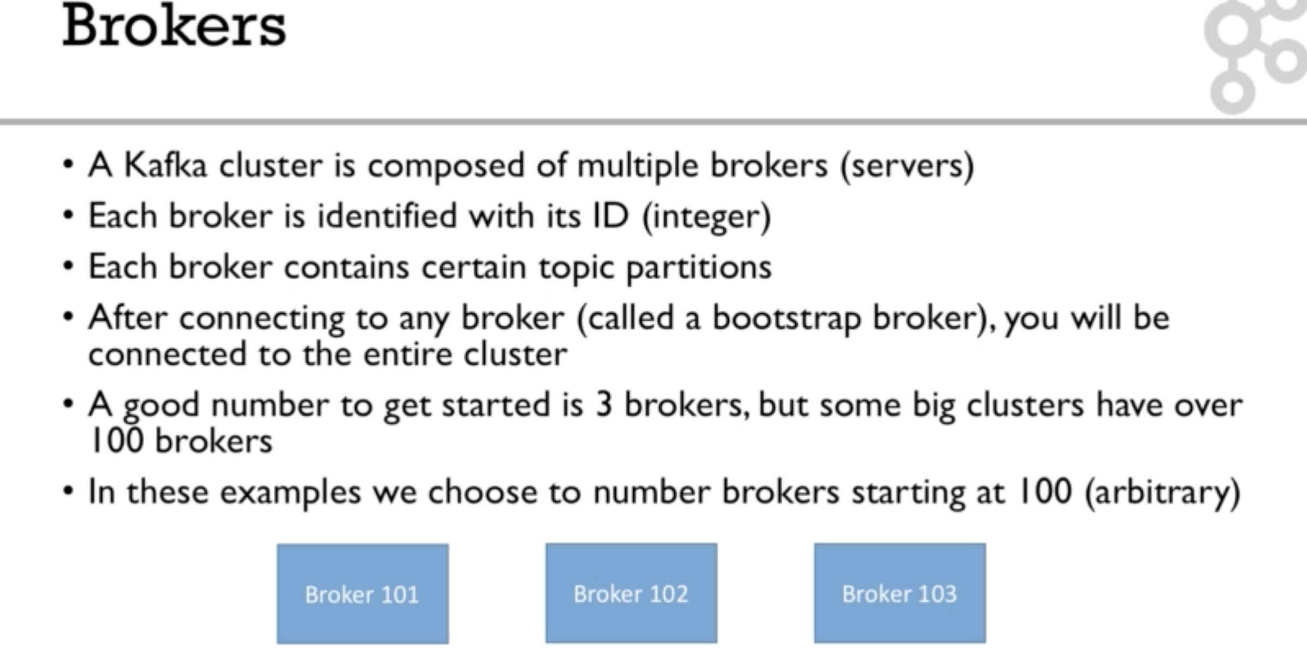

Brokers and Topics

1. When you create a topic, kafka spreads the topic over all the brokers and the partitions are assigned in random order to the brokers.

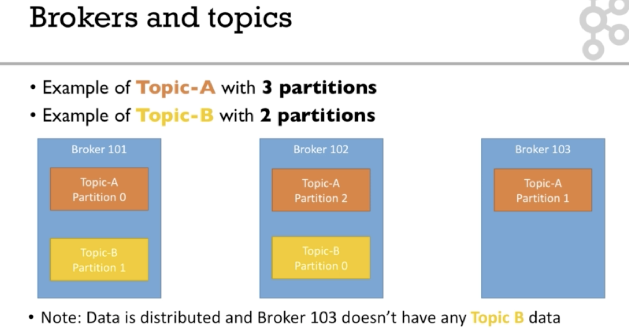

### Topic replication

1. Topics should have a replication factor > 1 (Usually 2 or 3, 2 is risky 3 is good)
2. If one broker is down, other broker can serve the data
3. Example: Topic A with 2 partitions and two replication

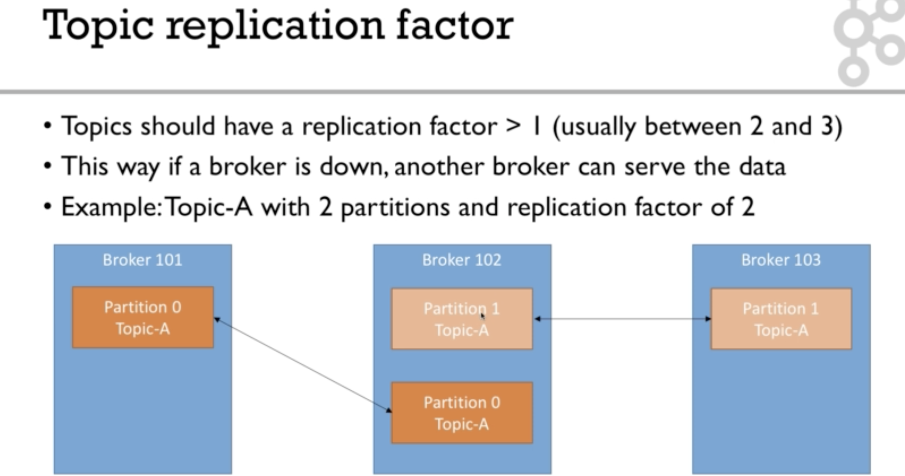

Leader of a Partition

1. There is only one broker leader for a given partition
2. Only one broker can receive and send data
3. Other brokers synchronize themselves with the leader - In sync Replica (ISR)
4. Here the leader and ISR are determined by ZooKeeper
5. One one broker goes down, the other broker will take charge as leader
6. If the dormant broker comes up again, it gets synchronized with the current leader and takes charge as leader when everything is OK

### Producers

Producers write data to Kafka.

1. Producers write data to topics
2. Producers automatically know which broker and partition to write the data
3. In case of broker failures, producers automatically recover
4. If the data is sent without id, then load balancing is done among the available brokers

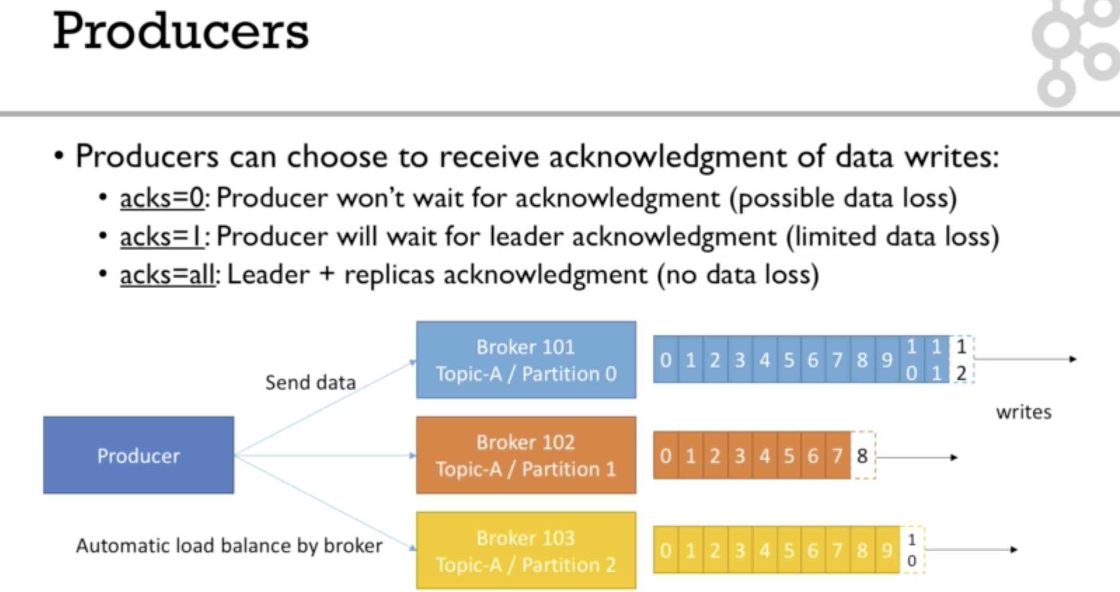

Acknowledgements

1. Producers can choose to receive acknowledgements
   1. acks = 0 is when producers send data and doesn't want wait for the acknowledgement
   2. acks = 1 is when producer waits for the acknowledgement from the leader
   3. acks = all is when producer waits for the acknowledgement from the leader and all the replicas



Producers: Message keys

1. Producers can choose to send key with the message (number or string etc can be anything)
2. If key = null, then the data is sent in round robin fashion (101, then 102 and so on for example)
3. If a key is sent, then all the messages for that key will always go to the same partition
4. A key is sent if you need ordering for a specific field

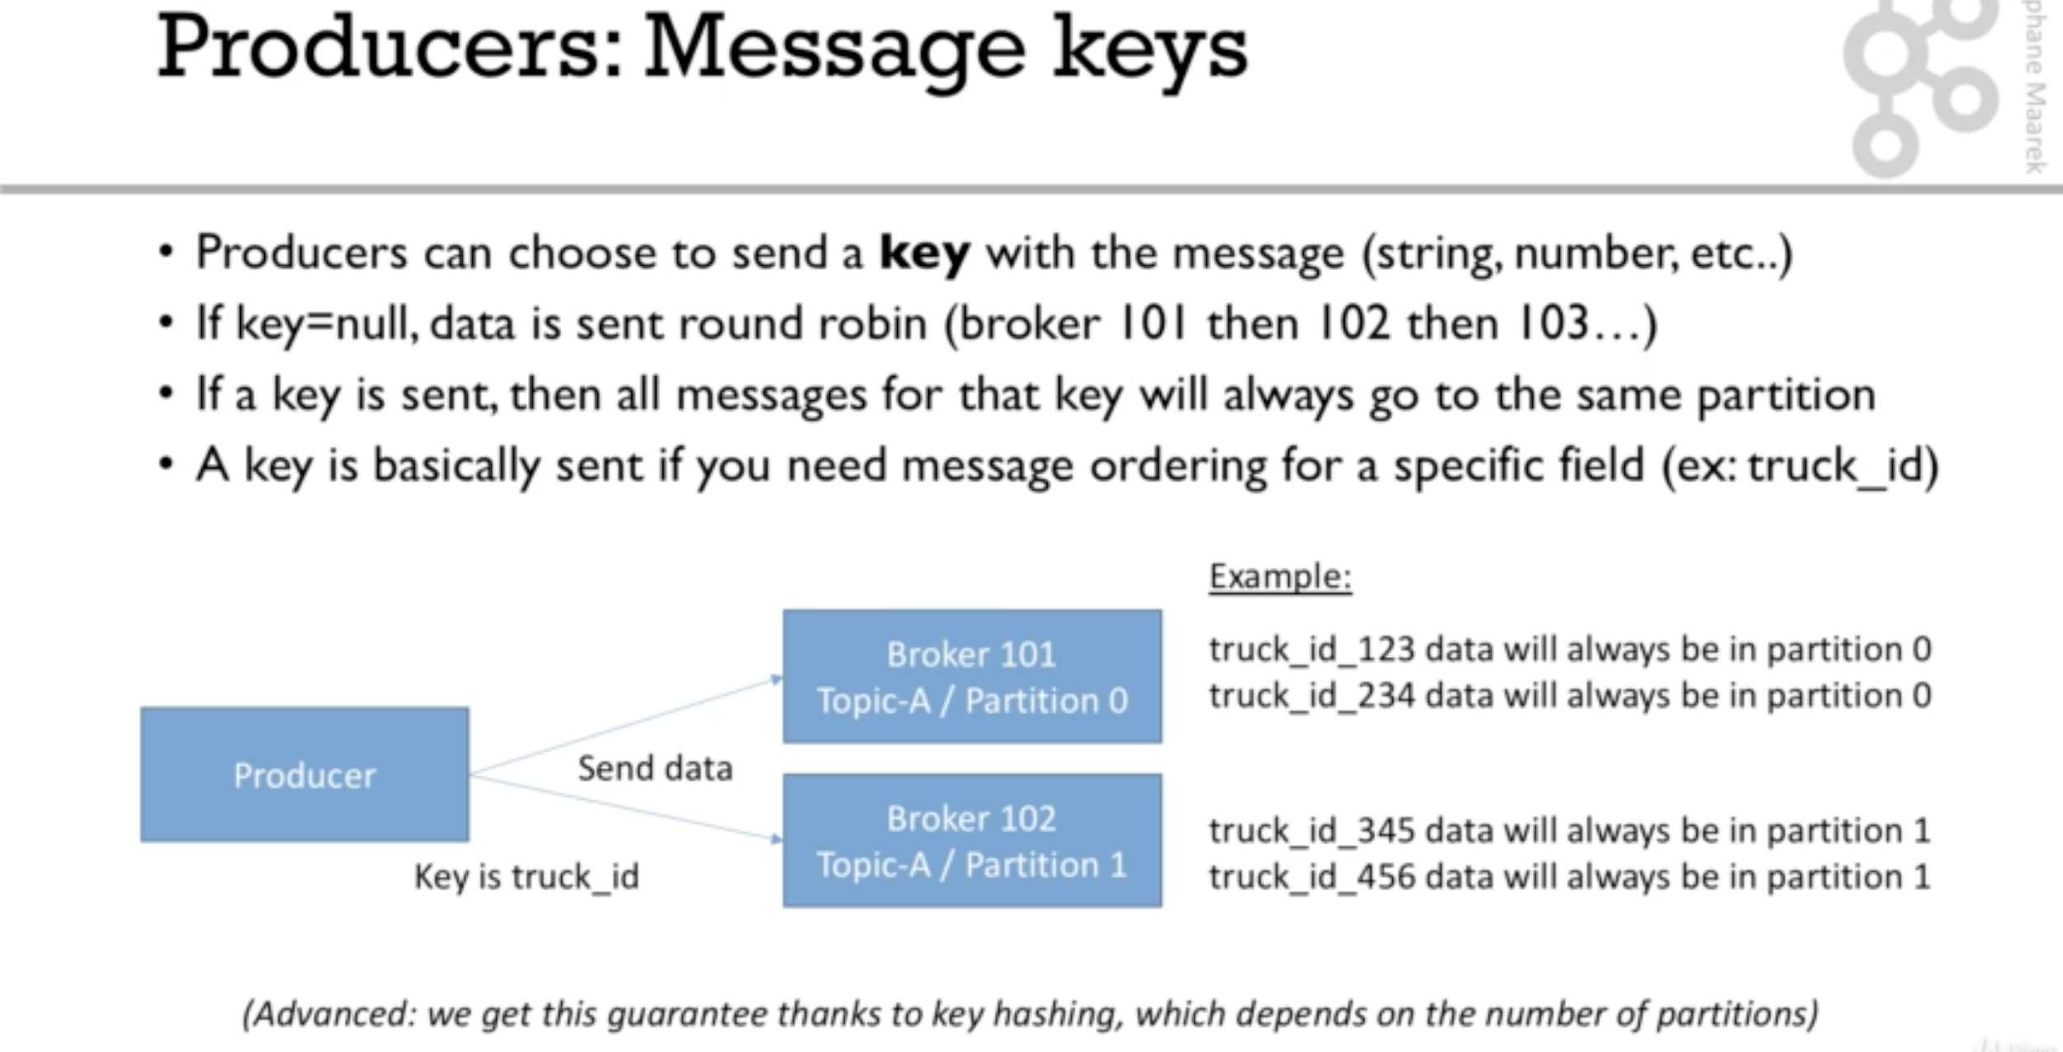

### Consumers

1. Consumers read data from brokers from a topic which is identified by a name
2. Consumer know which broker to read from, it already programmed
3. In case of broker failures, consumers know how to recover
4. Data is read in order within a partition.
5. Consumers can read data from multiple brokers at the same time. The data is always read in order from the partitions.
6. There is no guarantee on the speed of each broker while reading from multiple brokers, one partition can be read faster than the other partition of another broker.

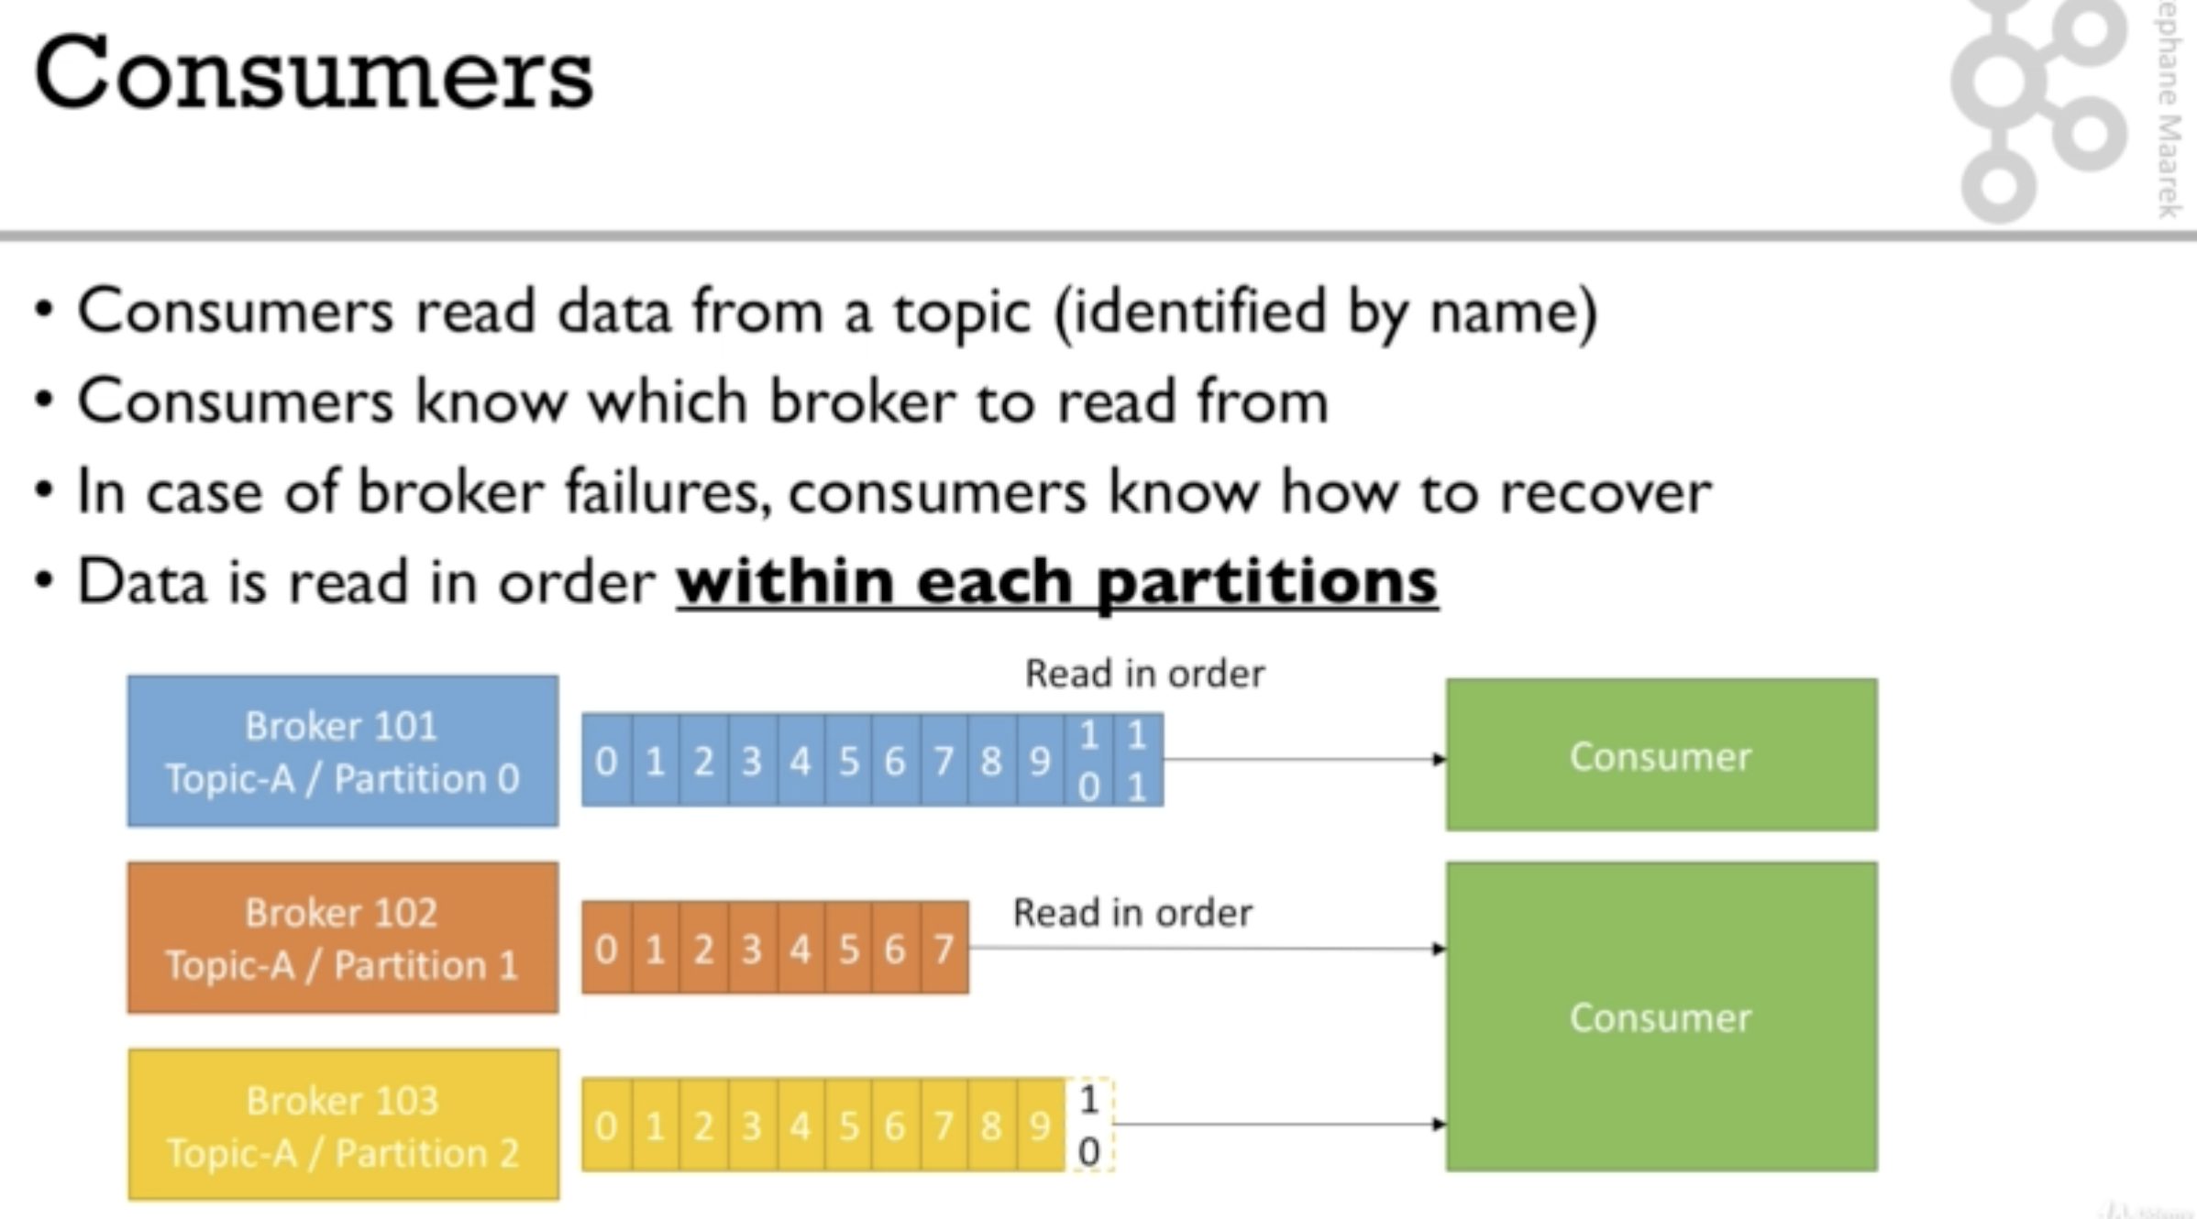

Consumer Groups

1. Consumers read data in consumer groups
2. Each consumer within a group reads from an exclusive partition
3. If you have more consumers than partitions, then some consumers will be inactive
4. Consumers use GroupCoordinator and ConsumerCoordinator to assign a consumer to a partition. This is already built in kafka, and we no need to do any programming for this.

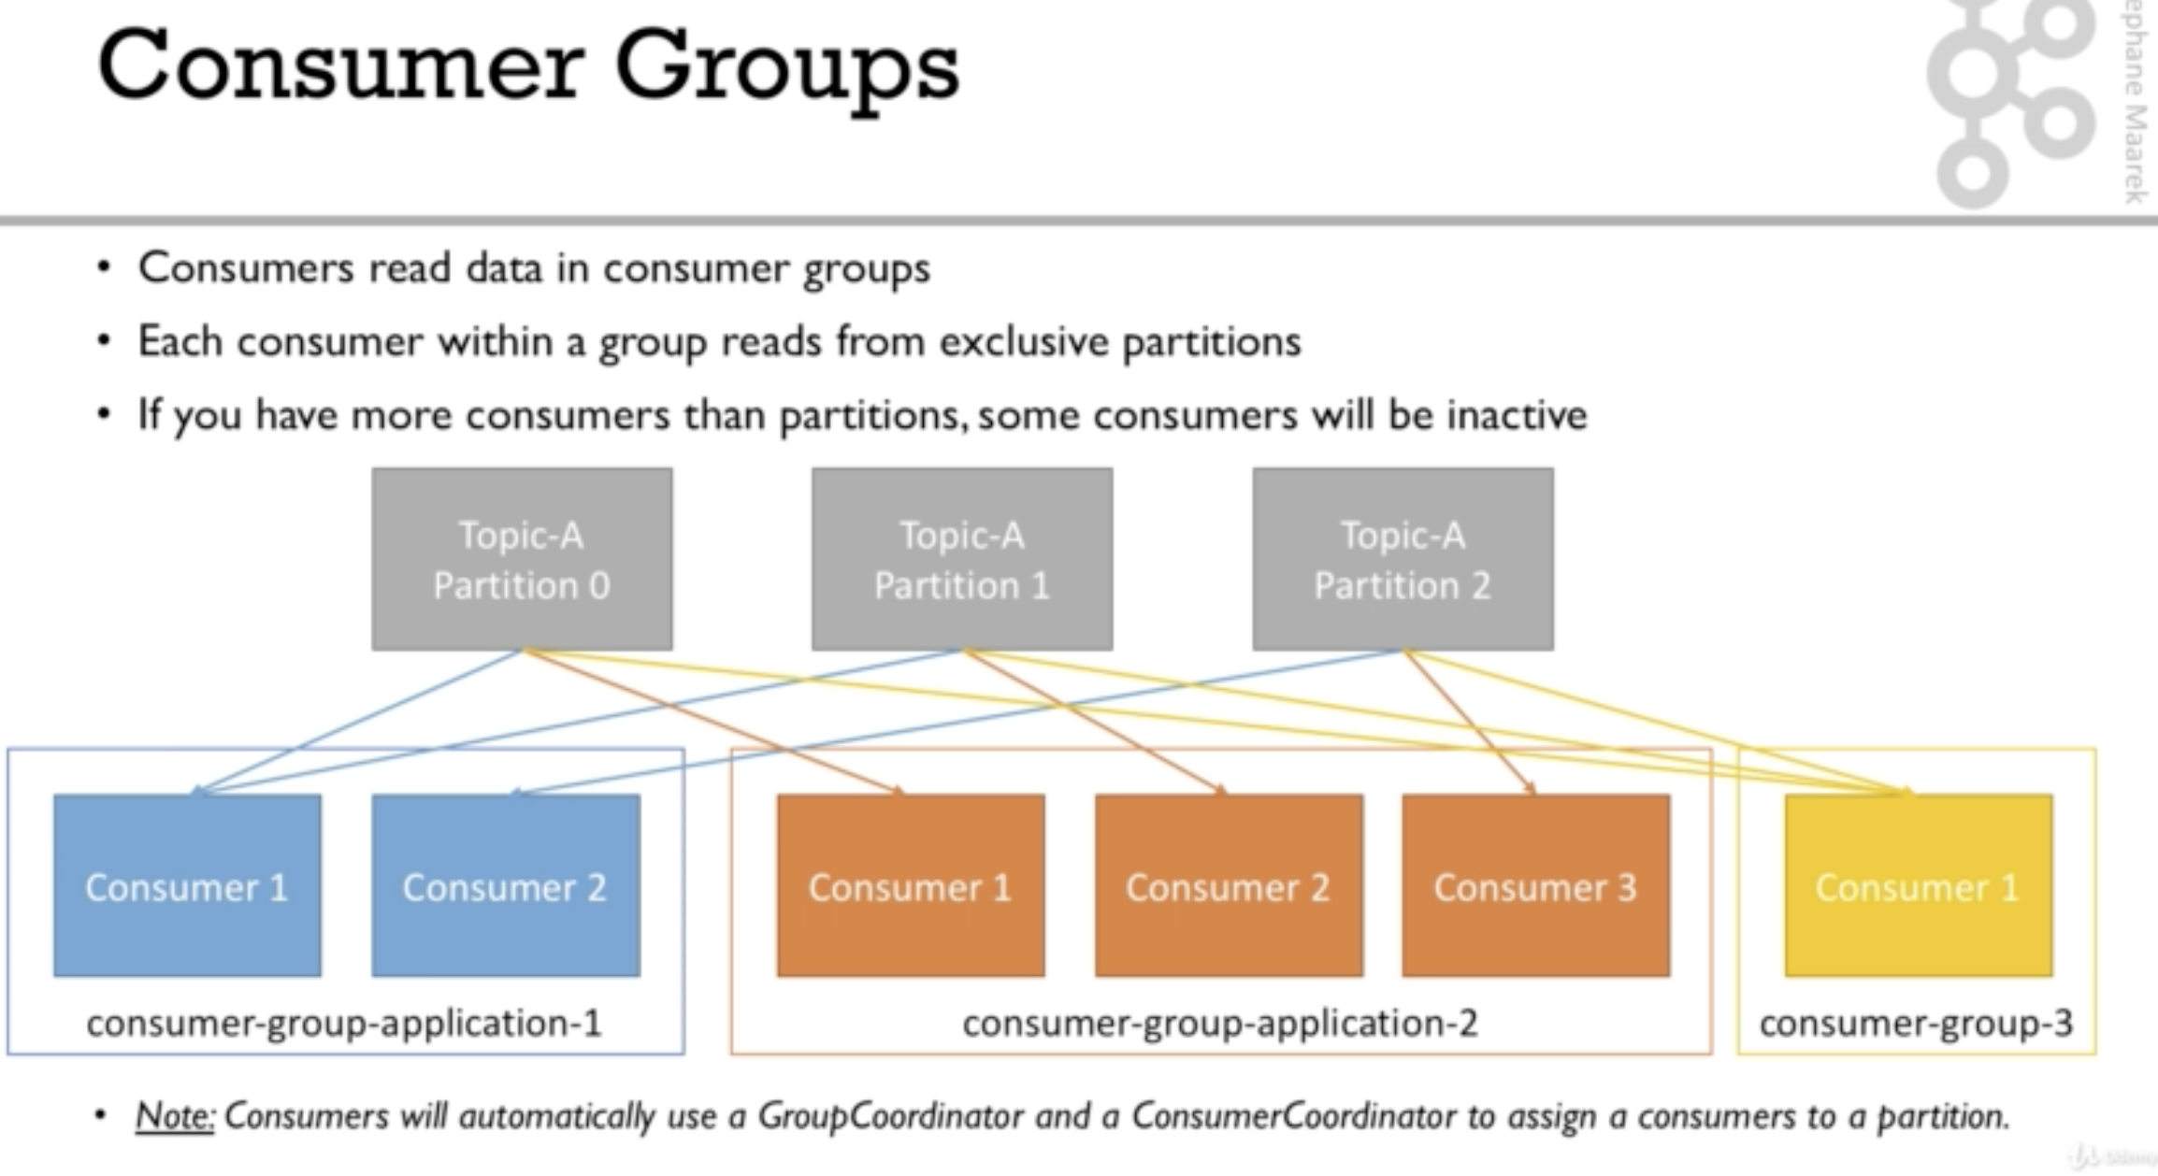

What if too many consumers

1. If we have too many consumers, then some will remain inactive
2. Better is to maintain as many consumers as there are partitions, otherwise, the other consumers need to be inactive

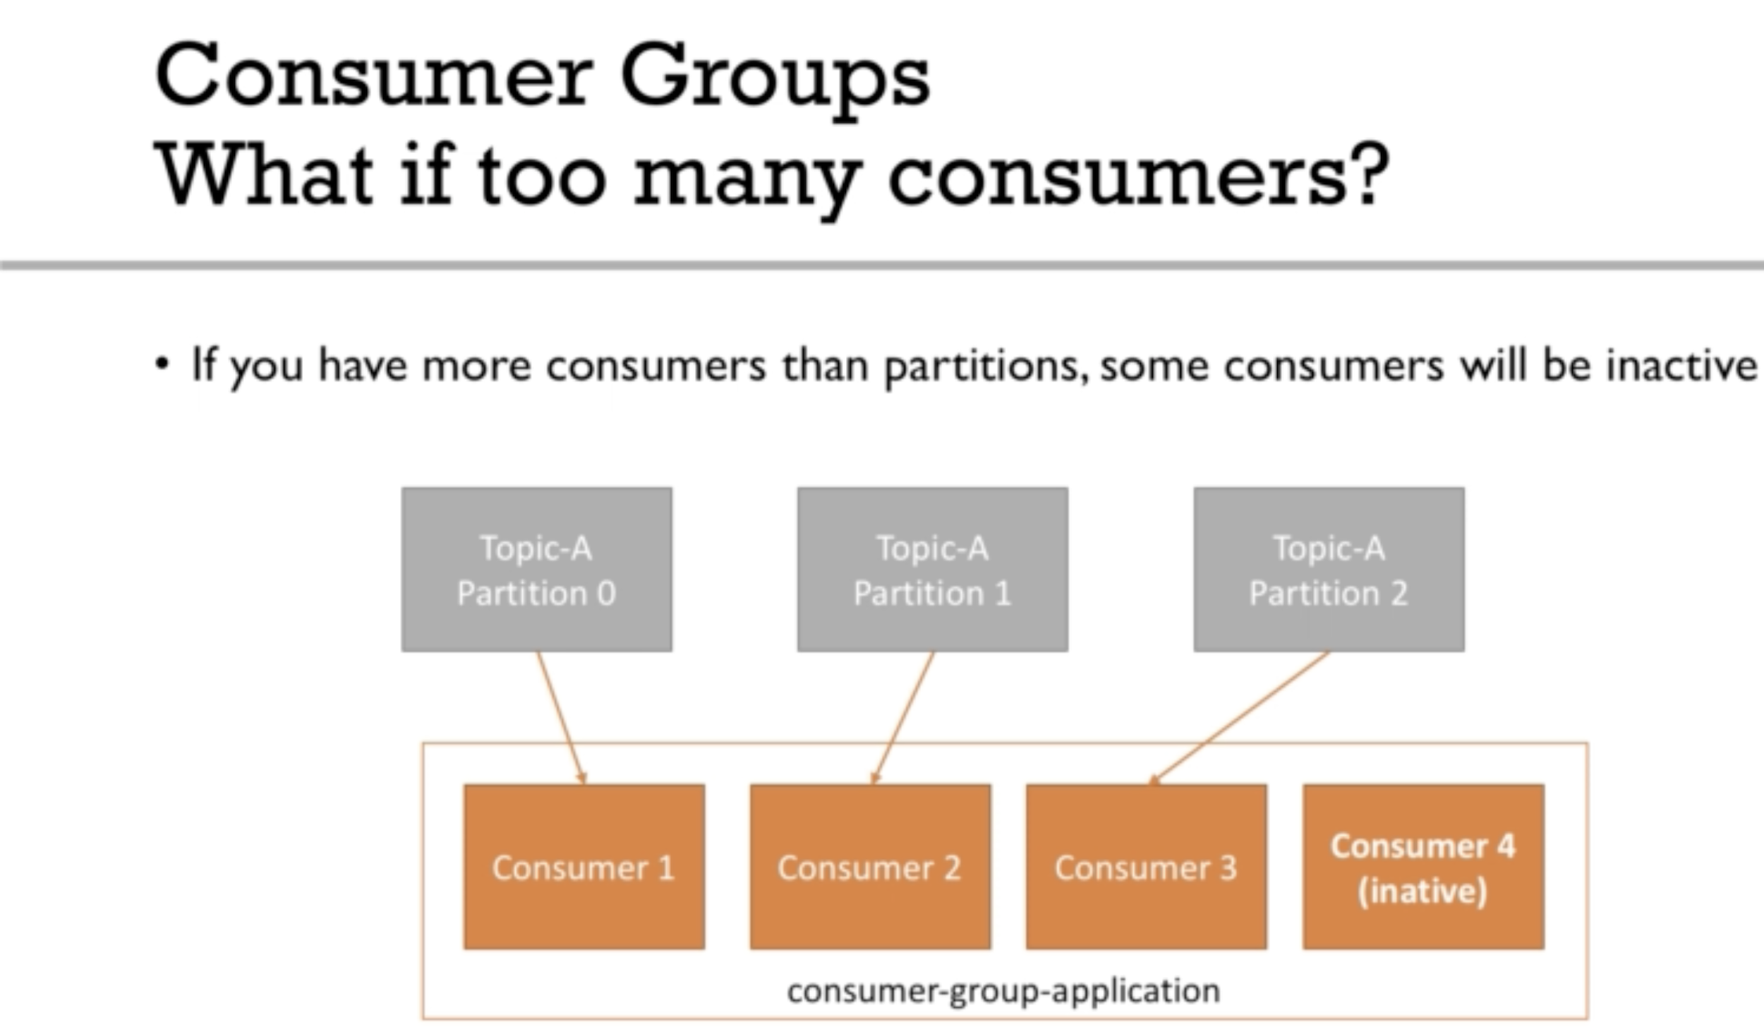

### Consumer offsets

1. Kafka stores the offsets at which the consumer groups has been reading
2. The offsets are committed in a kafka topic named __consumer__offsets
3. When a consumer processed the data received from Kafka, it should be committing the offsets
4. When a consumer dies and come to life after considerable amount of time, it can read the offset and process the data from where it left, *thanks to the committed consumer offsets*

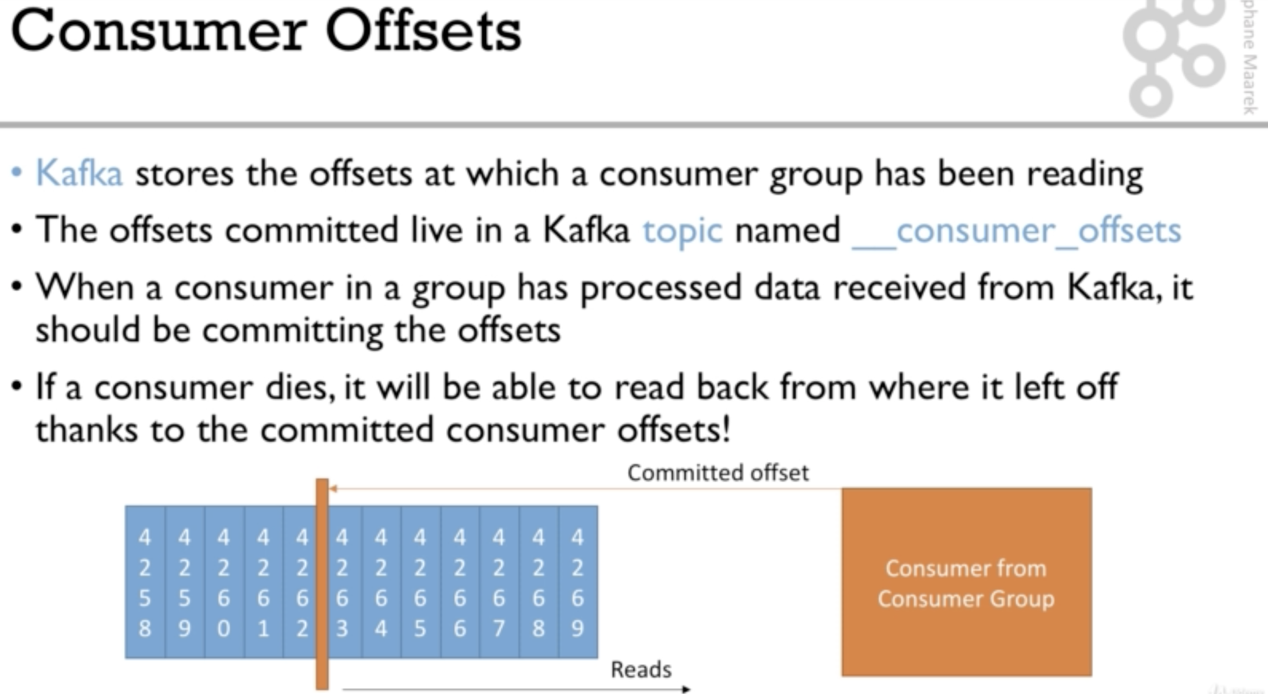

Delivery Semantics for Consumers

1. Consumers choose when to commit offsets
2. There are 3 delivery semantics
   1. At Most once
      1. Offsets are committed as soon as the data is received
      2. When something goes wrong, the message will be lost (It won’t read again)
   2. At least once
      1. Offsets are committed as soon as the message is received
      2. When something goes wrong, the message will be read again
      3. This can result in duplicate processing of messages, make sure your processing is idempotent.
   3. Exactly once
      1. Can be achieved for kafka to kafka workflows using kafka stream API
      2. For kafka to external systems workflows, we use idempotent consumers.

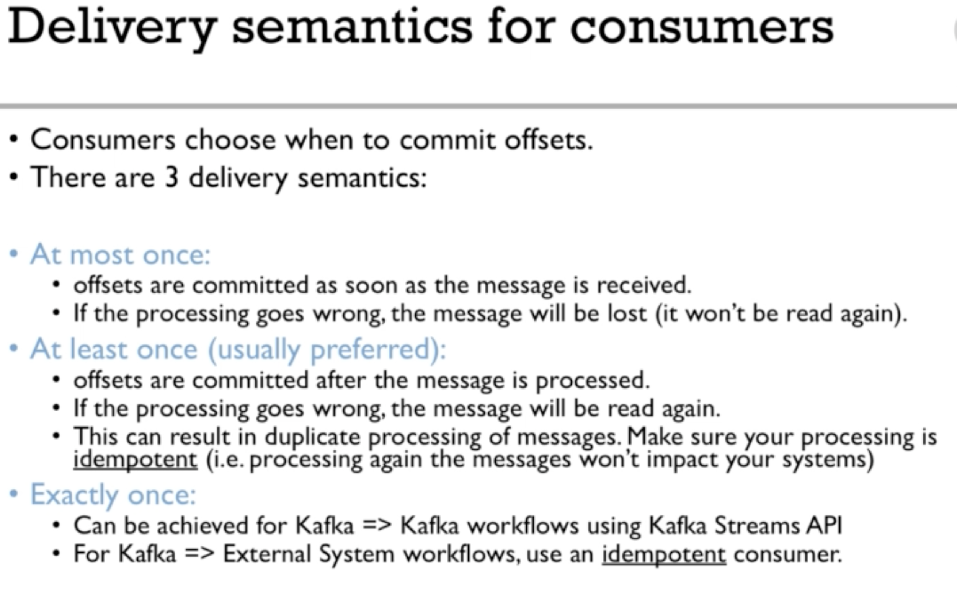

### Kafka Broker Discovery Server

1. Every kafka broker is also called as bootstrap server
2. This means that we need to connect to only one server, and we automatically connect to the whole cluster
3. Each broker knows all the brokers, topics and partitions (metadata)

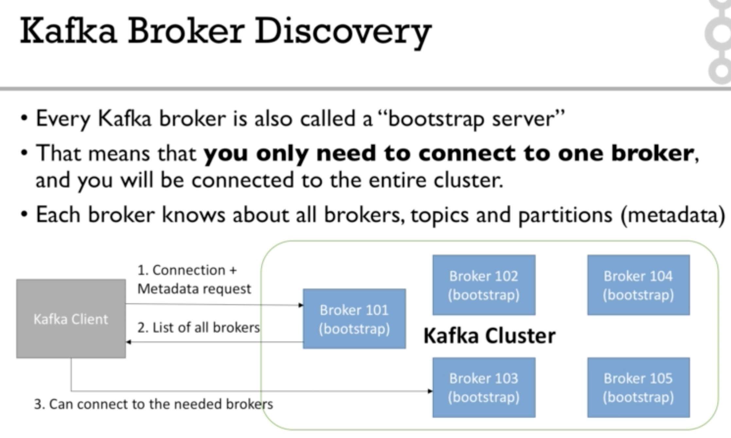

### Zookeeper

1. Zookeeper manages brokers (Keeps a list of them)
2. Zookeeper helps in performing leader election for partitions
3. Zookeeper sends notification to Kafka in case of changes (new topic, broker dies, broker comes up, delete topics etc)
4. Kafka can’t work without zookeeper
5. Zookeeper by design operates with odd number of servers
6. Zookeeper has leader that handles all the writes and followers that handles all the reads
7. Zookeeper does not store consumer offsets with Kafka (V > 0.10)

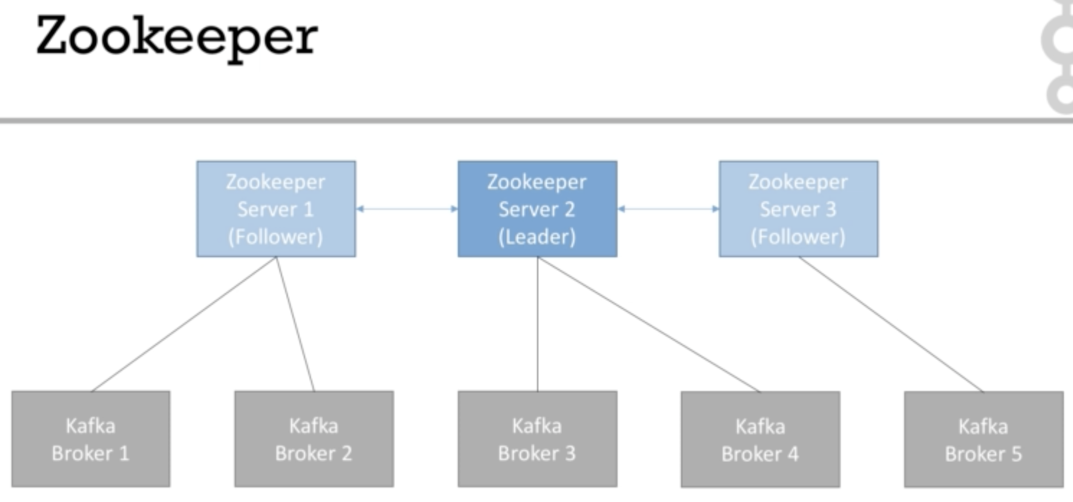

Kafka Guarantees

1. Messages are appended to the topic partition in the order they are sent
2. Consumers read messages in the order stores in topic partition
3. With a replication factor of N, Producers and Consumers can tolerate upto N-1 brokers being down
4. This is why replication factor is a good idea
   1. One broker can be taken down for maintenance
   2. Another broker can taken down unexpectedly
5. As long as the number of partitions remains constant for a given topic, the same key will always go to the same partition

Summary

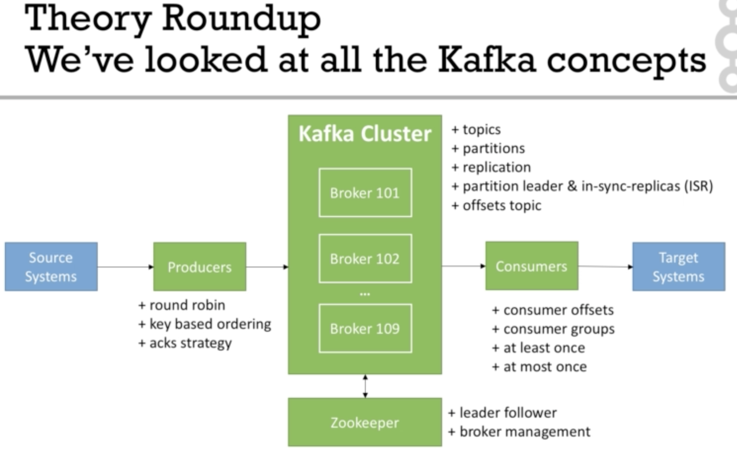

MCQs

**To produce data to a topic, a producer must provide the Kafka client with…**

Very important: you only need to connect to one broker (any broker) and just provide the topic name you want to write to. Kafka Clients will route your data to the appropriate brokers and partitions for you!

**To read data from a topic, the following configuration is needed for the consumers**

Very important: you only need to connect to one broker (any broker) and just provide the topic name you want to read from. Kafka will route your calls to the appropriate brokers and partitions for you!

### Commands while starting Kafka

Start Zookeeper

|  |
| --- |
| :> zookeeper-server-start.sh config/zookeeper.properties |

Zookeeper starts on 2181 port

Look into the configurations of the zookeeper, changing the data directory

|  |
| --- |
| :> cat config/zookeeper-properties  dataDir=/tmp/zookeeper  :> mkdir data  :> mkdir data/zookeeper  :> nano config/zookeeper-properties  dataDir=/Users/<user>/kafka_2.12-2.0.0/data/zookeeper  :> ctrl+x and save  **Restart the zookeeper** |

Similarly we also configure the log dir for Kafka

|  |
| --- |
| :> cat config/server.properties  logDir=tmp/kafka-logs  :> mkdir data/kafka  :> logDirs=/Users/<user>/kafka_2.12-2.0.0/data/kafka  :> kafka-server-start.sh config/server.properties |

### Kafka CLI Topics

1. Starting working with Kafka is by working with Kafka Topics

|  |
| --- |
| :> kafka_2.13-2.6.0 ag44284$ kafka-topics.sh **Create**, **delete**, **describe**, **or** change a topic. |

1. In Kafka we cannot create a replication factor greater than available brokers.

|  |
| --- |
| :> zookeeper-server-start.sh config/zookeeper.properties :> kafka-server-start.sh config/server.properties :> kafka-topics.sh --bootstrap-server localhost:9092 --topic first_topic --create --partitions 3 --replication-factor 1  WARNING: Due to limitations in metric names, topics with a period ('.') or underscore ('_') could collide. To avoid issues it is best to use either, but not both. Created topic first_topic.  :> kafka-topics.sh --bootstrap-server localhost:9092 --list First_topic :> kafka-topics.sh --bootstrap-server localhost:9092 --topic first_topic --describe  Topic: first_topic PartitionCount: 3 ReplicationFactor: 1 Configs: segment.bytes=1073741824 Topic: first_topic Partition: 0 Leader: 0 Replicas: 0 Isr: 0 Topic: first_topic Partition: 1 Leader: 0 Replicas: 0 Isr: 0 Topic: first_topic Partition: 2 Leader: 0 Replicas: 0 Isr: 0  :> kafka-topics.sh --bootstrap-server localhost:9092 --topic second_topic --create --partitions 3 --replication-factor 1  WARNING: Due to limitations in metric names, topics with a period ('.') or underscore ('_') could collide. To avoid issues it is best to use either, but not both. Created topic second_topic. :> kafka-topics.sh --bootstrap-server localhost:9092 --list first_topic second_topic  :> kafka-topics.sh --bootstrap-server localhost:9092 --topic second_topic --delete  :> kafka-topics.sh --bootstrap-server localhost:9092 --list first_topic |

### Kafka Console CLI

|  |
| --- |
| kafka-console-producer |

Producing messages

|  |
| --- |
| :> kafka-console-producer.sh --broker-list localhost:9092 --topic first*_topic* >Hello Abhilash! >Awesome Course! >Learning Kafka >Just another message :)  :> kafka-console-producer.sh --broker-list localhost:9092 --topic first_topic --producer-property acks=all  >Hello Abhi  >Producer is acknowledge with "all"  >This is yet another message :) |

Creating topic using producer

|  |
| --- |
| :> kafka-console-producer.sh --broker-list localhost:9092 --topic new_topic >Hello Abhilasha.Chary [2020-11-04 13:27:51,532] WARN [Producer clientId=console-producer] Error while fetching metadata with correlation id 3 : {new_topic=LEADER_NOT_AVAILABLE} (org.apache.kafka.clients.NetworkClient) >Here Producer created topic with default params >This is another message :)  :> kafka-topics.sh --bootstrap-server localhost:9092 --list first_topic new_topic  :> kafka-topics.sh --bootstrap-server localhost:9092 --topic new_topic --describe  Topic: new_topic PartitionCount: 1 ReplicationFactor: 1 Configs: segment.bytes=1073741824  Topic: new_topic Partition: 0 Leader: 0 Replicas: 0 Isr: 0 |

Here producer applies default configuration values to the topic. It is always advised to create a topic before sending messages by the producer.

### Kafka Consumer

1. Kafka console consumer does not read all the messages
2. It reads from the point of its inception
3. It intercepts the new messages only

|  |
| --- |
| **:> kafka**-console-consumer.sh --bootstrap-server localhost:9092 --topic first_topic <no response/**data**> |

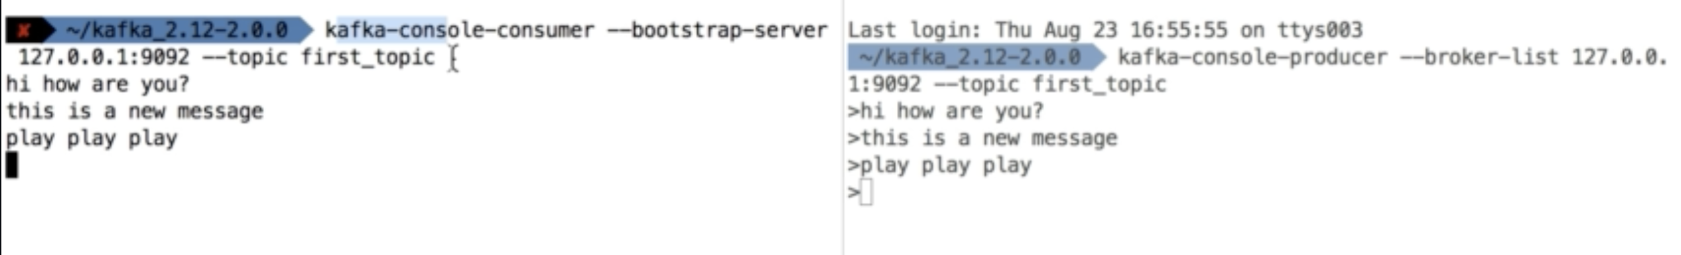

To read all the messages, including the old messages, it takes one more argument `from-begining`

|  |
| --- |
| :> kafka-console-consumer.sh --bootstrap-server localhost:9092 --topic first_topic --from-beginning Hello Abhilash! Learning Kafka Hello Abhi This is yet another message :) Awesome Course! Just another message :) Producer is acknowledge with "all" |

### Consumer groups

We can create consumers and associate with a group, by specifying the group name. Here as of now as we have three partitions, and if we create two consumers in the same group, then two messages will be processed by one consumer and one message will be processed by the other consumer. If we create three consumers in the same group, then three messages will be shared among the three consumers equally.

|  |
| --- |
| :> kafka-console-producer.sh --broker-list localhost:9092 --topic first_topic :> kafka-console-consumer.sh --bootstrap-server localhost:9092 --topic first_topic --group my-first-consumer-group hello namaste keka kevvu |

Three messages with two consumers

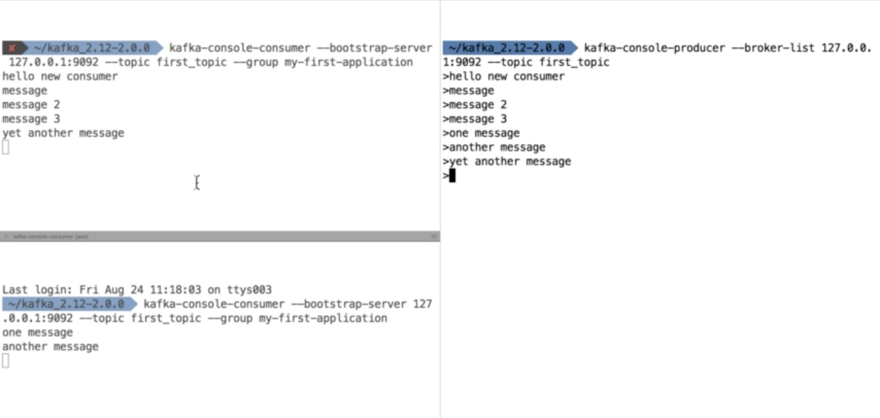

Three messages with three consumers

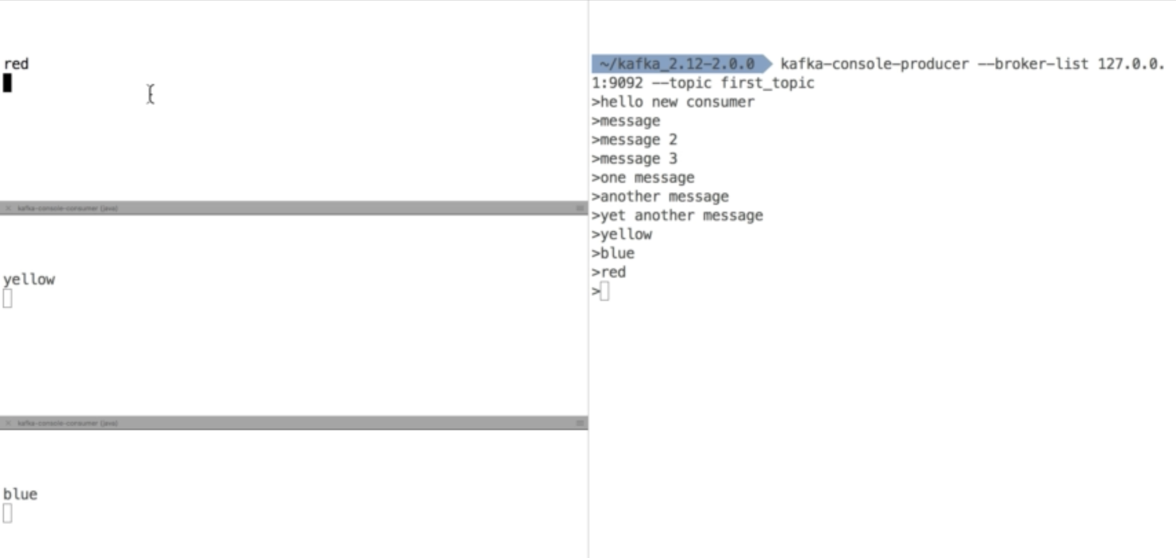

If one consumer goes down, the partitions are assigned automatically.

Consumer committed offsets

If we create a new consumer with a new group name, here my-second-consumer-group and read the messages from beginning, then consumer processes all the messages fed by the producer. If we run the same command with from beginning parameter, then none of the messages will be read by the consumer as the offset is already committed by the consumer

|  |
| --- |
| :> kafka-console-consumer.sh --bootstrap-server localhost:9092 --topic first_topic --**group** my-second-consumer-**group** --**from**-beginning Hello Abhilash! Learning Kafka Hello Abhi This **is** yet another message :) namaste kevvu Awesome Course! hello keka Just another message :) Producer **is** acknowledge **with** "all" ^CProcessed a total **of** 11 messages :> kafka-console-consumer.sh --bootstrap-server localhost:9092 --topic first_topic --**group** my-second-consumer-**group** --**from**-beginning |

### Consumer offsets

|  |
| --- |
| :> kafka-consumer-groups.sh --bootstrap-server localhost:9092 Command must include exactly one action: --list, --describe, --delete, --reset-offsets, --delete-offsets |

|  |
| --- |
| :> kafka-consumer-groups.sh --bootstrap-server localhost:9092 --list my-first-consumer-group my-second-consumer-group |

|  |
| --- |
| :> kafka-consumer-groups.sh --bootstrap-server localhost:9092 --describe --**group** **my-first-consumer-group** |



### Resetting offset

|  |
| --- |
| kafka-consumer-groups.sh --bootstrap-server localhost:9092 --**group** **my-first-consumer-group** --reset-offsets --to-earliest --execute --topic first_topic  **GROUP** **TOPIC** PARTITION NEW-OFFSET  my-first-consumer-**group** **first_topic** 0 0  my-first-consumer-**group** **first_topic** 1 0  my-first-consumer-**group** **first_topic** 2 0 |

|  |
| --- |
| :> kafka-console-consumer.sh --bootstrap-server localhost:9092 --group my-first-consumer-group --topic first_topic --from-beginning Hello Abhilash! Learning Kafka Hello Abhi This is yet another message :) namaste kevvu Awesome Course! hello keka Just another message :) Producer is acknowledge with "all" |

Shifting forward by 2 offsets

|  |
| --- |
| :> kafka-consumer-groups.sh --bootstrap-server localhost:9092 --**group** **my-first-consumer-group** --reset-offsets --shift-by 2 --execute --topic first_topic  **GROUP** **TOPIC** PARTITION NEW-OFFSET  my-first-consumer-**group** **first_topic** 0 2  my-first-consumer-**group** **first_topic** 1 2  my-first-consumer-**group** **first_topic** 2 2 |

### 

### Creating a Kafka project

### Client Bi-Directional compatibility

* An OLDER kafka client can talk to newer broker
* A NEWER client can talk to older broker
* It is advisable to always use the newer versions of client library even if the brokers are of older versions

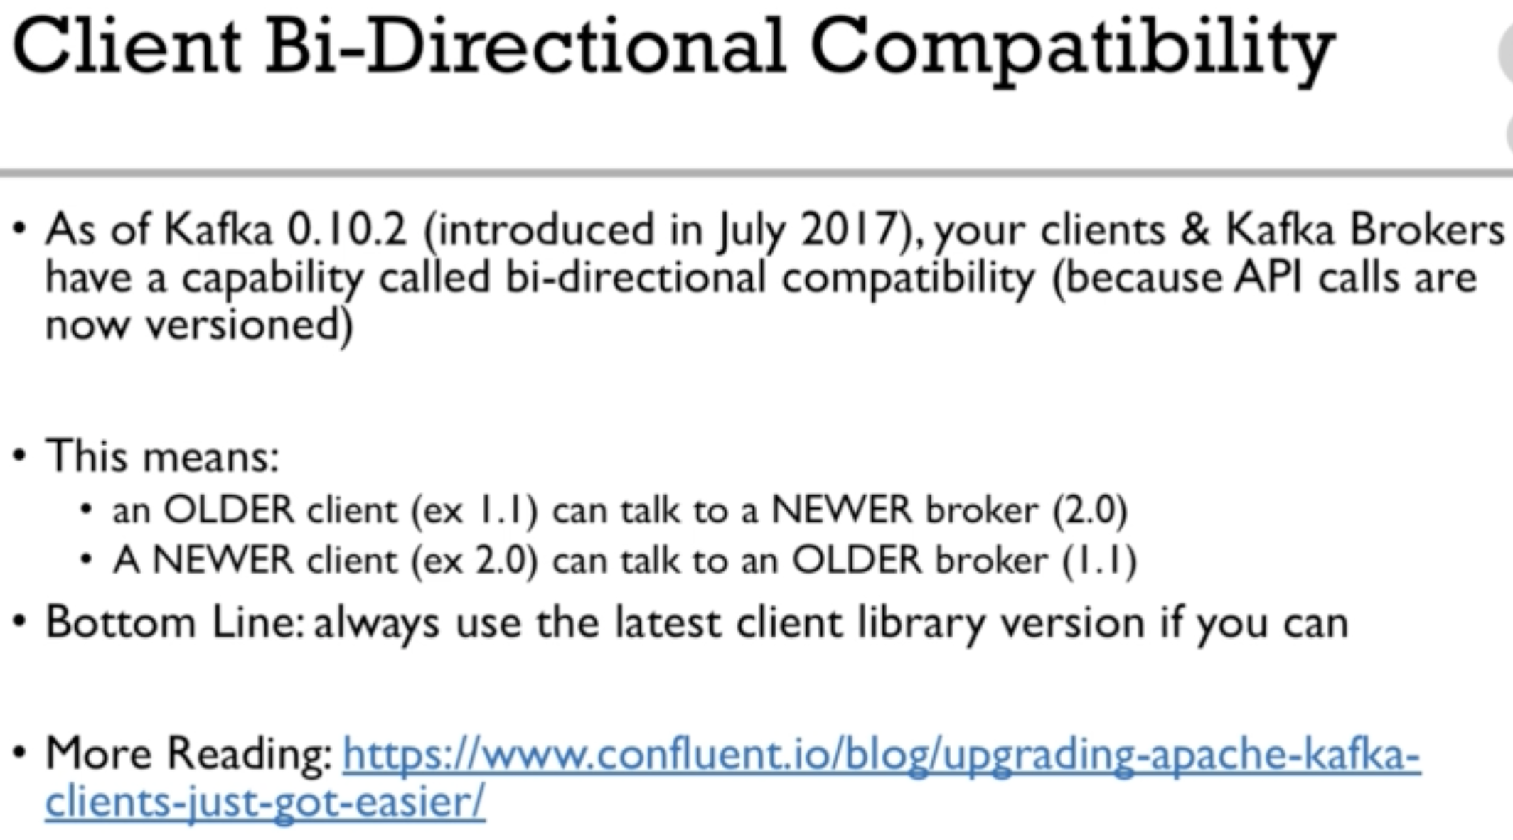

### Real World Project

API Key: jrNeOtpihMCgD5RkbXVtMIFSx

API Secret Key: WWmNFHNBh9M5e8Oo5Gcy2jYFO2RiOiJzakkhvVV7QRQMaJaIE3

Bearer token: AAAAAAAAAAAAAAAAAAAAALRGKAEAAAAAM9LmBYObJsHh5tejB%2F06R%2FVc2%2BA%3D7TEG6O23VvvQz5yL5MVVW0DCsJH2iNm7K5hUrLIoVCbFNxGbVL

Twitter API key: jrNeOtpihMCgD5RkbXVtMIFSx

Twitter API secret key: WWmNFHNBh9**M5**e8Oo5Gcy2jYFO2RiOiJzakkhvVV7QRQMaJaIE3

Twitter bearer token: AAAAAAAAAAAAAAAAAAAAALRGKAEAAAAA**M9**LmBYObJsHh5tejB%2F06R%2FVc2%2BA%3D7TE**G6**O23VvvQz5yL5MVVW0DCsJH2iNm7K5hUrLIoVCbFNxGbVL

### producer acks = 1

* When acks = 1 only leader of the brokers responds to the producer.
* Replication happens in the background
* If the ack is not received, the producer may retry
* If somehow, the leader goes down and replicas haven't happened yet, then there is a data loss which is not at all good

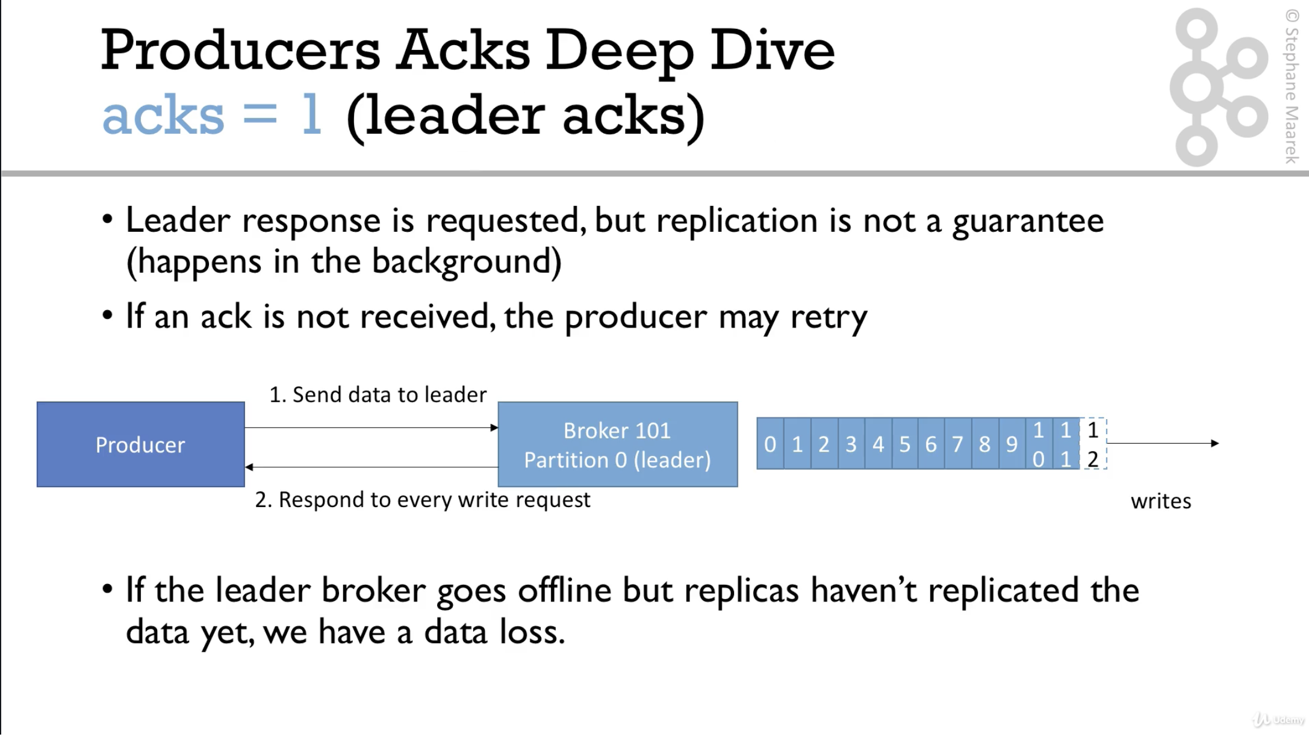

### Producer ack = all

* acks = all must be used in conjunction with min.insync.replicas.
* min.insync.replicas = 2 implies that at-least 2 brokers that are ISR must respond that they have data
* This means that if we have replication factor 2, min.insync = 2 and acks = all, then we can tolerante one **broker** going down, otherwise producer will receive **an** exception **on** **data** **send**

*If we need a safe producer, then acks should be all always*

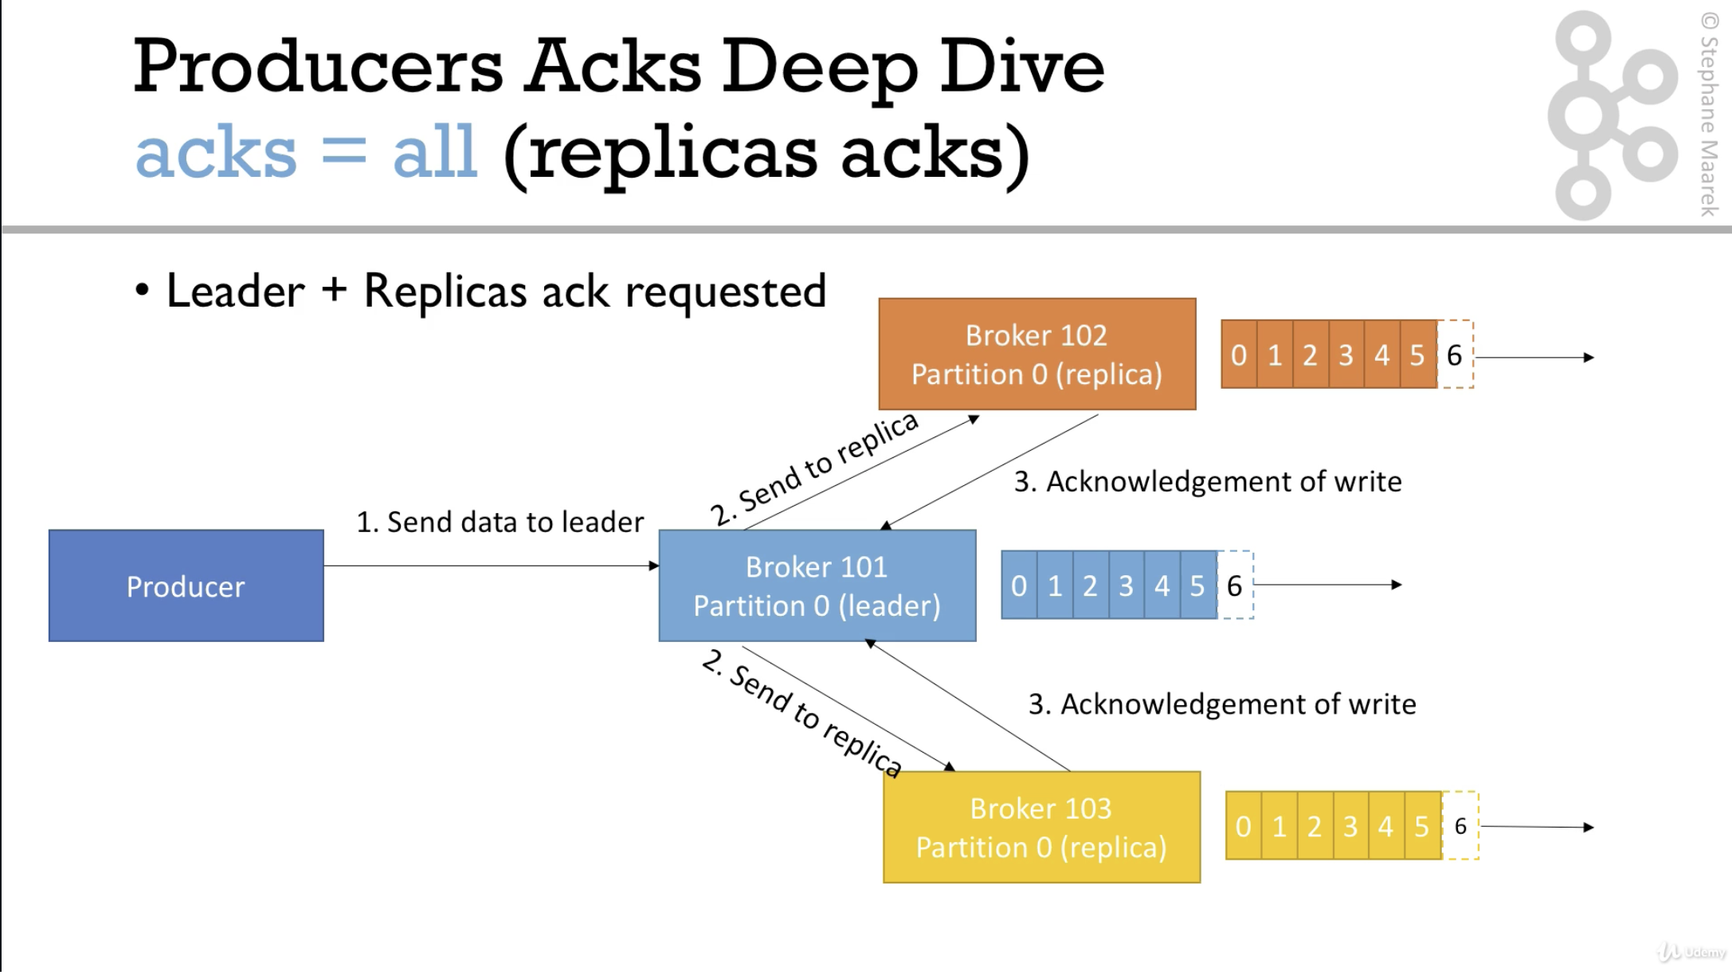

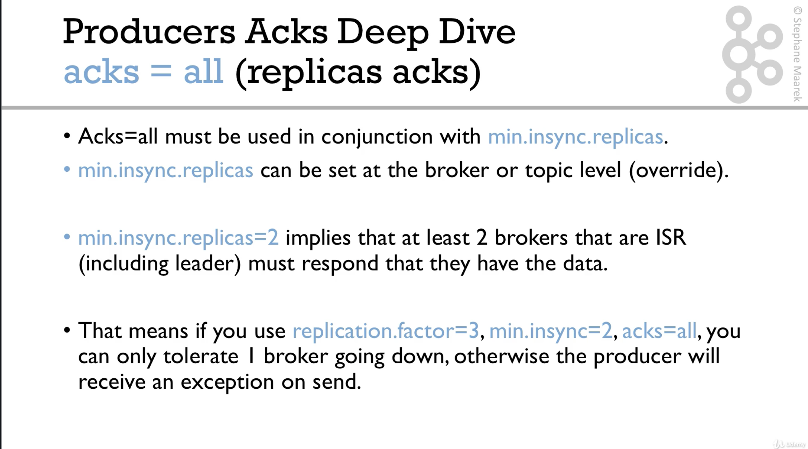

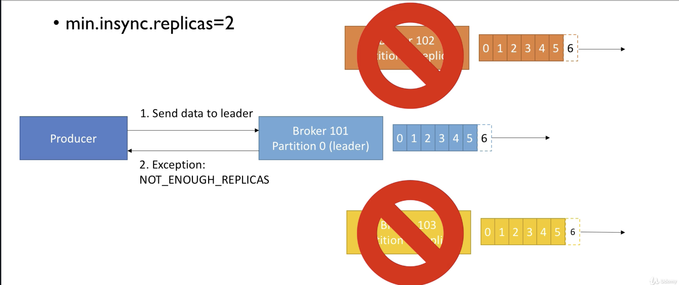

|  |
| --- |
| It is **the** role/responsibility **of** **the** producer to retry so that **the** producer gets **the** success response |

### 

### Producer retries

Incase of exceptions, producers have to handle the exceptions, otherwise the data will be lost.

Example

* NOT_ENOUGH_REPLICAS

The default the retries is 0 for kafka 2.0

Integer.MAX defaults to 2147483647 for Kafka > 2.1

retry.backoff.**ms** **= 100ms** implies the producer retries after every 100ms

|  |
| --- |
| For **a** high value **of** producer retries (Integer.MAX), **the** producer will **not** retry infinite times, there is **a** concept called producer timeout, where **for** **a** high value **of** retries, **the** Producer times out **after** 2 minutes. |

|  |
| --- |
| delivery.timeout.ms = 2min This is the default setting |

If we want the producer to retry for infinite times, we can set the delivery timeout milliseconds to 10 years. Producer will keep on trying until it gets a successful response.

Producer retries warning

* In case of retries, there is a possibility that the messages will be sent **out** **of** **order**
* There is a setting max.in.flight.requests.per.connection which controls how many requests can be sent in parallel by the producer to the broker. Suppose if the factor is 5 and if one of the requests fails, the producer retries that particular request and which will result in messages sent out of order.
* To avoid this we need to set **the** value to 1 but **at** **the** cost **of** lowered throughput

|  |
| --- |
| *In kafka >= 1.0.0, we have a better solution called Idempotent producers* |

1. If Kafka <= 2.0, then the default setting is 0
2. For Kafka > 2.0 the default setting for setting is maximum value of the integer = Integer.MAX - very high number of times
3. How often? = retry.backoff.ms = 100ms (default)
4. Is it going to retry forever?
   1. No, there is a timeout, delivery.timeout.ms = 120000ms = 2 minutes
   2. If the reties for 2 minutes still fail, then Kafka will not able to save the data and Producer should handle such scenarios **in** producer callback

### Idempotent producer

With retries set for the producer, there is a possibility of producer sending duplicate requests as below

* Producer sends a message
* Kafka receives the message and acknowledges the same
* But due to network error, the ack never reaches the producer
* So, producer thinks it as a failure situation and retries the message again
* Kafka receives it and commits the message leading to a duplicated message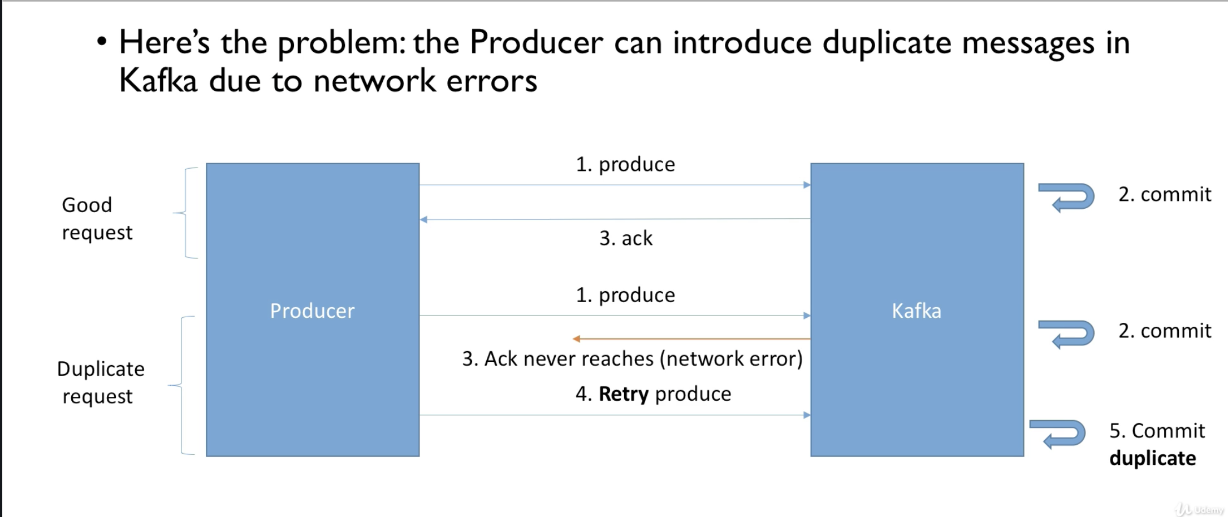

How idempotent producer solves it

* Producer sends a message
* Kafka receives the message and acknowledges the same
* But due to network error, the ack never reaches the producer
* So, the producer thinks it as a failure situation and retries the message again, but here the idempotent producer always sends a produce message id along with the message.
* Kafka receives it and treats it as a duplicate request, and does not commit it, but it sends the ack that it received the message

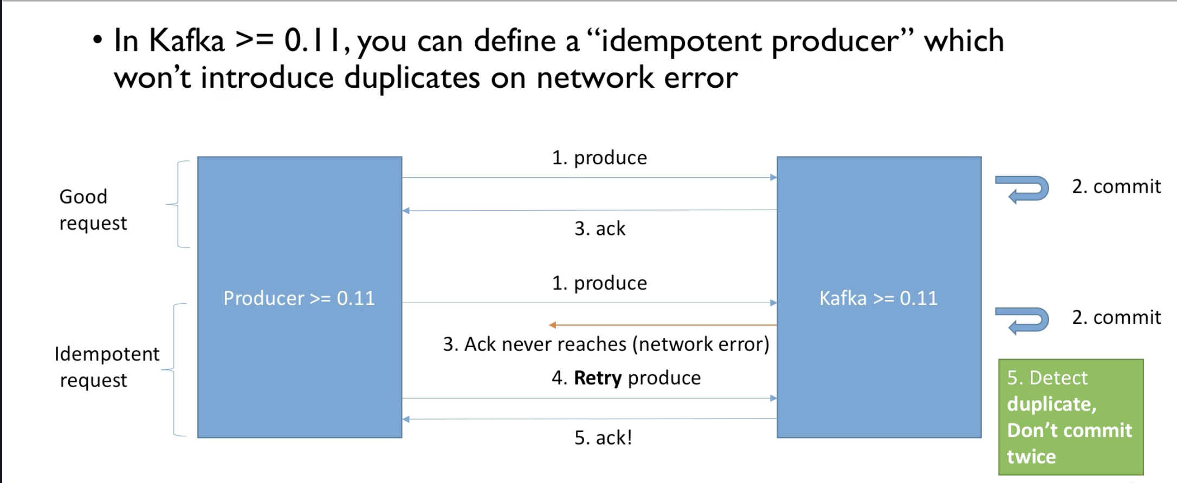

For an idempotent producer, the default settings are as below

* retries = Integer.MAX ($2^{31}-1$), unless we manually set a value
* max.in.flight.requests = 1 (Kafka = 0.11)
* max.in.flight.requests = 5 (Kafka >= 1.0)
  + High performance and keeps ordering

*All these settings are set by default after starting the producer if we don't set them manually*

|  |
| --- |
| To make **a** producer idempotent producerProps.put("enable.idempotence", true) |

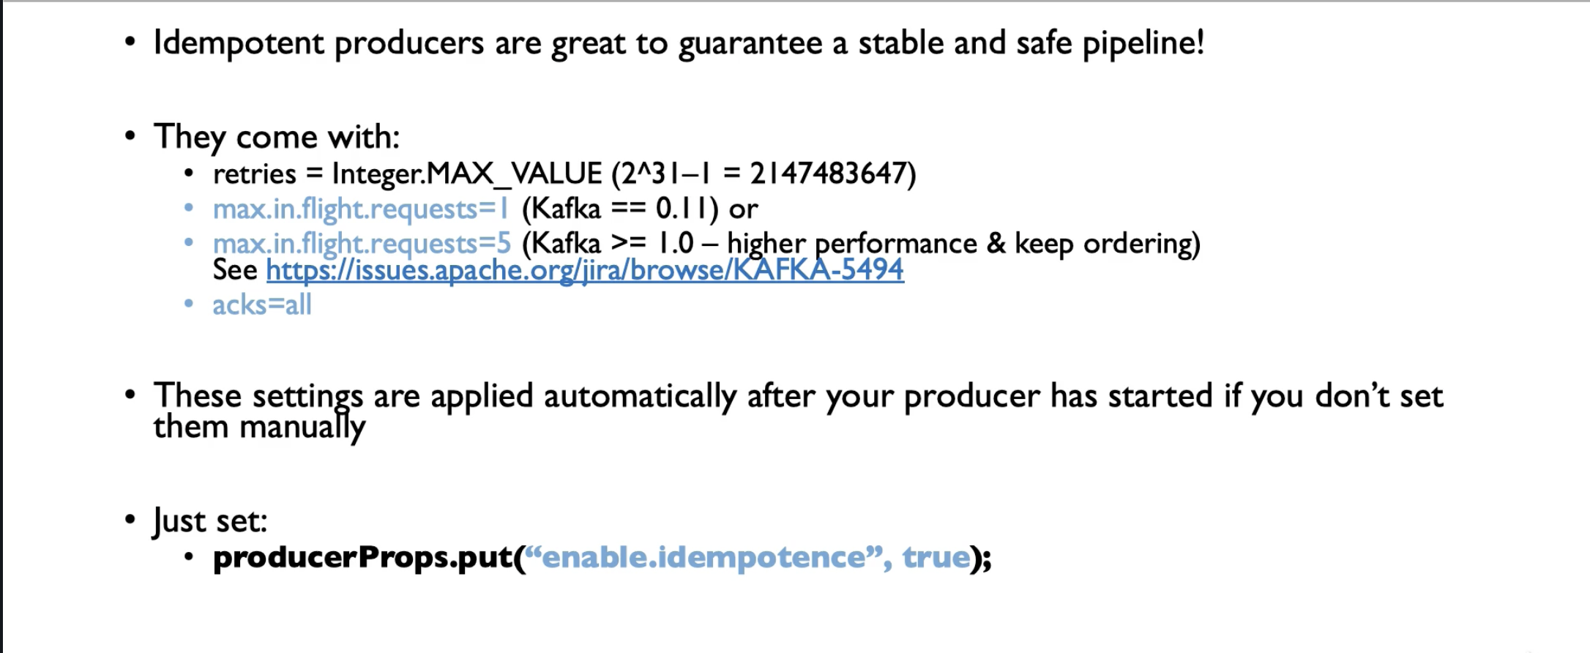

### Safe producer summary and demo

Kafka < 0.11

* acks = all
  + Data is properly replicated across all the replicas
* min.insync.replicas = 2
  + Ensures at least two brokers have the saved message data
* reties = Integer.MAX
  + Ensures transient errors are retried indefinitely
* max.in.flight.requests.per.connection = 1
  + Ensures ordering is maintained, prevents reordering incase of retries

Kafka >= 0.11

* enable.idempotence = true (producer level)
* min.insync.replicas = 2 (Broker/topic level)
* *Keeps the performance and ordering*

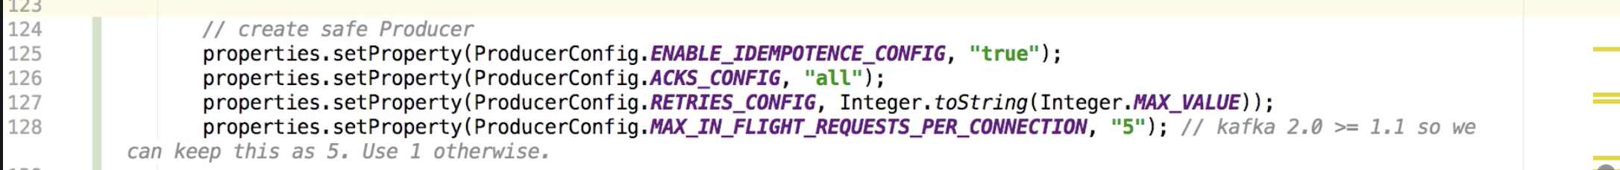

### Message compression - Producer compression

|  |
| --- |
| *The another setting* ***that******is*** *so important* ***but*** *everyone misses* ***is*** *message compression* |

* Producer generally sends messages to Kafka in the form of text, usually JSON data.
* JSON is text heavy, so **it** is very important to compress **the** producer message
* Compression is done at the Producer level and does **not** require **any** changes **at** Consumer **or** broker level
* The compression types are
  + None
  + Gzip
  + Lz4
  + Snappy
* The more data we send the more compression is useful

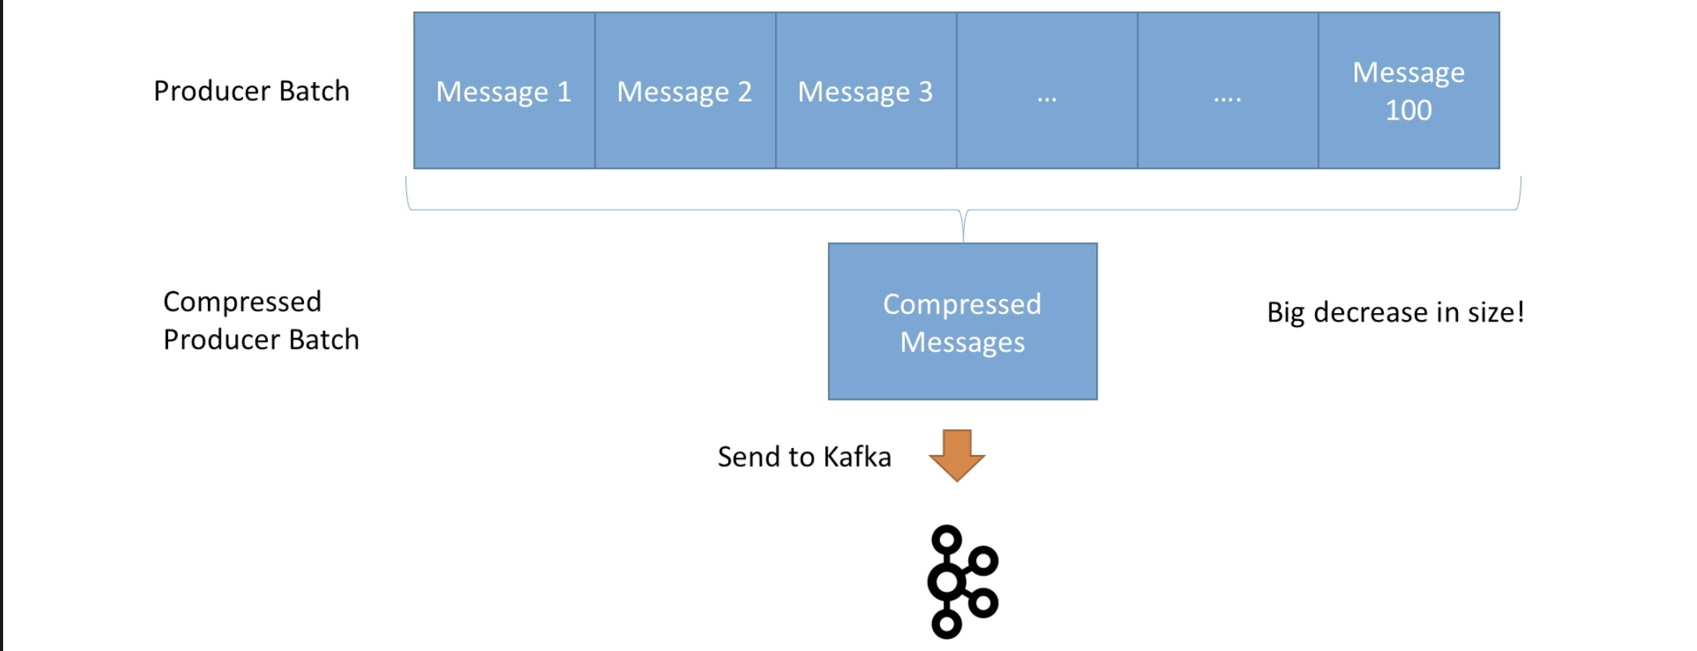

Advantages of compression

* Much smaller size message/ request size, sometimes can be 4X smaller
* Faster transfer of data due to less data
* Less latency and high throughput
* Effective usage of disk space on kafka
* High speed replication at Kafka due to less size message

Disadvantages

* CPU labour for compression of the message (Minor)
* CPU labour for decompression of the message (Minor)

|  |
| --- |
| **Better** compression types can **be** used are snappy **and** lz4 for **better** optimal compression speed |

|  |
| --- |
| GZip has highest compression ratio, **but** **it** **is** **not** very fast |

Recommendation

* Find an algorithm that compresses better, don't stick to just one, test all.
* Always better to use some compression of the requests
* Consider tweaking linger.ms and batch.size, such that the bigger the batch size, the better is the compression and throughput

### 

### Producer batching - High throughput producer

* By default Kafka tries to send the messages as soon as possible
  + It will take upto 5 requests at a time in parallel
  + If more requests are to be sent while others are in flight, Kafka is smart enough and starts batching them while they wait to send them all at once
* This batching allows Kafka to increase the throughput and low latency
* As the batch sizes increases, there will be a better compression ratio

|  |
| --- |
| Kafka gives this functionality **out**-**of**-the-box, we need **not** **do** any changes. **If** there are thousands **of** messages **on** the .send() **method**, **Kafka** **producers** **automatically** **batch** **them** **and** **push** **them** **to** **the** **broker**. |

How to control the batching mechanism?

Linger.ms = It is the number of milliseconds that the producer is willing to wait to send the next message

* By default, the value is 0, meaning the producer sends the messages right away and doesn’t wait at all
* If apply some delay, for example linger.**ms** **= 5** (5 milliseconds), then producer can wait upto 5 milliseconds before sending the next message
* Producer out of the box creates batches while it is waiting, 5 milliseconds in our example, and sends to broker when the delay matures
* If the batch is full (batch.size) before the exhaustion of the linger.ms, **then** producer sends **the** batch **of** messages right away **without** waiting **for** **the** delay
* This type of introducing delay gives
  + Better compression of messages
  + Higher throughput
  + Better performance

batch.size

* It is the maximum number of bytes that can go into a batch
* The default is 16KB
* It is most common to increase the batch size to 32 or 64, which generally increases the compression ratio, throughput and performance

|  |
| --- |
| A single message **greater than** **the** batch size will **not** be batched |

### High throughput producer

1. Snappy compression (Generally used algorithm, eben by google)
2. Linger ms config (generally we can give 20ms)
3. Batch size, can be 32KB



### Producer default partitioner and key hashing

* Keys are generally hashed using murmur2 algorithm
* There is an inbuilt partitioning logic. We can also provide custom partitioning logic using Partitioner.class, but is highly **NOT** recommended
* Formula for partitioning is

|  |
| --- |
| Utils.**abs**(Utils.murmur2(**record**.key)) % number **of** partitions |

* This means the same key always goes to the same partition
* With a change in number of partitions, it totally changes the result of the formula

Advanced concepts

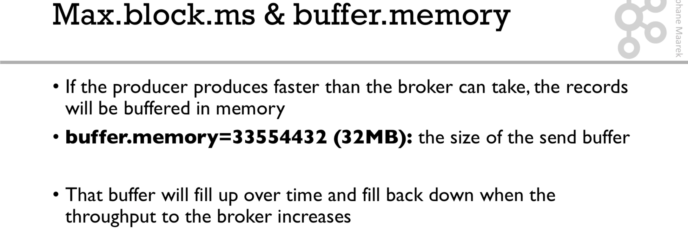

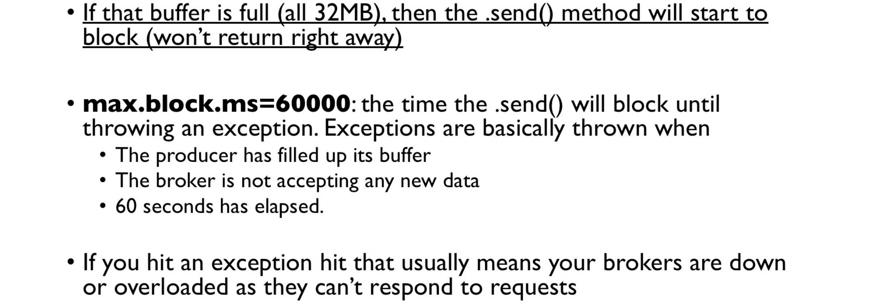

### Delivery semantics

**At Most Once:**

* Messages are committed by Kafka as soon as the batch is received
* Kafka commits the message as soon as the message batch is received. If the processing of any of the messages in the batch goes wrong, then the message is lost and Kafka does not read the message again.

*Here in our example the processing of data represents feeding data to elastic search*

Scenario:

|  |
| --- |
| 1. Producer sends message 2. Kafka acknowledges **the** receival 3. Consumer starts **the** processing **of** **the** data, processes two chunks **of** **the** batch 4. Consumer goes down 5. Consumer comes up 6. Consumer does **not** process **the** point where **it** went down, but from **the** point Kafka is committing 7. So **the** data is lost, **and** Kafka does **not** commit **the** message again **as** **it** is At most once |

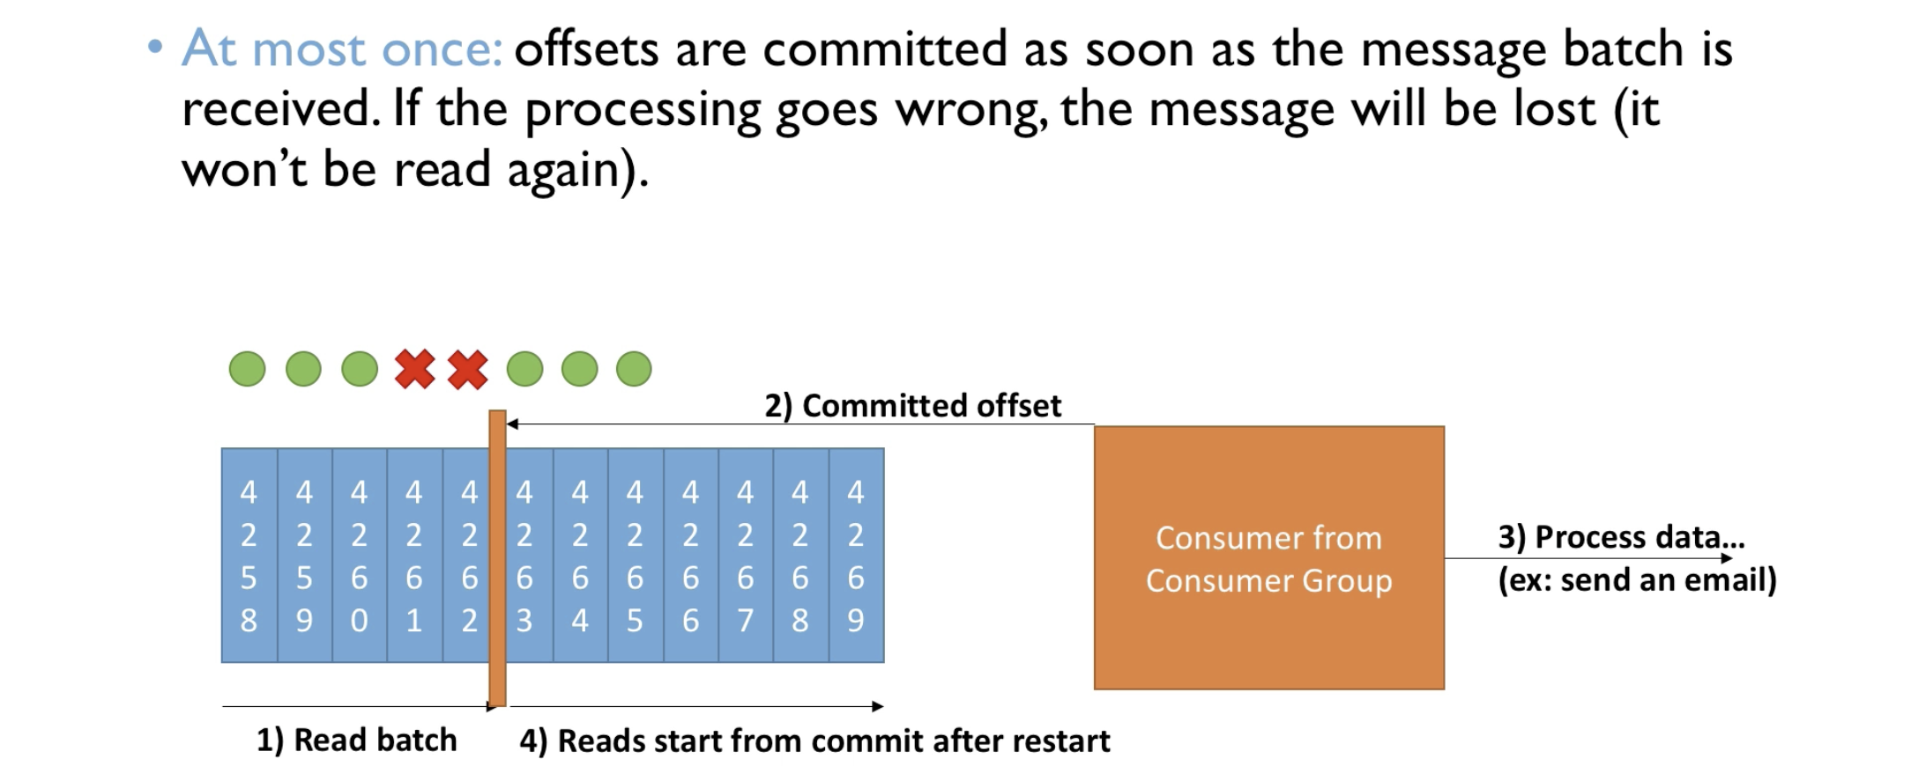

**At least once:**

* Kafka commits the batch only after the the batch is processed completely
* If something goes wrong, the **message** will be **read** again. This may lead to duplicate messages. To avoid this we make sure to have the processing **to** **be** idempotent

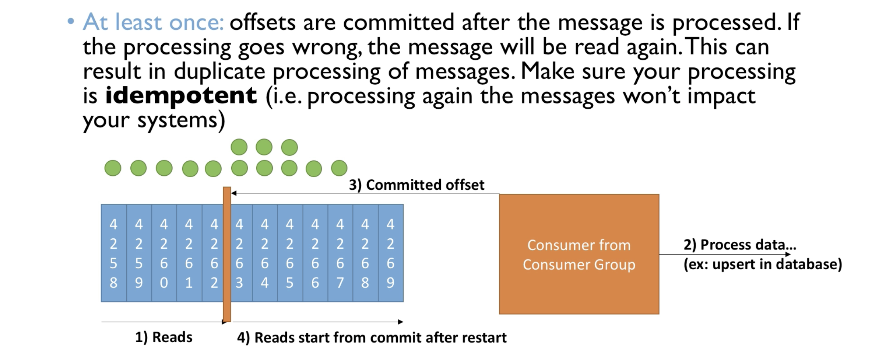

* Incase of restarts there is a chance of reading the messages again, in our case, feeding the data to elastic search again.
* We need to make sure the consumer processing to be idempotent

Summary

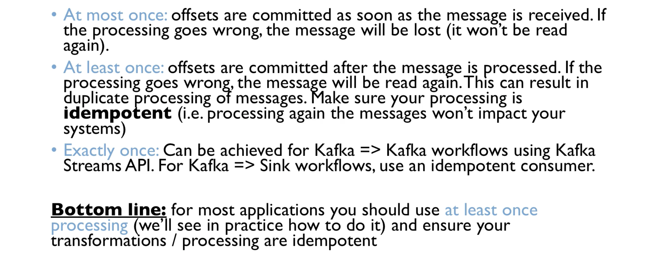

### Consumer idempotence

By default the consumer is at least once. If we don't set anything for offset commit, the default setting is auto-commit of the offsets and it is at least once.

In order to make the consumer idempotent, we need to make use of unique ids. We have two ways of creating ids.

Here we force and id as the id of the data, so next time when the consumer tries to commit the same offset, it uses the same id and reinserts the same data against the same id.

In order to make the consumer idempotence we have two strategies

1. We can use the kafka default id generation

|  |
| --- |
| id = record.topic() + "_" + record.partition() + "_" + record.offset(); |

1. We can use the id of the data we processing
   1. Suppose we are processing a tweet JSON, we can make use of the ID of the tweet already present in the tweet details.

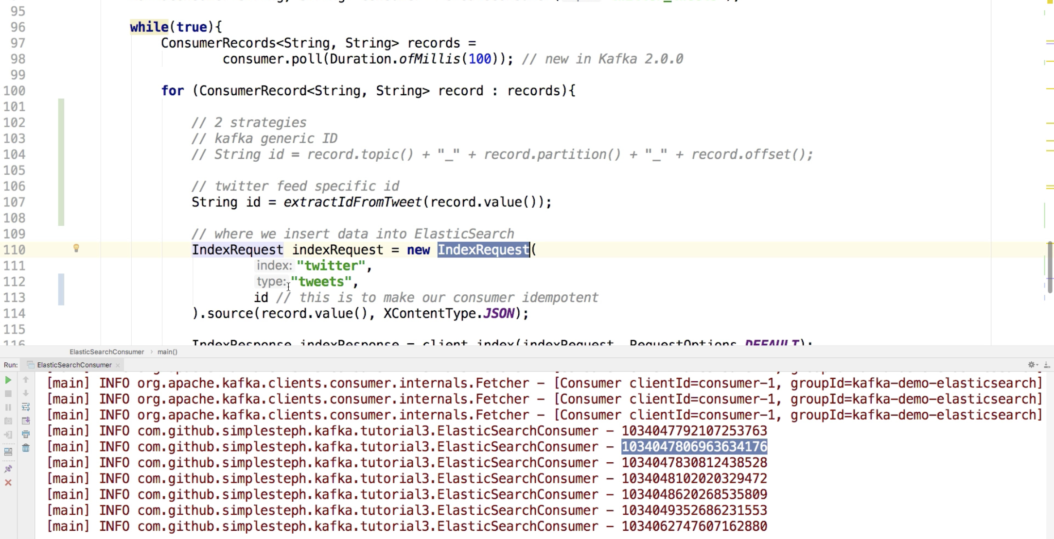

So, even if the consumer goes down for a while and comes up again a few moments later, as we have already been processing the messages in the batch by forcing an ID to each message, the consumer processes the messages from where it left but by using the same ID. This avoids any chance of duplication.

### Consumer poll behavior

* Kafka consumers have a poll model, while many other messaging bus in enterprises have push model, where the broker pushes the data to the consumer while consumer waits for the data
* This gives control to the consumer in from where in the log to consume the data, how fast to consume and how much to consume and ability to replay the events

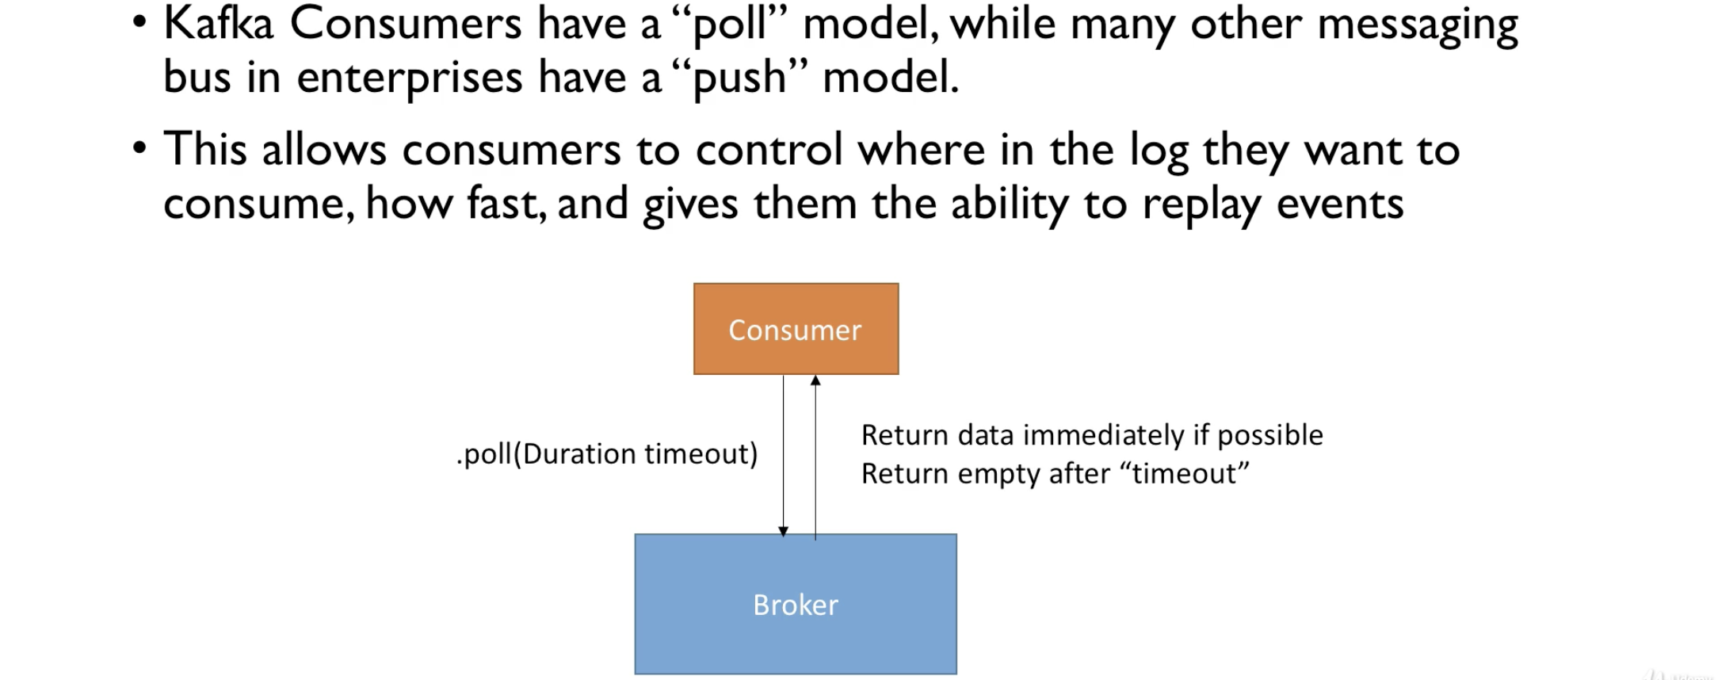

Control

* fetch.min.bytes(default 1)
  + Controls how much data to be pulled at least for each request
  + We can customize to KBs, which can increase the number of requests and throughput at the cost of some processing latency
* max.poll.records (default 500)
  + Indicates how many records to be pulled at least per each request
  + We can increase this if the messages are small and we have lot of RAM and we need to process more records
* max.partitions.fetch.bytes (default 1MB)
  + Maximum size of the data to be fetched per poll per partition
  + If we read from 100 partitions, we need a lot of memory
* fetch.max.bytes (default 50MB)
  + Indicates the max amount of data to be fetched per poll across all the partitions
  + This is observed while the consumer is making multiple poll requests in parallel

|  |
| --- |
| All these are good with the default settings. **Not** recommended **to** change them. |

### Consumer offset commit strategies

We can now learn the offset committing strategies. Generally we have two strategies of offset commits

1. enable.auto.commit = true default setting makes Kafka commit the messages automatically and do the batch processing synchronously
2. enable.auto.commit = false we need to manually apply the commit of the offsets

* With enable.auto.commit = true, offsets are committed at regular intervals auto.commit.interval.**ms** **= 5000** by default.
* This is good if we are doing synchronous batch processing
* If we are doing async processing, then the auto commit will be at most once because the messages are committed before the processing.
* So auto commit is quite risky for beginners

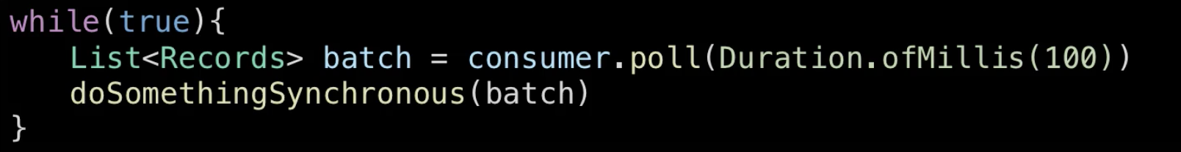

If we do asynchronous processing, then without our knowledge we are in at-most-once strategy offset commit. Offsets are committed before the data is processed. This strategy is risky for beginners.

enable.auto.commmit = false

* Here we control when to commit the offsets after receiving the messages
* Like we can have a condition which when true manual commit can be made
* Example, we accumulate the records in a buffer and commit flush them into a DB once the buffer is full, when the operation is success only then we can commit the messages

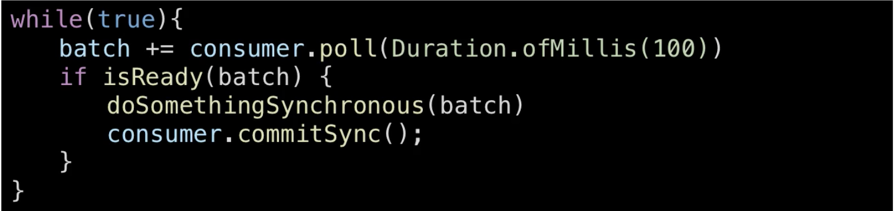

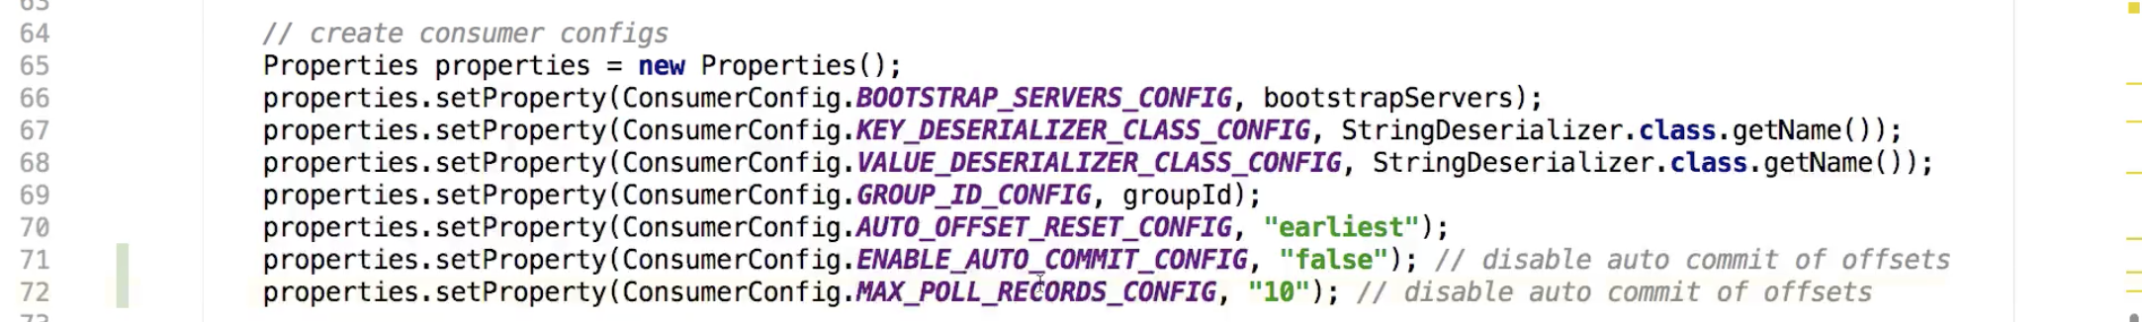

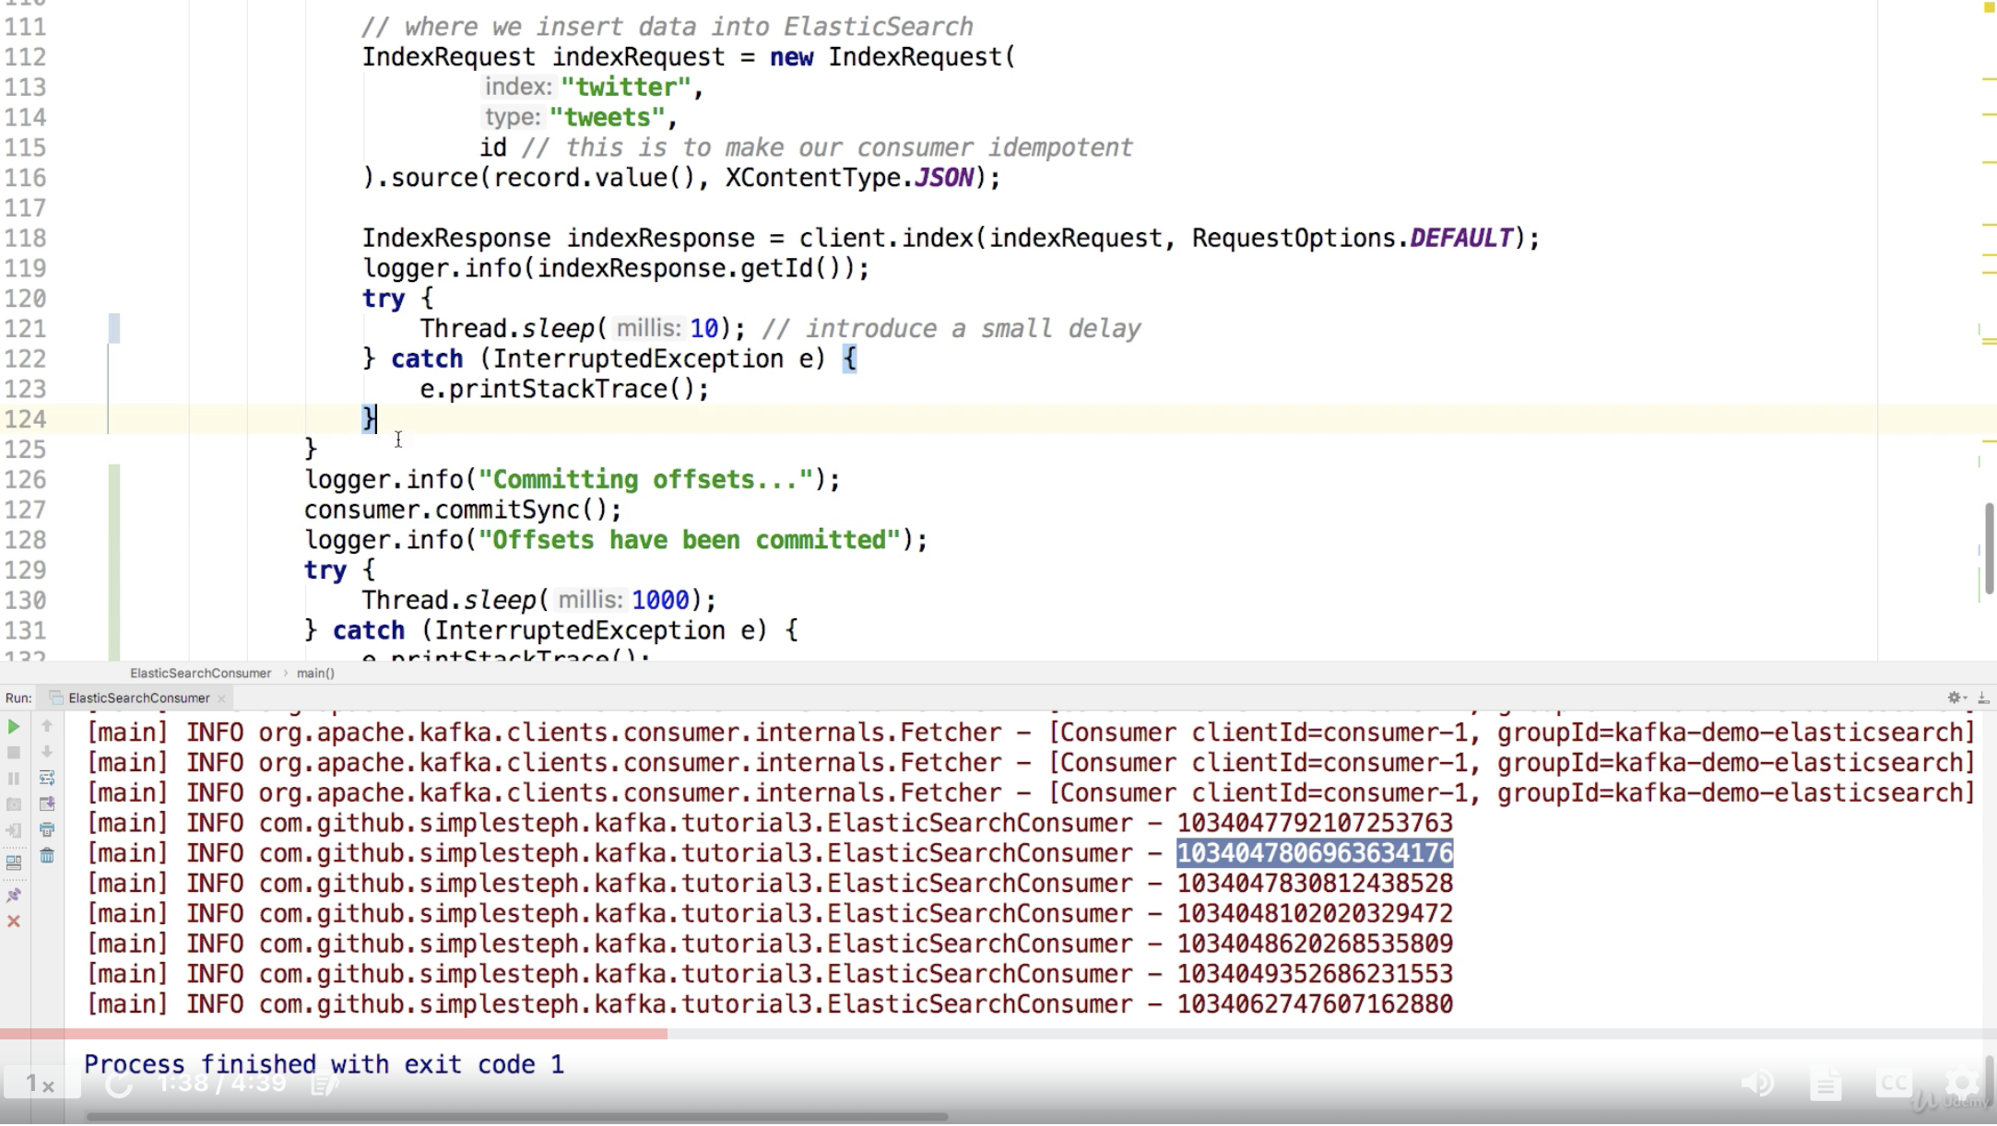

### Consumer performance improvement - Batching

* We are using an index request which processes a small amount of data. Inorder to process data in large amount then we can use BulkRequest.
* We create Index requests normally while looping over the records and we add the index request created in each iteration to bulk request
* Once we have reached the max poll messages, we push the bulk request for processing
* This increases the performance by dealing with large amounts of data in less time.
* For batching we need to create bulk request to push bulk amount of data.
* Then we loop over the records and add them to the bulk request
* When we are done with the for loop, we trigger **client**.bulk(**bulkRequest**, **ResponseOptions**.DEFAULT);
* And then we can commit the offsets

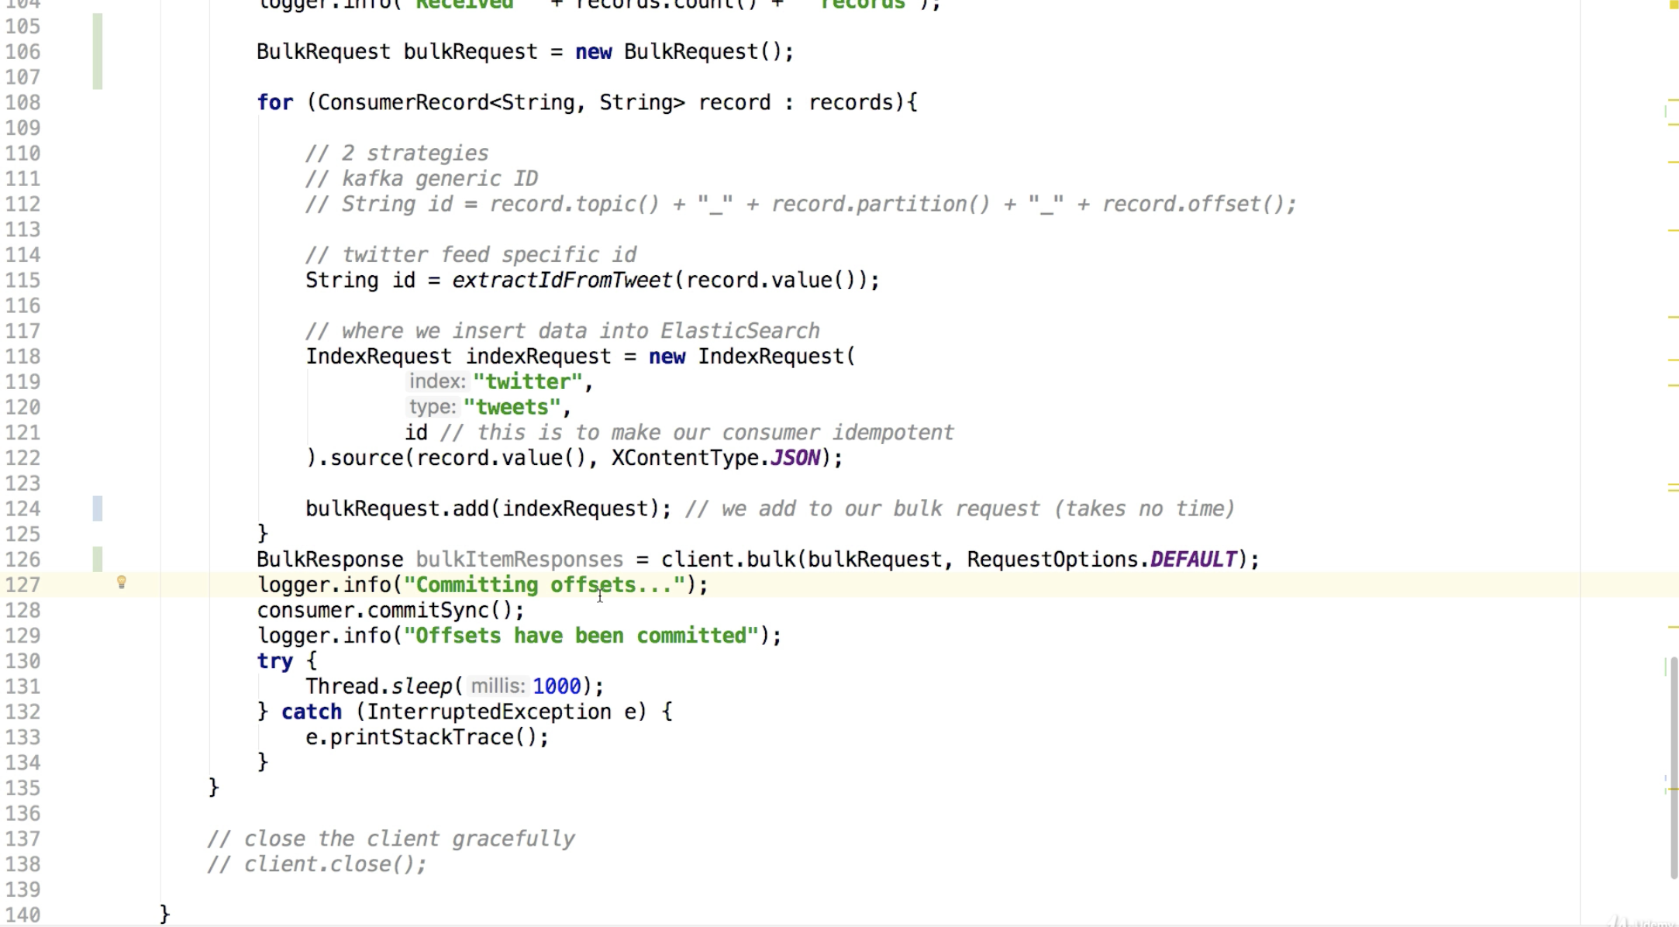

### Consumer offset reset behavior

* A consumer is expected to read the data continuously
* If a consumer goes down for one day, then as Kafka (>= 2.0) has the offset retention support of 7 days
* But if the consumer goes down for more than 7 days, then Kafka revokes the retention and the data is lost
* So to deal with this we have a setting

offset.retention.minutes

Set this value to high enough to avoid data loss

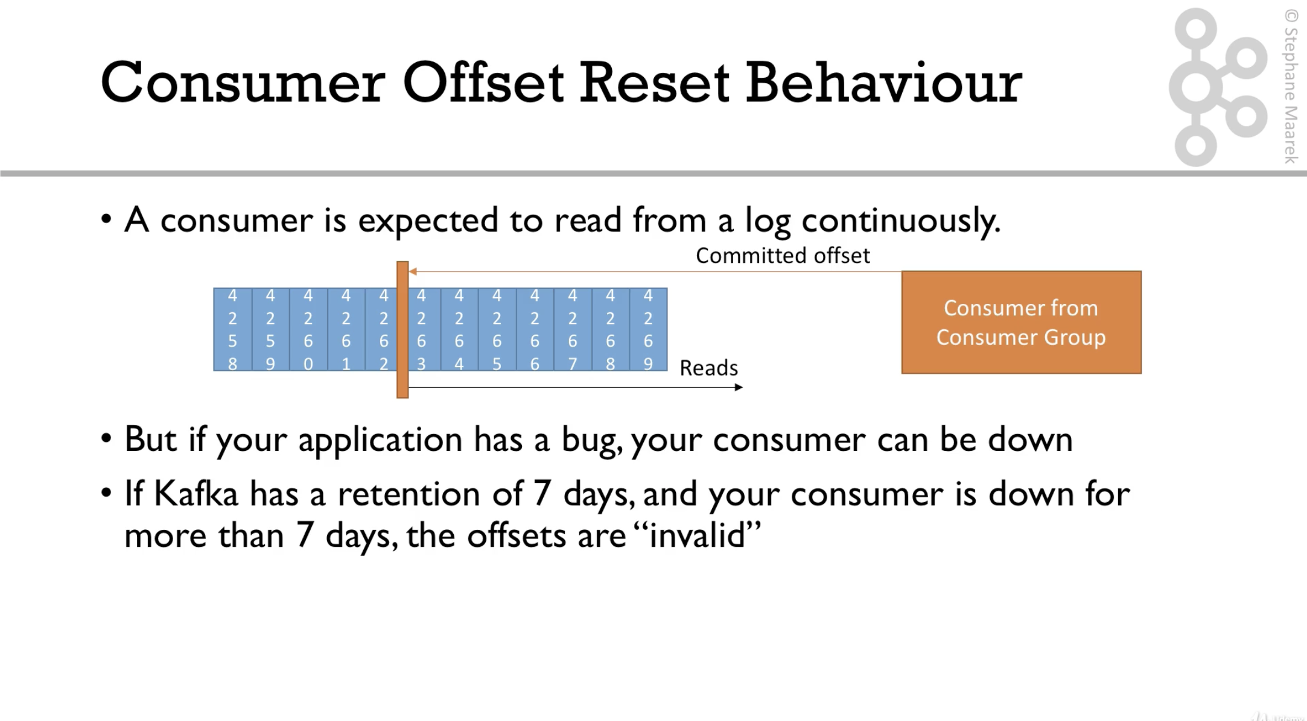

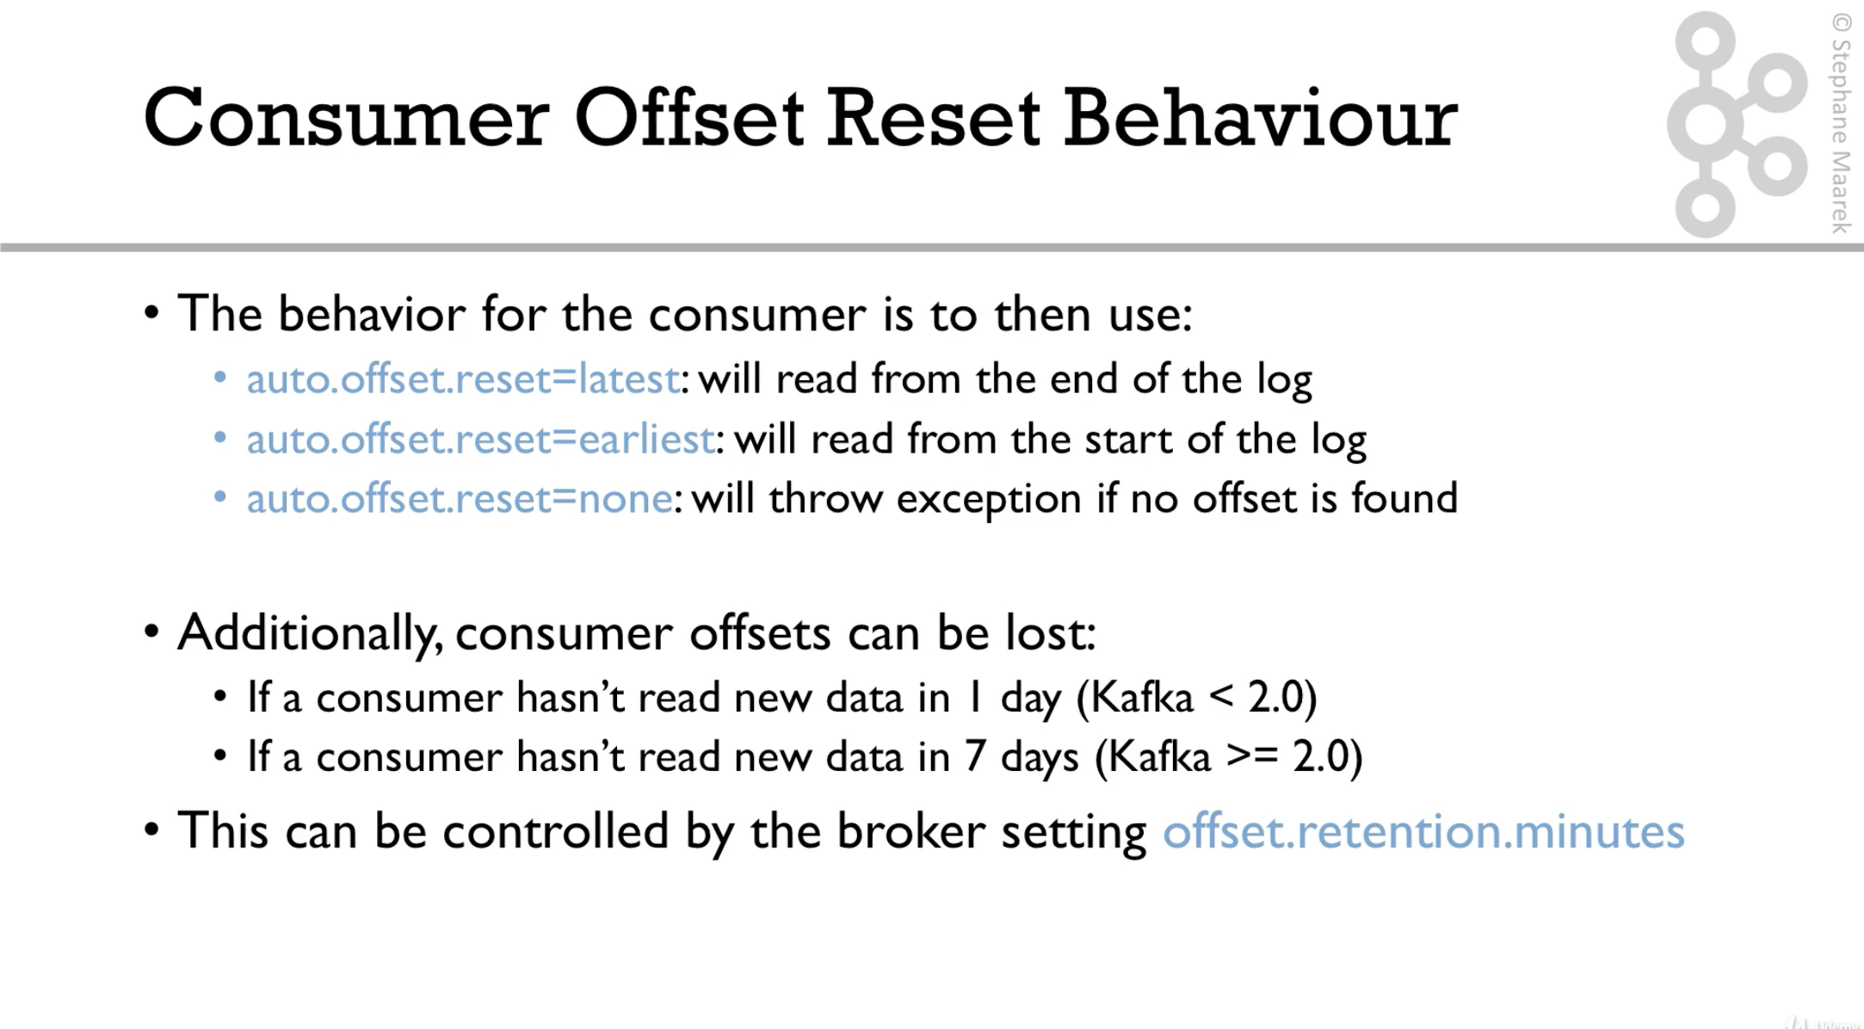

Replaying data for consumers

To replay

* Take all the consumers of a particular group down
* Use **kafka-consumer-groups** command to set the offset value to the value we want
* Restart the consumers’ offsets
* Use replay capability incase of server down scenarios

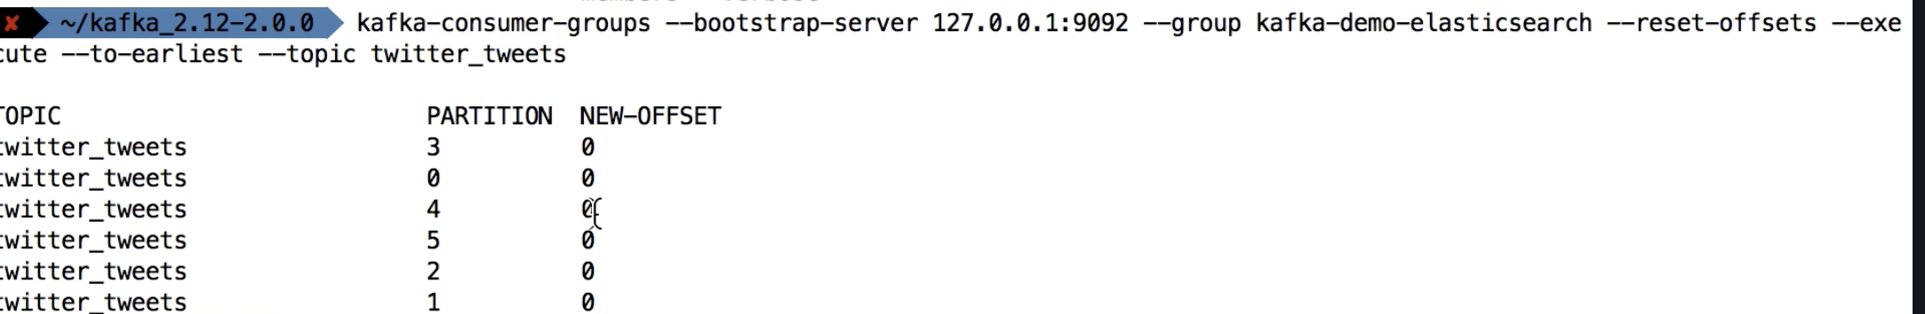

### Consumer liveliness

* Consumer polls broker continuously to fetch the data from the broker and process.
* Consumer also sends **heartbeats** to a broker called Consumer Coordinator, acting broker
* These heartbeats are used to monitor the liveliness of the consumers, and to know if there are any consumers that went down

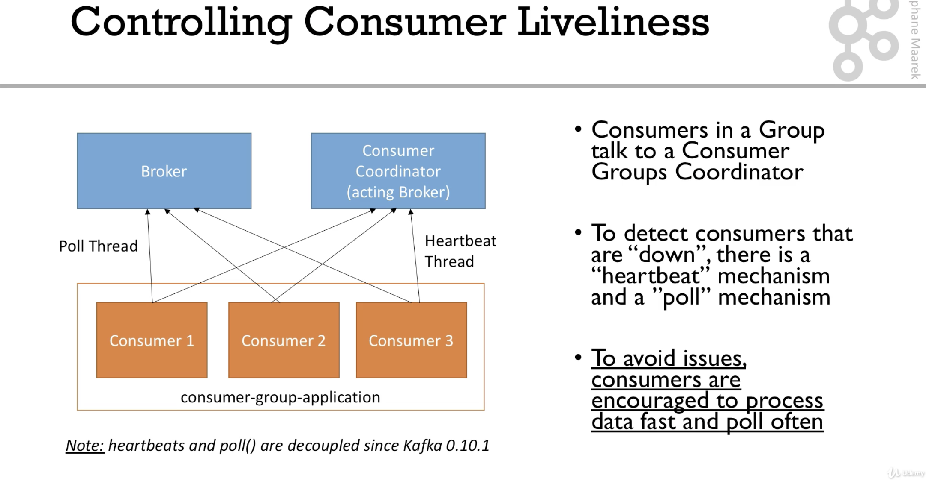

Settings

session.timeout.ms (default 10 seconds)

* Heartbeats are sent periodically
* If a heartbeat is not heard in the given period of time, then the consumer is considered to be down
* Default is 10s, set even lower for faster rebalances

heartbeat.interval.ms (default 3 seconds)

* Heartbeats are sent in regular intervals of time
* Generally the interval is set as 1/3rd of the timeout ms

Consumer poll thread

max.poll.interval.ms (default 5 minutes)

* Maximum amount of time between two .poll() calls
* If no poll is heard within this period, then the consumer is considered to be dead
* If we are dealing with bg data or if the data processing takes a lot of time, then we need to give a high value of minutes for this setting.

*An even better approach is to make the data smaller and thereby make the processing faster.*

### Kafka Connect API

Kafka connect is all about code and connections re-use.

* Kafka connect API is like a framework used to reduce all the boiler plate code while creating connections to various systems like DBs or APIs

Four scenarios of using Kafka Connect and Streams

* Source → Kafka Kafka Connect Source API
* Kafka → Kafka Consumer Producer API → Kafka Streams
* Kafka → Sink Consumer API → Kafka Connect Sink
* Kafka → App Consumer API → Kafka Connect Sink

|  |
| --- |
| These APIs **help** us **to** easily **get** the **data** **in** **and** **out** **of** Kafka Simplifying **data** with**in** Kafka **without** relying **on** **external** libraries |

Kafka Connect

* All the programmers/business cases want to get the data from some sources like Twitter, DynamoDB, rethinkDB, CouchBase, SAP etc
* And programmers who want to store data dumps the data in one of the sinks like MongoDB, DynamoDB, rethinkDB, SAP Twitter etc
* To set up a system for this is absolutely tiresome, laborious highly prone to system instability
* Tough to achieve fault tolerance, idempotence, distribution and ordering
* Many programmers around the world would have faced the same issues and would have solved these problems in clever way

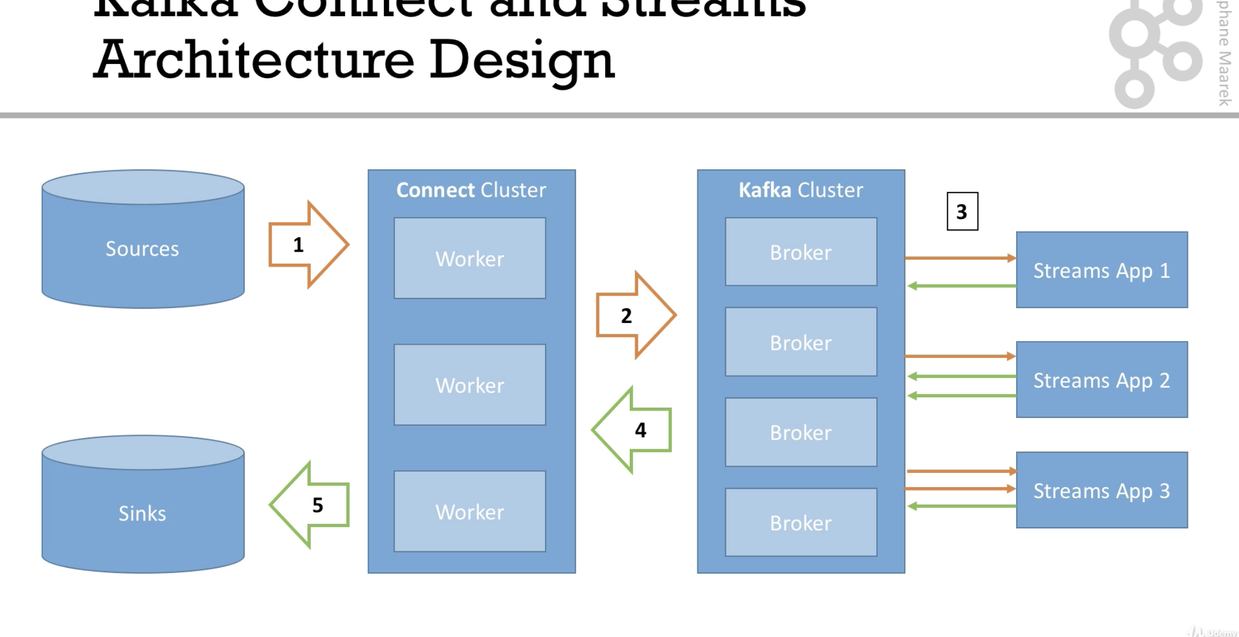

* Kafka connectors get the data from common datasources
* And push the data into a cluster of Kafka Brokers
* Then we have a Kafka streams API which filters the data/ transform/enrich the data in Kafka
* When the data is ready in broker, we ask connect cluster to pull the data from Kafka Cluster and put into the sinks which nothing but a consumer API
* Sink connectors to push data into common data sources

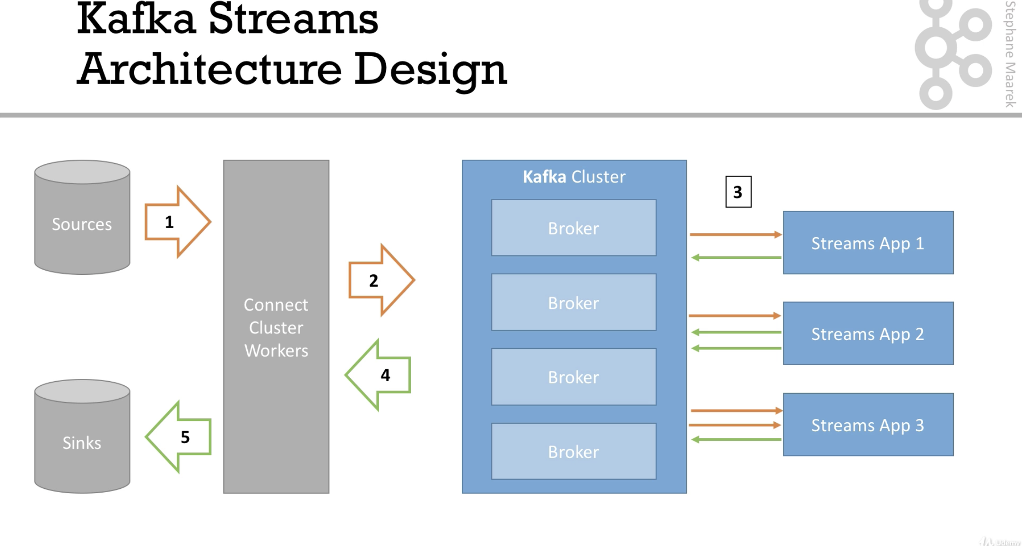

### Kafka Connect handson

<https://www.confluent.io/product/connectors/>

<https://github.com/jcustenborder/kafka-connect-twitter>

### Kafka Streams Introduction

* Suppose we want to filter the tweets from twitter_tweets topic which has not less than 100 likes
* Or we want to count the number of likes that received on a particular hashtag per hour
* Or if we want to combine both and get trending topics
* This we can do with traditional producers and consumers but could be tedious and will be low level and not developer friendly.

Kafka Streams:

* Kafka streams is used for data processing and data transformation at the Kafka end

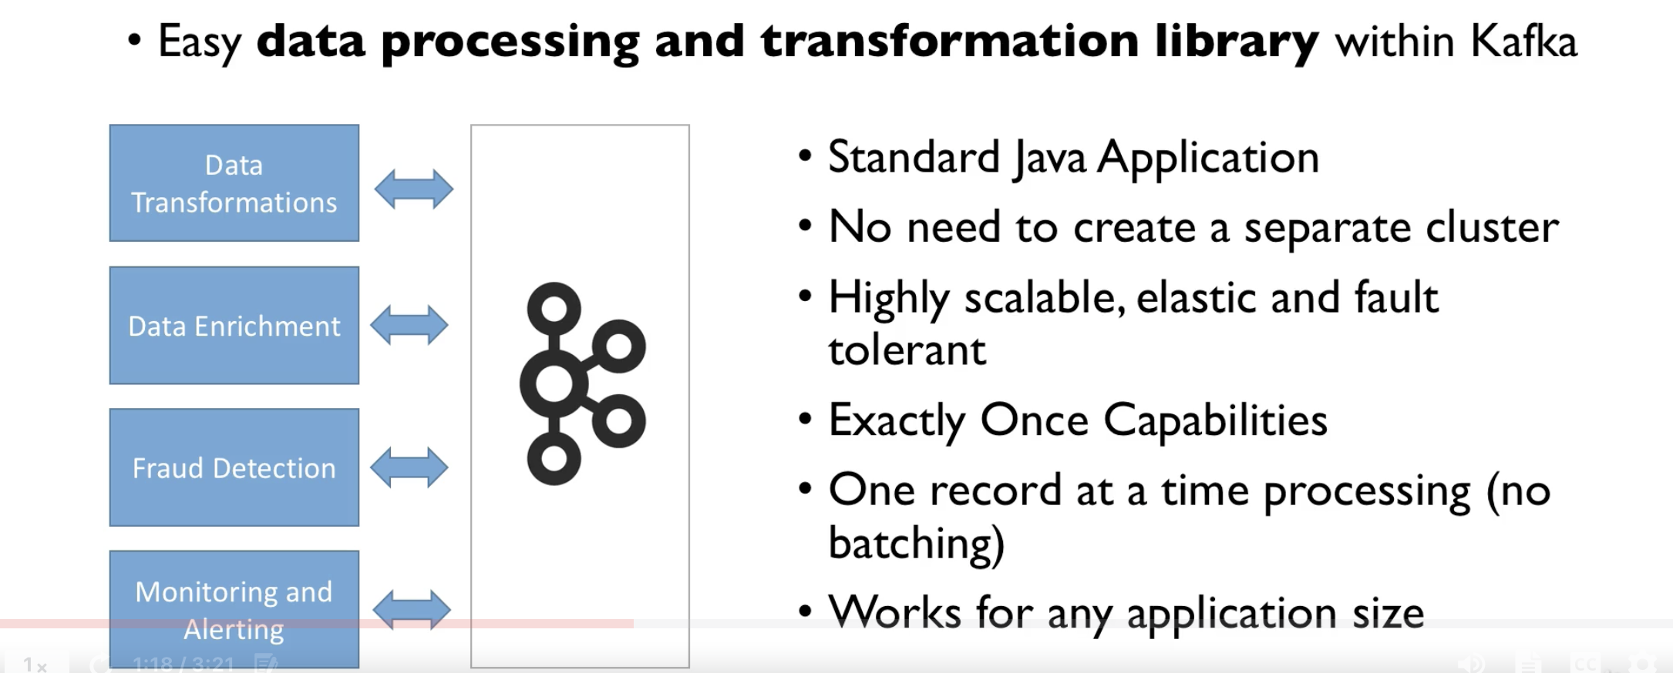

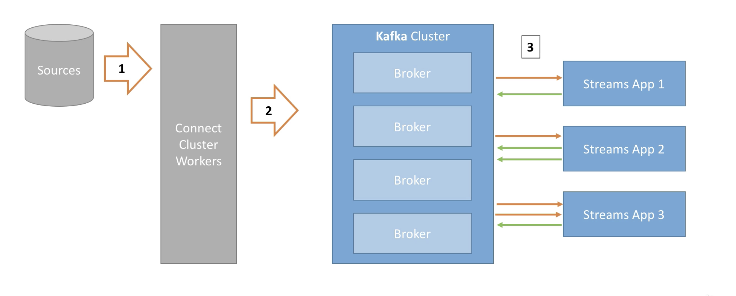

* Kafka streams takes data from one topic or multiple topics and transforms the dats and them pushes the enriched data into one topic or multiple topics

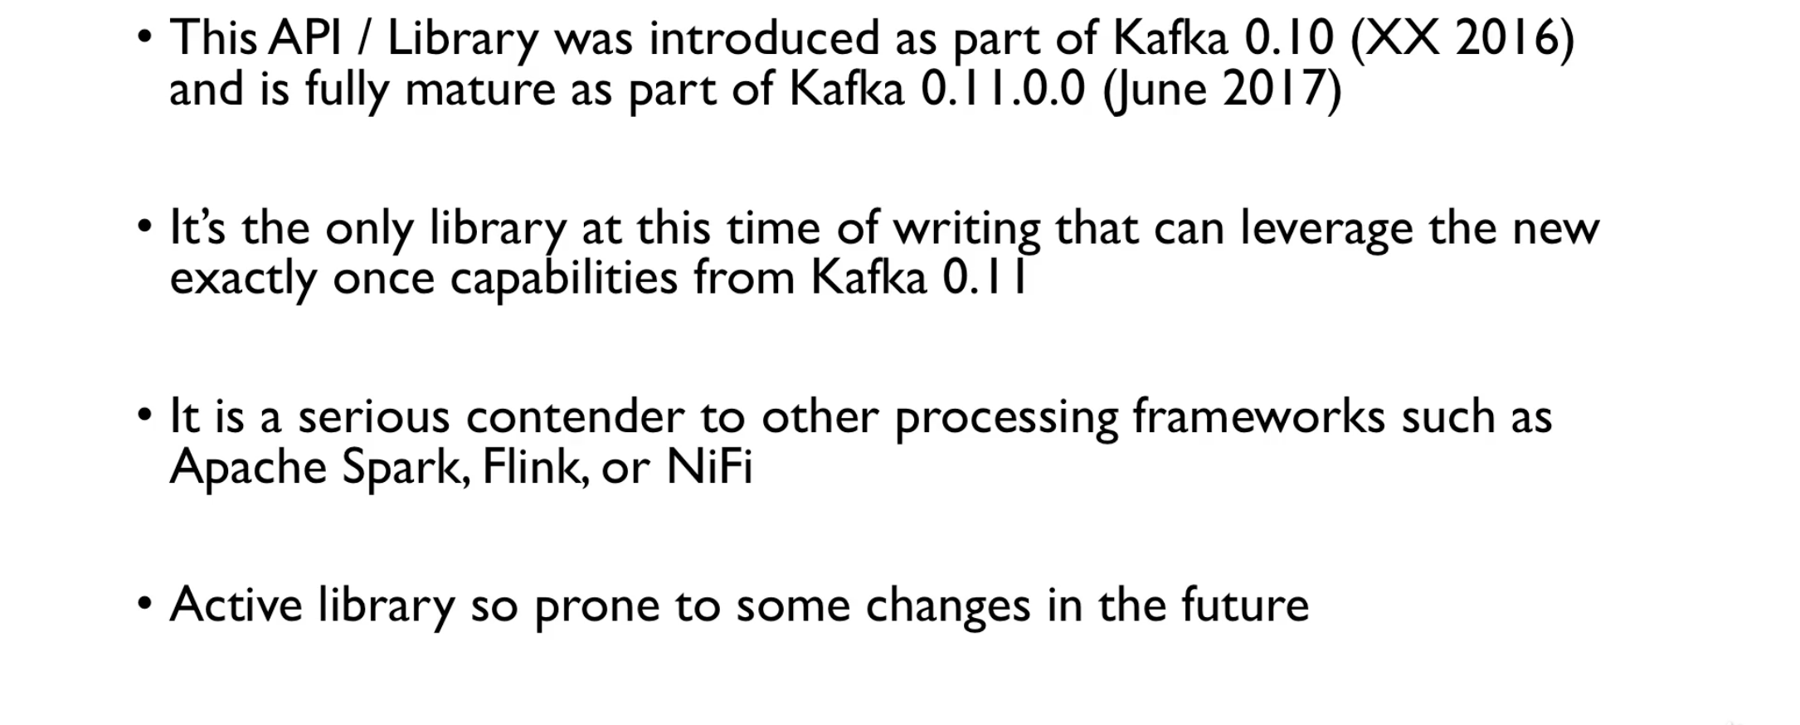

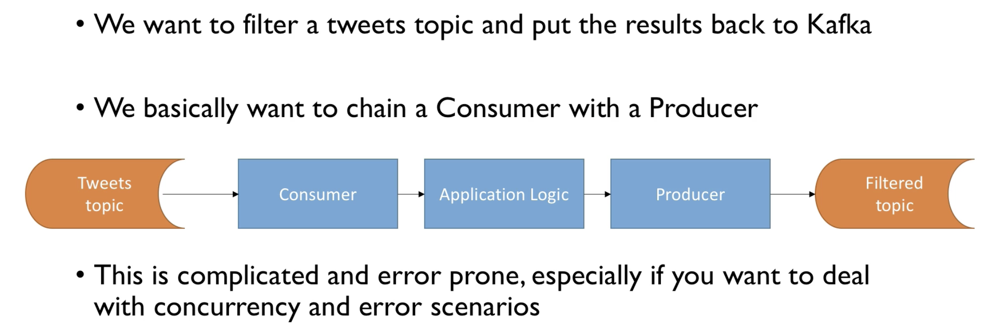

### Kafka Schema Registry introduction

* Kafka takes bytes as input and outputs bytes
* There is no data verification
* What if the data format changes?
* What if a variable name changes?
* So we need data to be self describable
* We need to be able to evolve the data without affecting the downstream systems
* So we need a proper standard/schema for data and a schema registry

Kafka doesn't do any schema verification

* Kafka don't even read the data, it just receives the bytes and sends them to the consumer for processing - Zero CPU usage
* Kafka does not save the data in to the memory, it is just like a passthrough
* Kafka doesn't even know the data type of a variable of the data passed to it
* This makes Kafka extremely performant

The schema registry has to be a separate component

* Producers and consumers needs to able to talk to it
* Schema registry must be able to reject bad data
* A common data format must be agreed upon
  + It needs to support schemas
  + It needs to support evolution
  + It needs to be lightweight

The confluent Schema Registry  
Apache Avro is the agreed data format

Without schema registry



With schema registry

1. Store and retrieve schemas for producers and consumers
2. Enforce backward, forward and full compatibility
3. Decrease the size of the payload if required

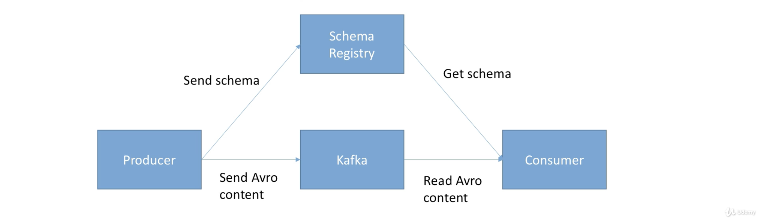

* Utilizing Schema has benefits
* We need to
  + Make sure it is highly available
  + Make some changes in producer and consumer
  + St it up well
* Apache Avro is very good data format than JSON but has some learning curve
* The Schema is free and open source by Confluent

|  |
| --- |
| Real world insights **and** case studies - **Big** data / Fast data |

### Choosing partition count and replication factor

These are the two most important things to consider while creating a topic

1. Number or partitions
2. Number of replicas

These properties the stability and performance of the overall system

|  |
| --- |
| Suppose that we have specified **the** number **of** partitions **and** replicas **while** creating **a** topic, **and** **if** during **the** lifecycle **the** number **of** partitions increases, **then** there is **a** possibility **of** disturbance **in** keys ordering guarantee |

|  |
| --- |
| Suppose that we have specified **the** number **of** partitions **and** replicas **while** creating **a** topic, **and** **if** during **the** lifecycle **the** number **of** replicas increases, **then** there will be a pressure created on the cluster and can lead to unexpected performance hits |

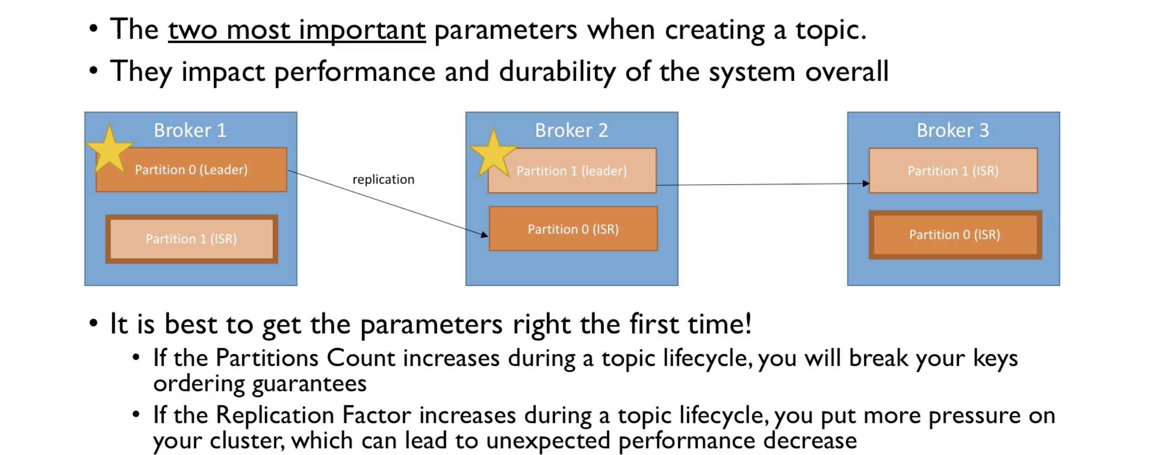

Yes, we cannot know the details in advance while creating the topics, but we need to speculate and test them similar to a load test.

### Partitions count

* Each partition can handle a throughput of a few MBs of data.
* If we have more partitions, then there will be a higher throughput and better performance.
* It is better to have more partitions so we can leverage more number of consumers, because we cannot have consumers more than partitions
* With more number of consumers we have more number of partition and more parallel operation which increases the performance and throughput of the system
* We can leverage more brokers for higher number of partitions
* BUT there will be elections overhead to zookeeper
* And more files opened on Kafka

Guidelines

1. Number of partitions per topic = Million dollars question
2. Small cluster (<6 brokers) = 2 x number of brokers
3. Large cluster ( > 12 brokers) = 1 x number of brokers
4. Adjust the number of brokers for better parallelism at higher throughput

If the consumers are performant intense at peak time that may require up to 20 consumers, then plan at least for 20 partitions

Overall we have to think and speculate the traffic for the next 2 years and decide on the numbers

If we have very high throughput producers, then plan the number of producers like 3 times the number of brokers

### Replication factor

* Replication factor should be at least 2, usually 3, and maximum 4
* For higher replication, better resilience in the system
* BUT higher latency for acks=all
* But more disk space on your system (50% more if the replication factor is 3 instead of 2)

Guidelines

* Set it to 3 initially. You should have at least 3 to get started => at least 3 brokers
* If replication factor is causing performance issue, then go for a better broker, never compromise on replication as it is a matter of system resilience
* Never ever set it to 1

### Cluster guidelines

* It is okay/good to have 2000 to 4000 partitions across all topics per that broker and not more than that
* Additionally Kafka cluster should have 20000 partitions across all the brokers
* Latency as the zookeeper need to perform elections in case there is a broker down situation
* If you need more partitions, add brokers instead
* If you need more than 20000 partitions, then like netflix model, create more clusters
* Overall you don't need a 1000 partitions per topic for higher throughput. Start with a reasonable number and test the performance.

Naming Conventions: <https://medium.com/@criccomini/how-to-paint-a-bike-shed-kafka-topic-naming-conventions-1b7259790073>

### Case study - Movie flix

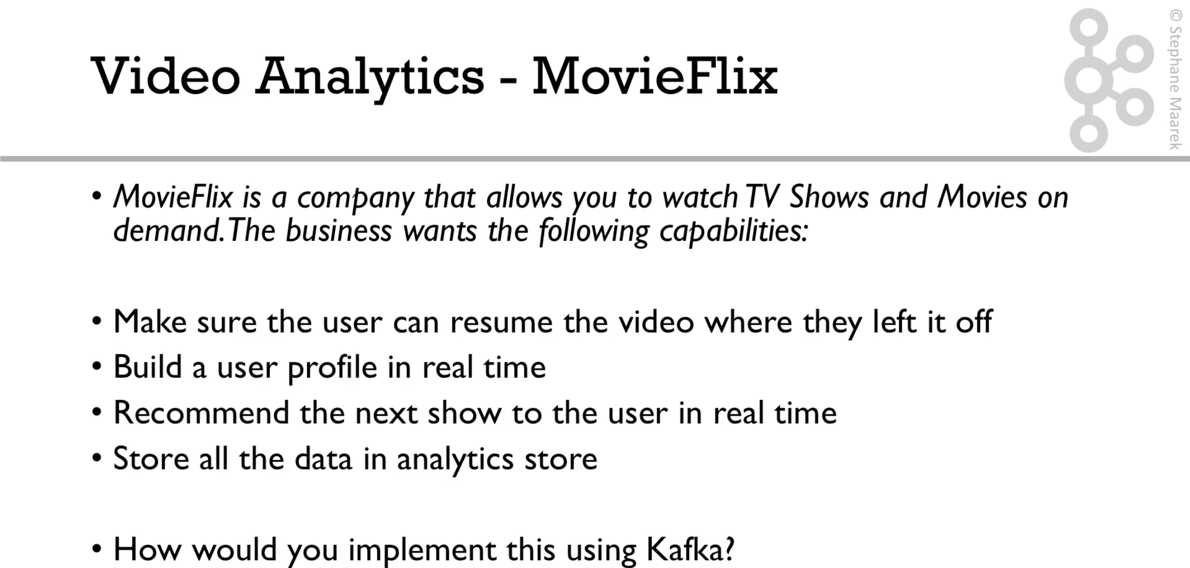

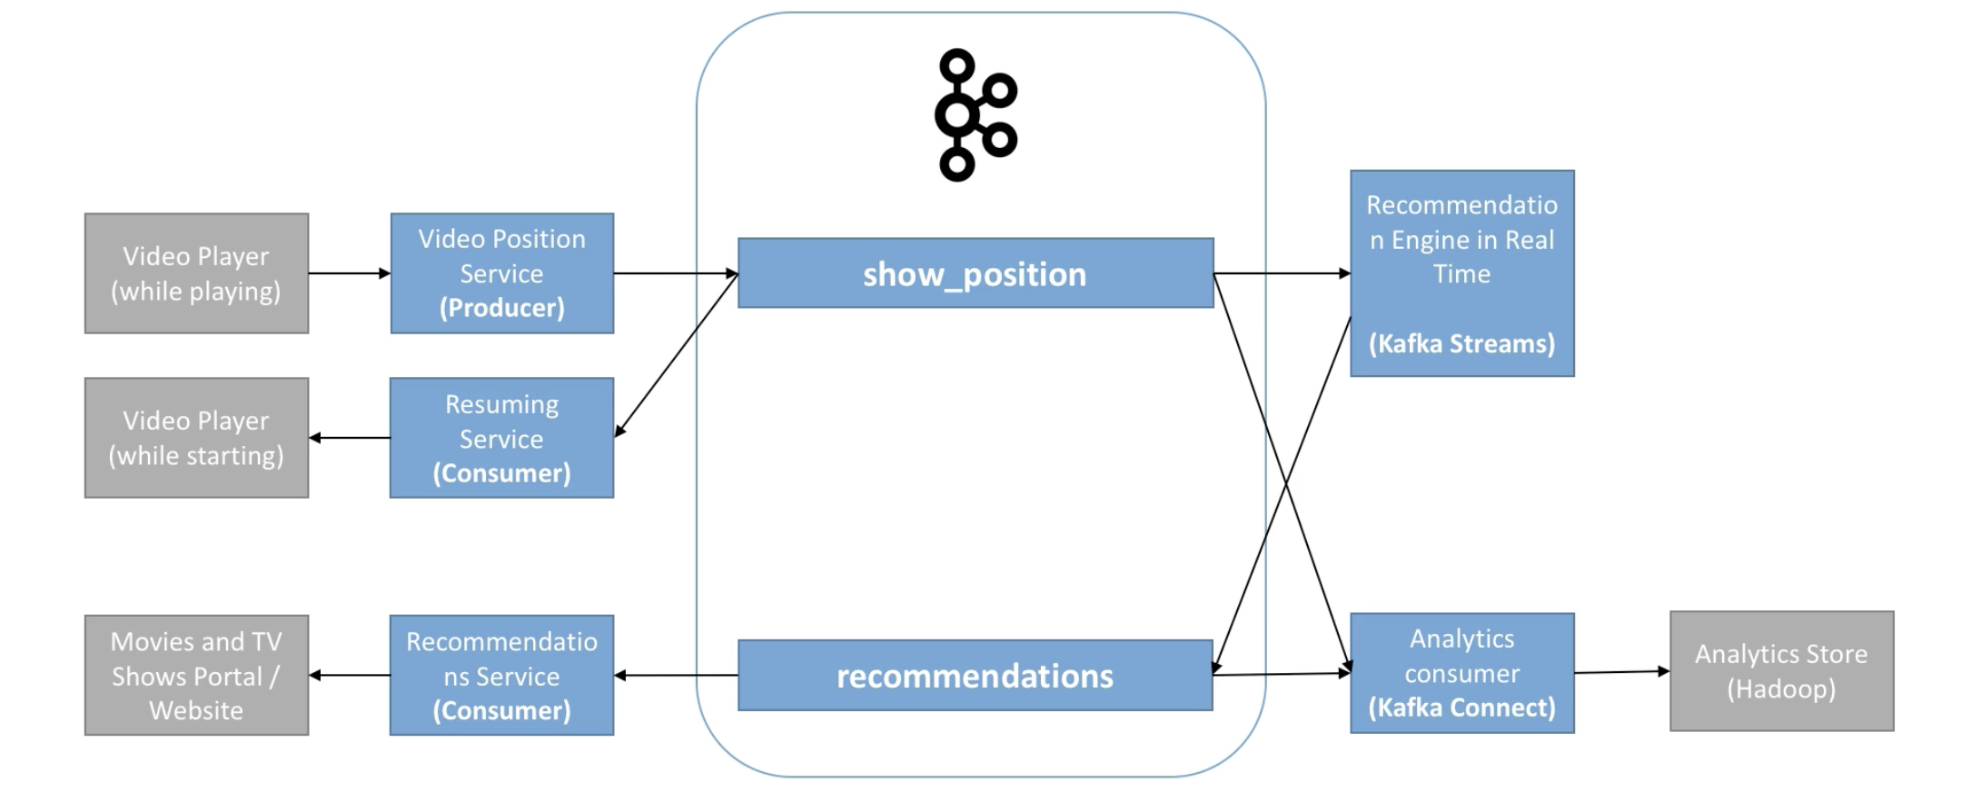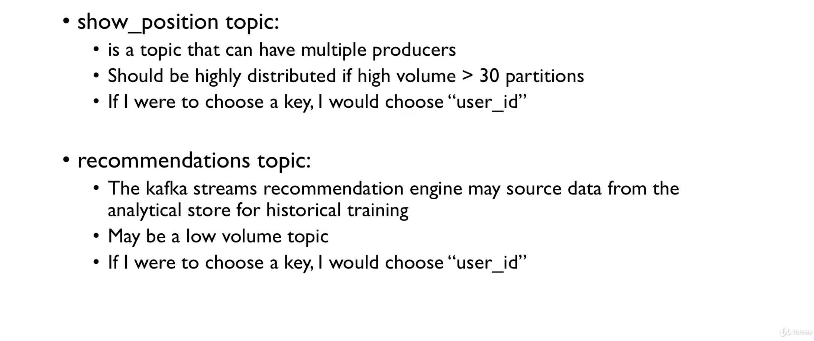

### 

### Case study - Get Taxi

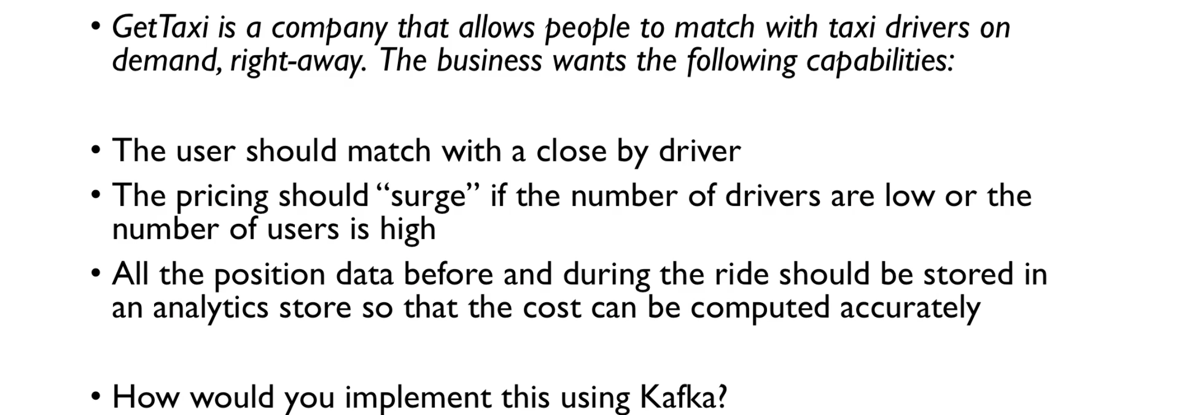

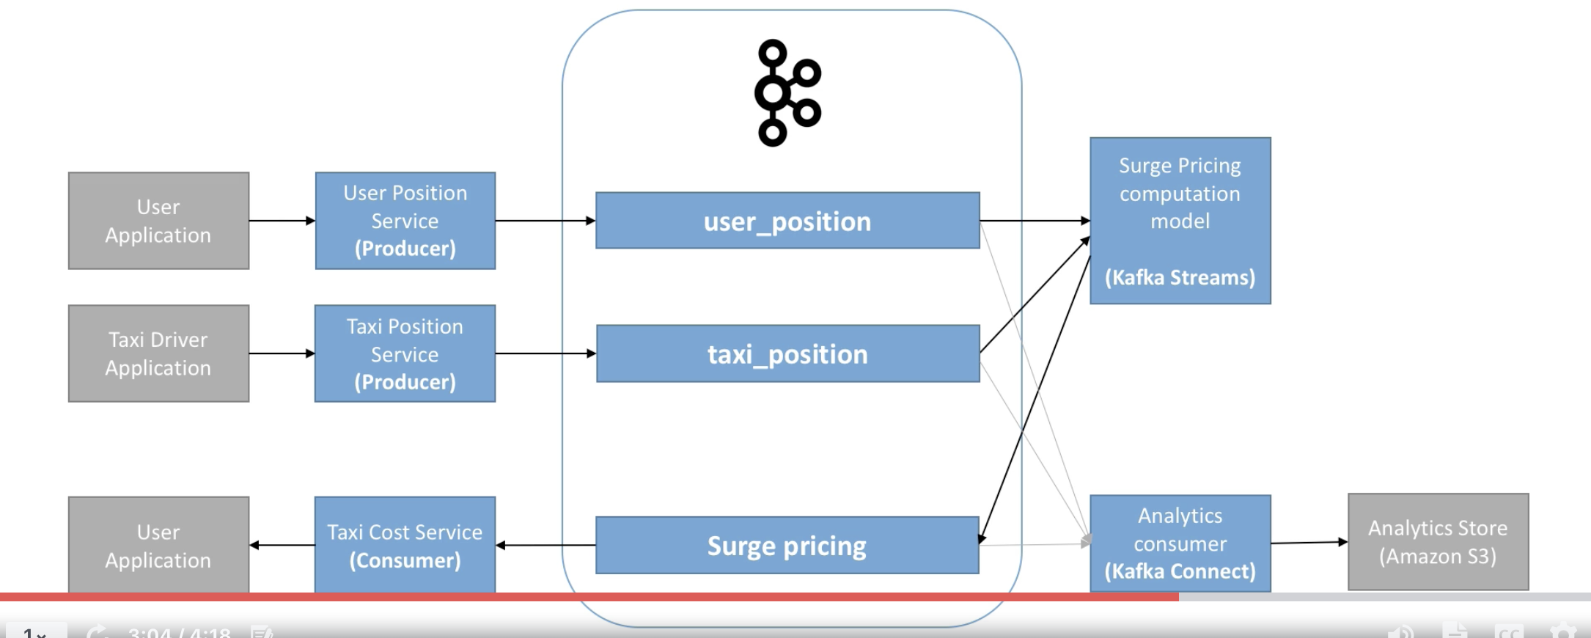

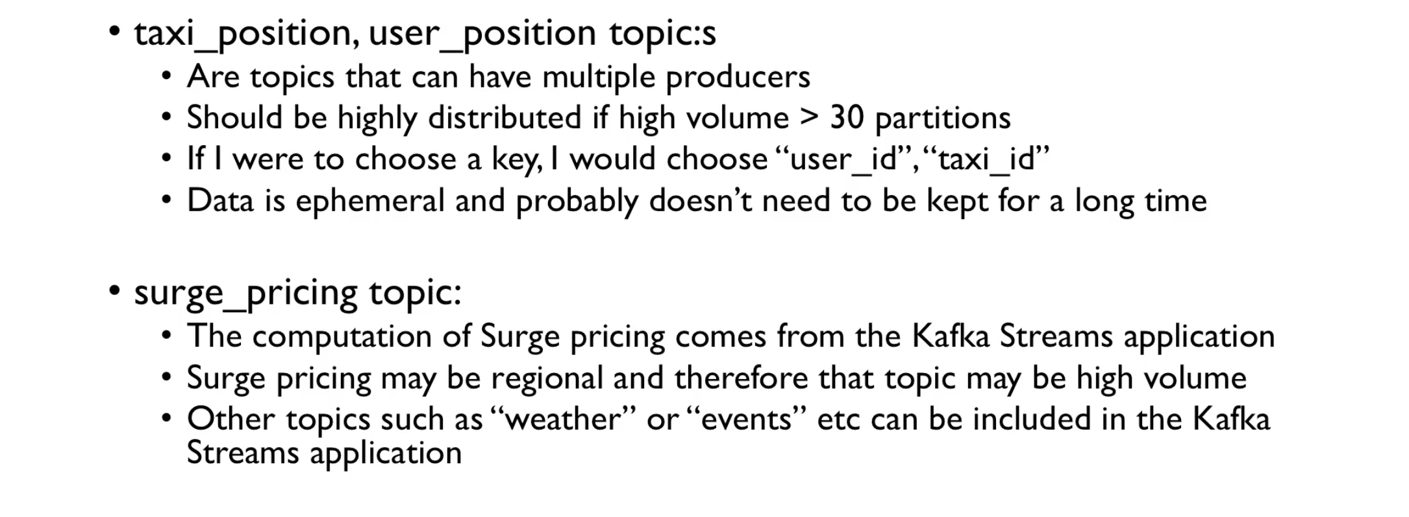

### Case study - My Social Media

CQRS = Command query responsibility segregation

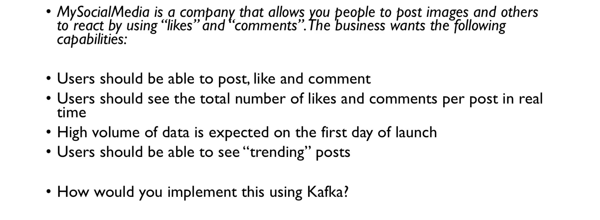

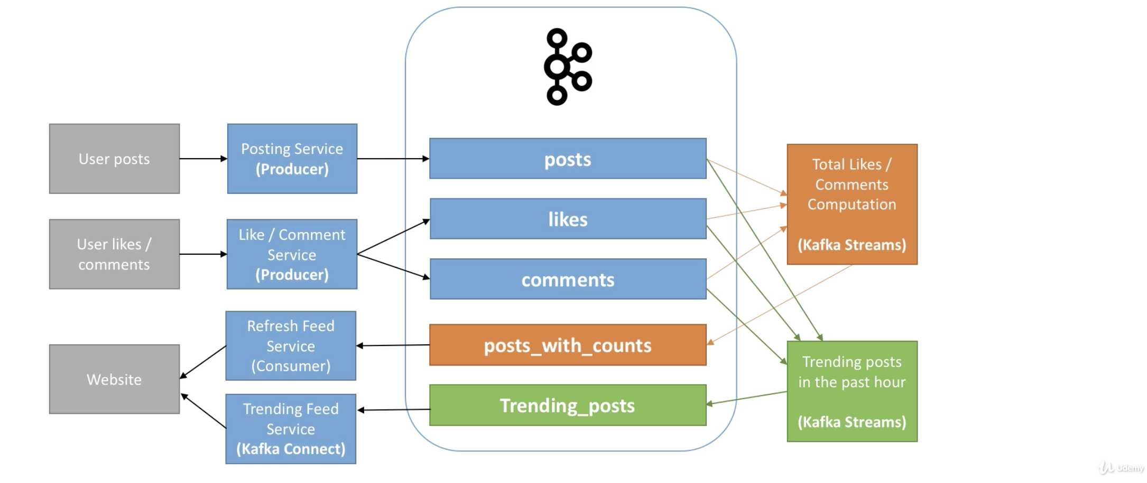

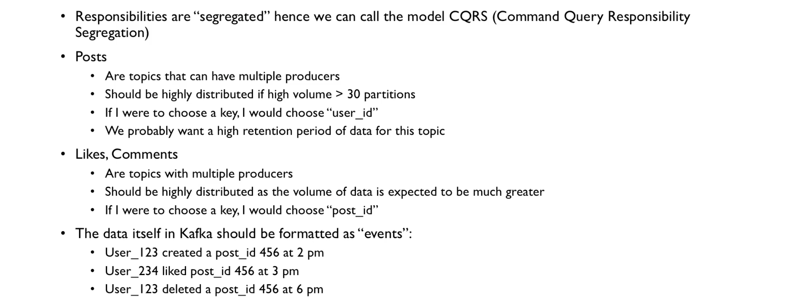

### Case study - My Bank

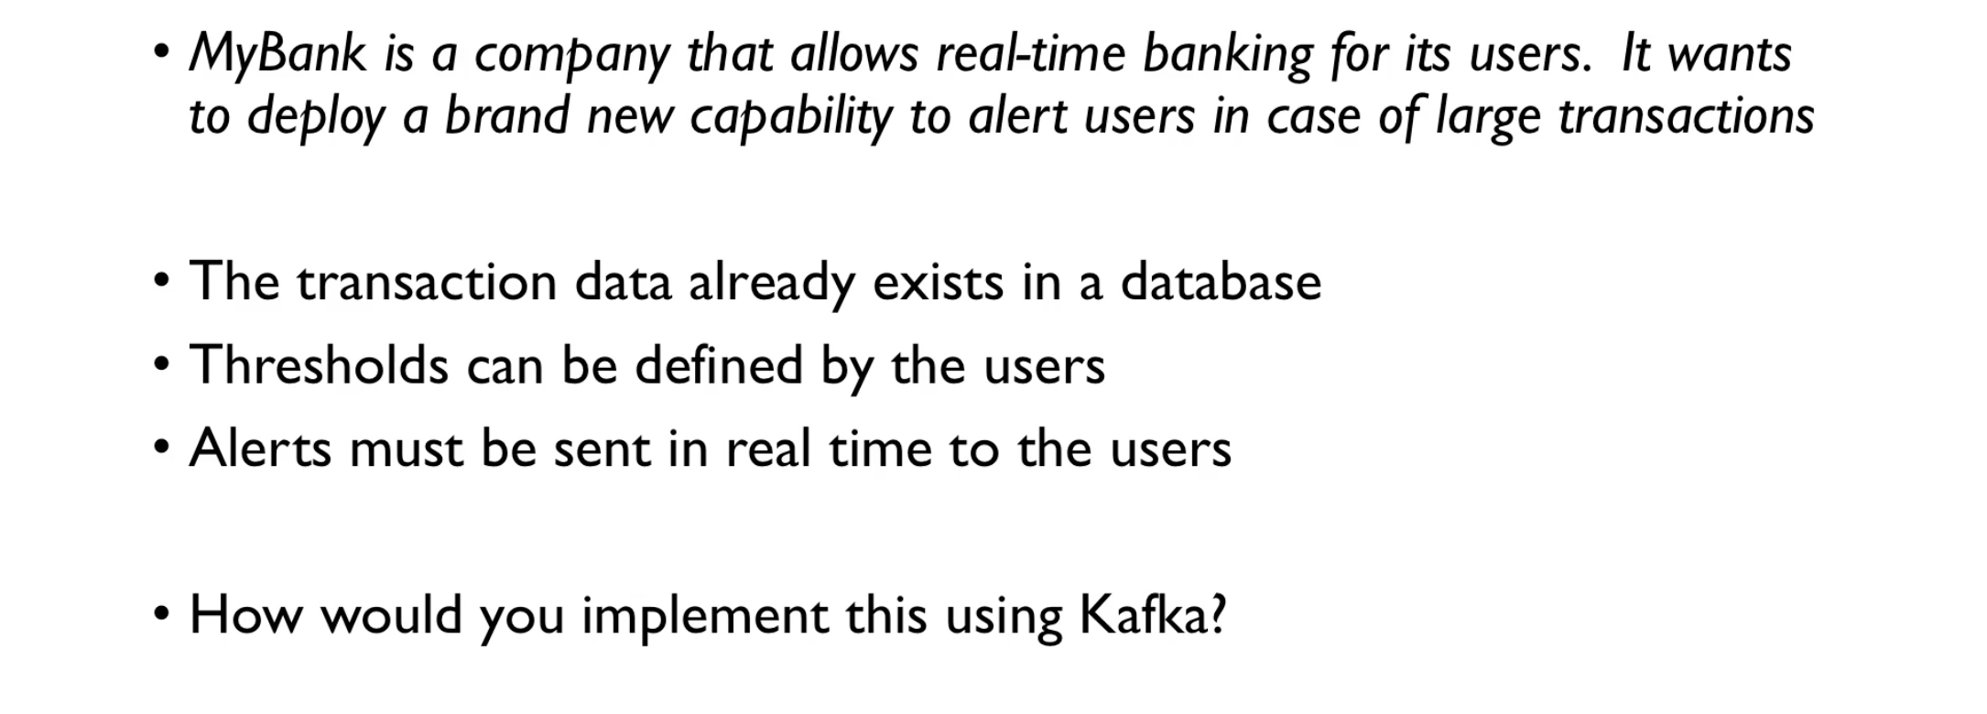

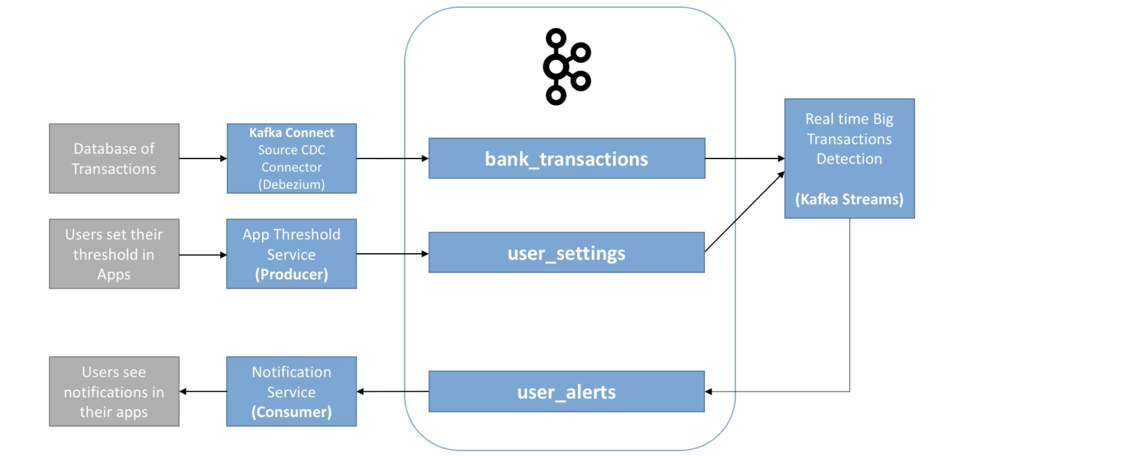

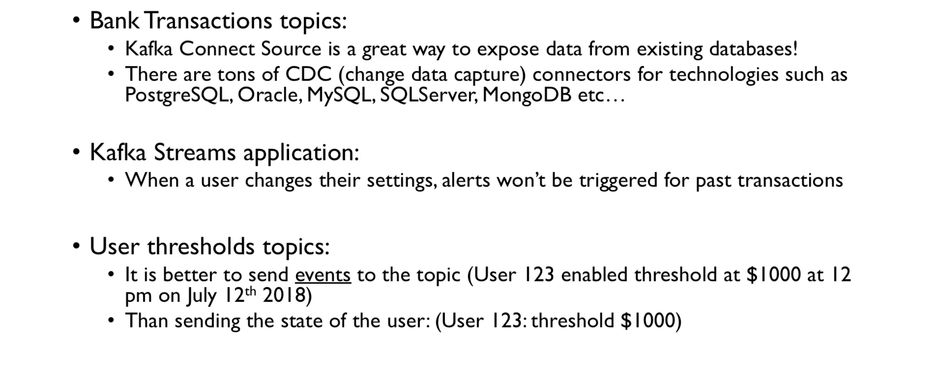

### Case study - Big data ingestion

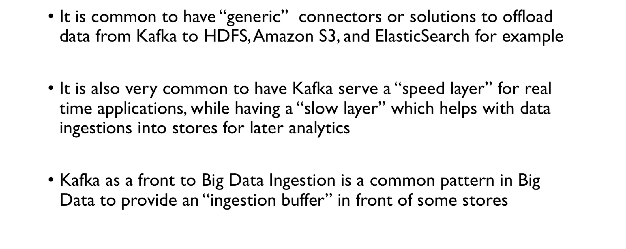

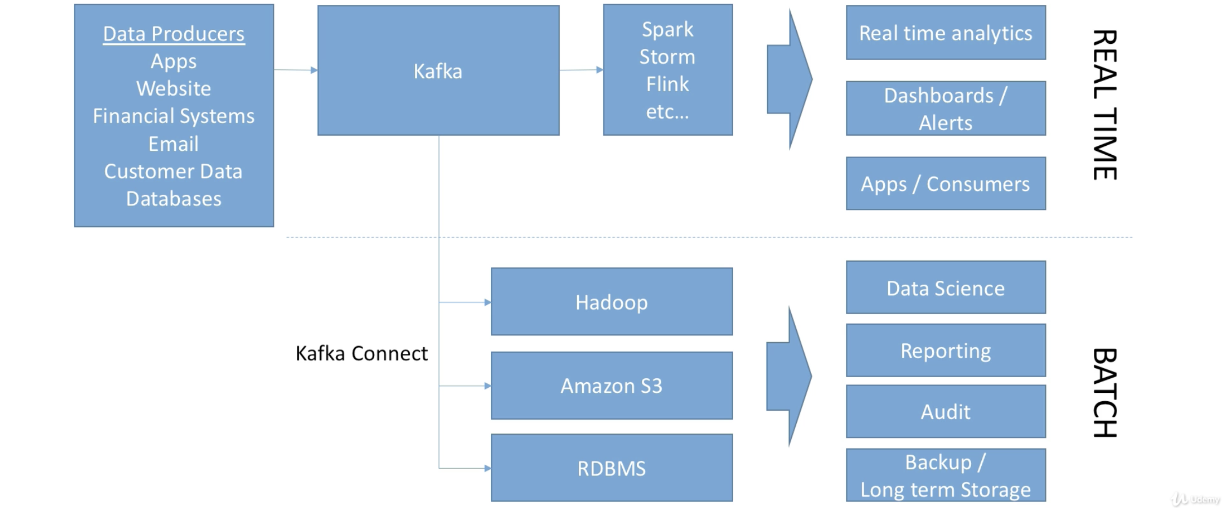

### Case study - Logging and metrics aggregation

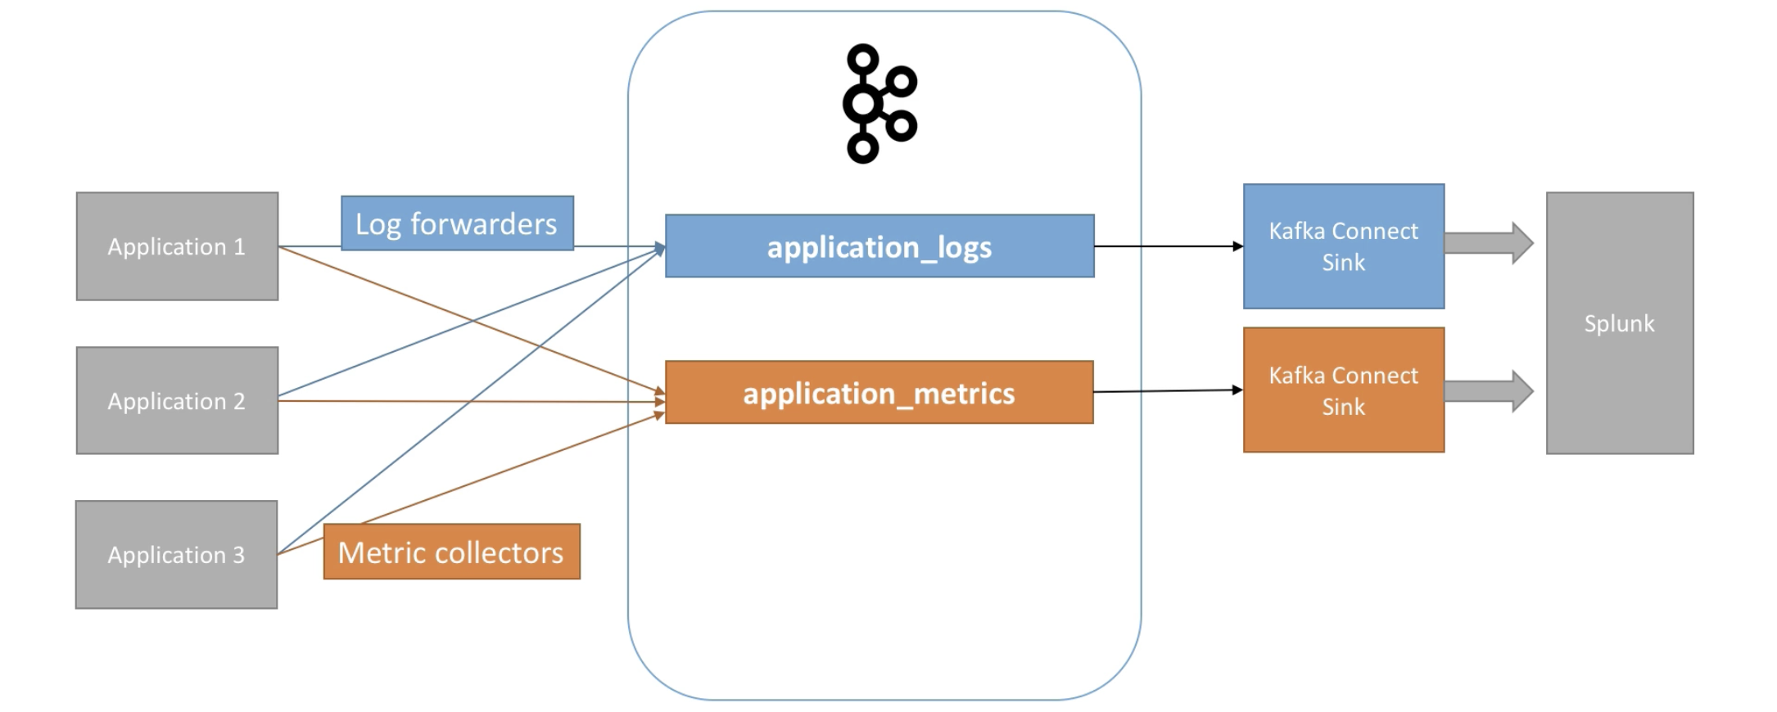

|  |
| --- |
| Kafka **In** the enterprise **for** Admins |

### Kafka Cluster Setup

* We need to have multiple brokers in multiple data centers to distribute the load
* We also need at least 3 zookeepers. Or can be 5 or 7, but not an even number
* In AWS we have 3 availability zones

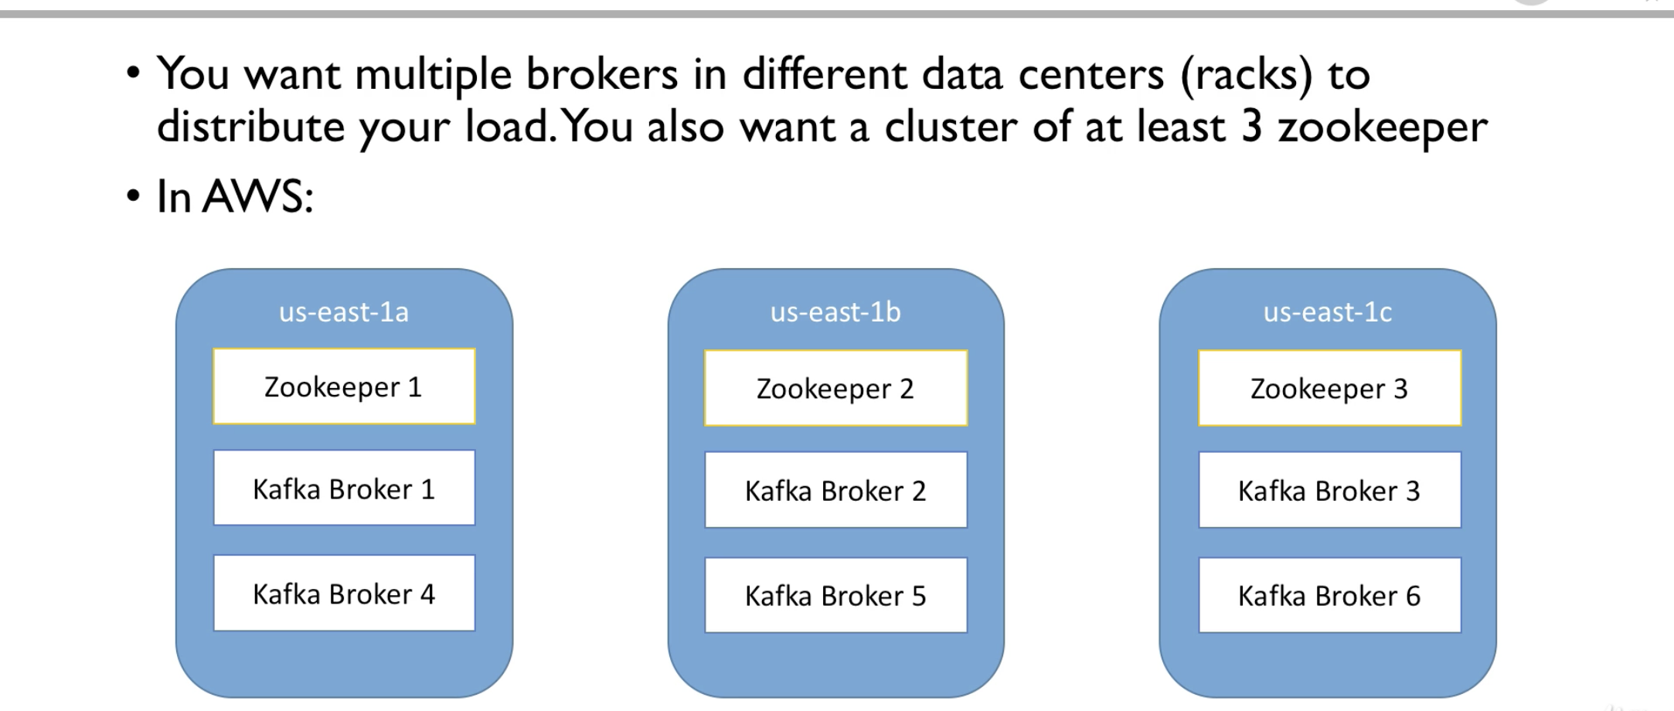

* It is not necessary to have number of brokers as multiples of availability zones, but it is important to have the brokers to spread out for better high availability
* We can have 21 brokers instead of 6 and 5 zookeepers instead of 5. But the above depiction is the minimum one should expect to run in production

Gotchas

* It's not easy to set up clusters
* We cannot run zookeepers and brokers on one machine, both should have a separate machine and isolated
* We need to implement monitoring
* Operations must be mastered
* We need to have a really good Kafka Admin
* An alternative is to have a Kafka As a Service like Kaka and get relieved from the above burdens but at the cost of the service

### Kafka Monitoring Operations

* When we have a cluster we need set up monitoring and operations for our cluster
* Basically Kafka is a big data Java application
* It is important to capture the metrics to make sure the system is performing correctly, and check of the consumers are working properly and no lag and etc
* Kafka exposes metrics via JMX
* Common places to host the Kafka metrics
  + ELK
  + Datadog
  + Relic
  + Kafka Control Center
  + Prometheus
  + Etc..

Some of the important metrics

* Under replicated Partitions: The petitions that have problems with ISR. This indicate there is stress on the system etc
* Request handlers: Check if the Kafka clusters are reading from the network or write to this or reply to request etc. We need to make sure that these threads are not busy all the time. Otherwise we need to add threads and CPUs too to keep up with the load
* Request timing: How much time it is taking to respond to a request. This always needs to be low for better performance or low latency. Make sure that even the high latency request does not take more than 200 ms

Operations

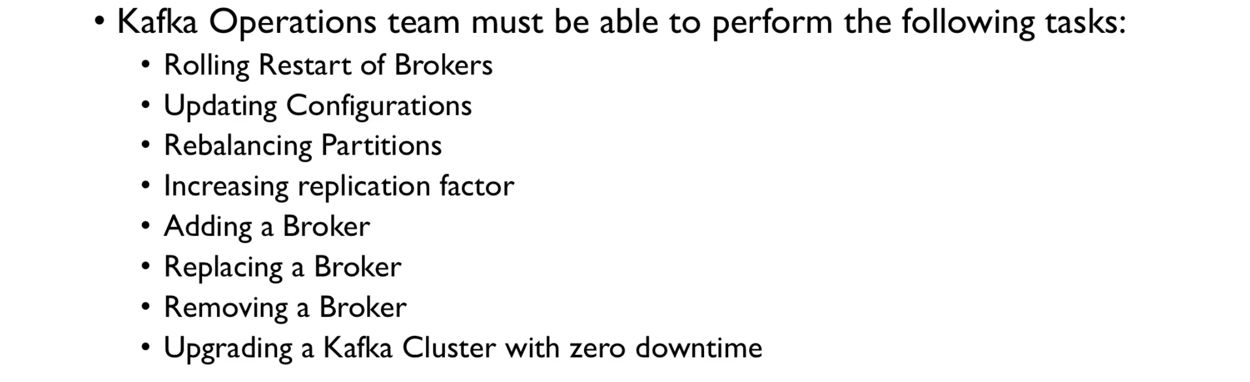

### Kafka Security

Encryption authentication and authorisation in Kafka

* Currently out Kafka cluster is reading and writing plain text data
* Any producer and consumer that is spinned up can access our Kafka cluster as there is no password to restrict the access
* Someone can intercept the data or push some bad data over the line
* Someone can steal data or can delete topics
* These all are unwanted scenarios in our PROD clusters and there demands a need for security - Authentication Authorisation and Encryption

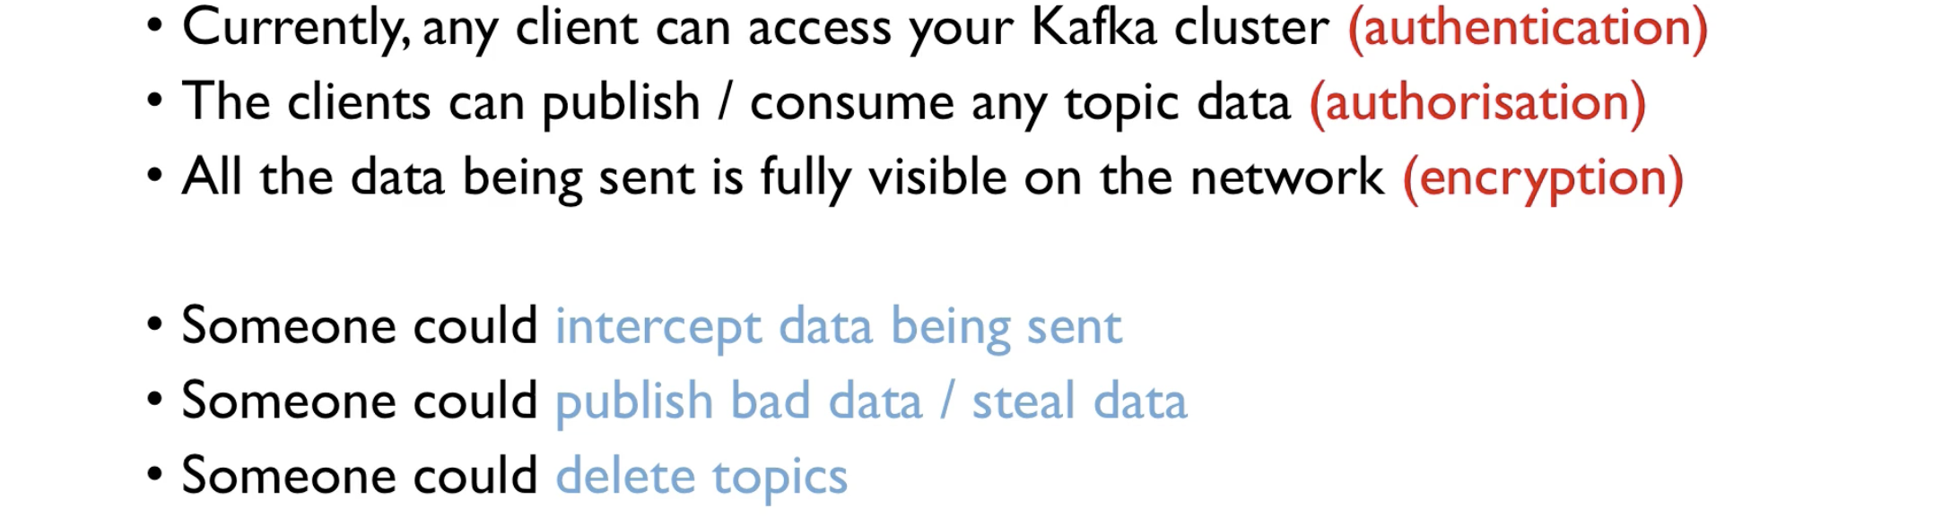

* Encryption is basically the exchange if information from Producers, Consumers and Kafka is done securely
* There should be a proper encryption of the data so that no one can decrypt the data during the flight
* This is similar to the concept of https website - The information we exchange with the web is encrypted

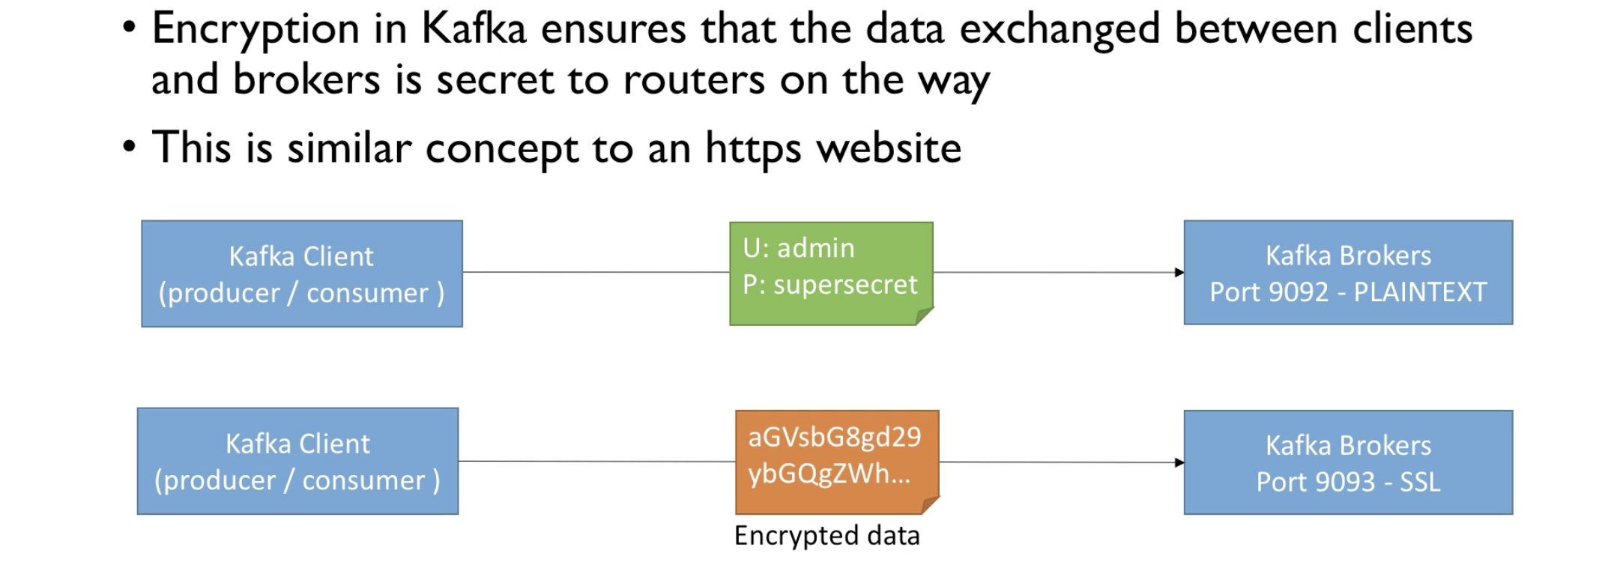

Authentication

* Authentication in Kafka ensures that only those clients which have proved their identity can access Kafka
* This is similar to concept of username and password

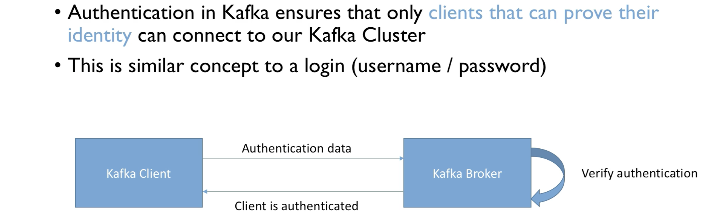

* Types of authentication
  + SSL authentication: Clients authenticate with Kafka using SSL certificates
  + SASL
    - PLAIN: username and password authentication (week and easy to set up)
    - Kerberos: Microsoft Active Directory (Strong and hard to set up)
    - SCRAM: username password (Strong and medium to set up)

Authorisation in Kafka

* Once the authentication is done, we still need to combine with authorisation so that Kafka gives constrained access to the Kafka data
  + Like a user can only few topics and not the others
  + So and so user can view all the topics but not push data to any topic etc
  + This is ACL, Access Controlled List, maintained by Admins
  + An onboarding process in place to achieve this authentication and authorisation

### Multi cluster and mirror view

* Kafka can work well can work well only in one region
* If there is a cluster in America, it will not work well in Asia and vice-versa
* So it is important that for a global enterprise, it usually have clusters around the world with some level of replication between them

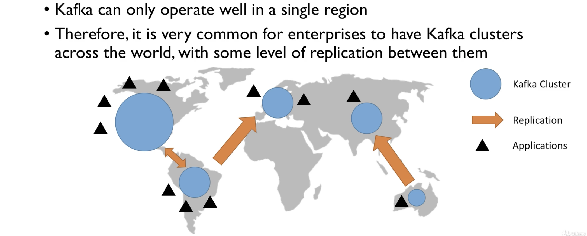

* So the applications operating in one region speaks with the cluster in that region
* If one application want the data from other region, then there will be specific replication between the clusters with high throughput
* The replication can happen in any way with any region

Replication application

* It is simple - A consumer from one cluster and a producer in one cluster
* Tools:
  + Mirror maker - Open source tool shipped by kafka
  + Netflix Flink: Not open source
  + Uber’s uReplicator: Open source
* Comcast: has their own open source kafka connect source
* Confluent has their own Kafka Connect Source (paid)

Multi cluster and replication

* Producer writes to one cluster called an active cluster, and consumers poll the data from the active cluster. There exists a passive cluster which replicates the active cluster and a consumer can poll the data from passive cluster as well

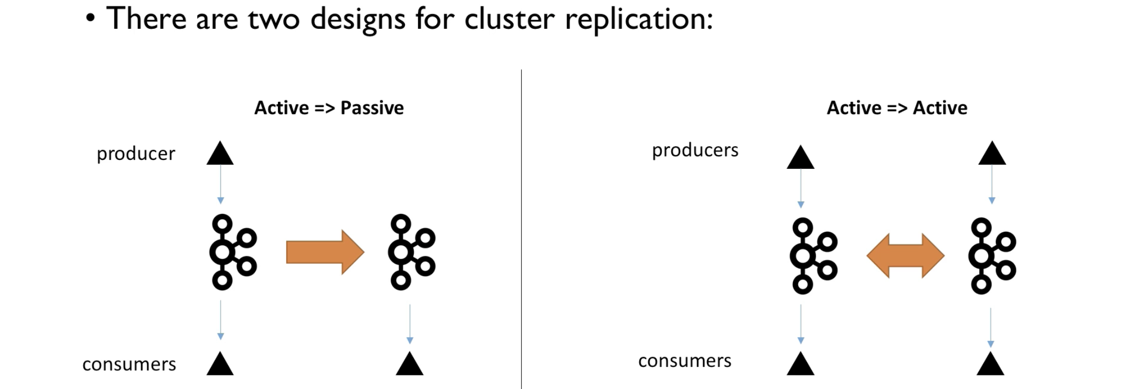

* Active active - Producers produce data to the same topic in both the clusters and the clusters are smart enough to replicate the data between the two topics. If the data is from the same topics, then there will be a suffix to the data info so that there will be no overlap and infinite loop
* First strategy can be used for analytics
* Second can be used for global enterprise when the application speaks with the clusters globally

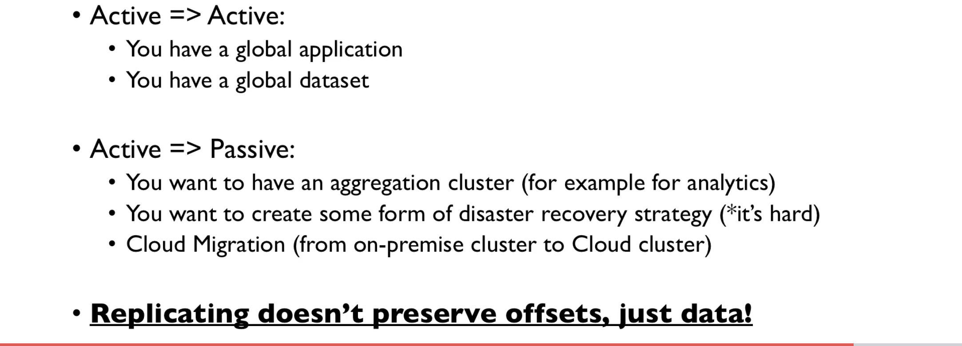

|  |
| --- |
| Advanced Kafka Topic Configuration |

### Changing a topic configuration

* Generally brokers have default topic configuration settings
* These default settings have the direct effect on performance and topic behavior
* But sometimes topics need custom configurations other than the default ones
  + Replication factor
  + Number of partitions
  + Replication factor
  + Number of insync replicas
  + Etc

|  |
| --- |
| :> zookeeper-server-start.sh config/zookeeper.properties  :> kafka-server-start.sh config/server.properties  :> kafka-topics.sh --zookeeper 127.0.0.1:2181 --create --topic configured-topic --partitions 3 --replication-factor 1  Created topic configured-topic.  :> kafka-configs.sh --zookeeper 127.0.0.1:2181 --entity-type topics --entity-name configured-topic --describe  Configs for topic 'configured-topic' are  :> kafka-configs.sh --zookeeper 127.0.0.1:2181 --entity-type topics --entity-name configured-topic --add-config min.insync.replicas=2 --alter  :> kafka-configs.sh --zookeeper 127.0.0.1:2181 --entity-type topics --entity-name configured-topic --describe  Configs for topic 'configured-topic' are min.insync.replicas=2  :> kafka-configs.sh --zookeeper 127.0.0.1:2181 --entity-type topics --entity-name configured-topic --delete-config min.insync.replicas --alter  Completed updating config for entity: topic 'configured-topic'. |

### Segment and Indexes

* Topics are made of partitions
* Partitions are made of segments
* Each segment represents a file
* Last segment is active as it is being written into
* Always only once segment is active

log.segment.bytes

* The max size of a single segment in bytes

log.segment.ms

* The time kafka waits before committing a segment if not full. By default it is 7 days in the latest version of kafka

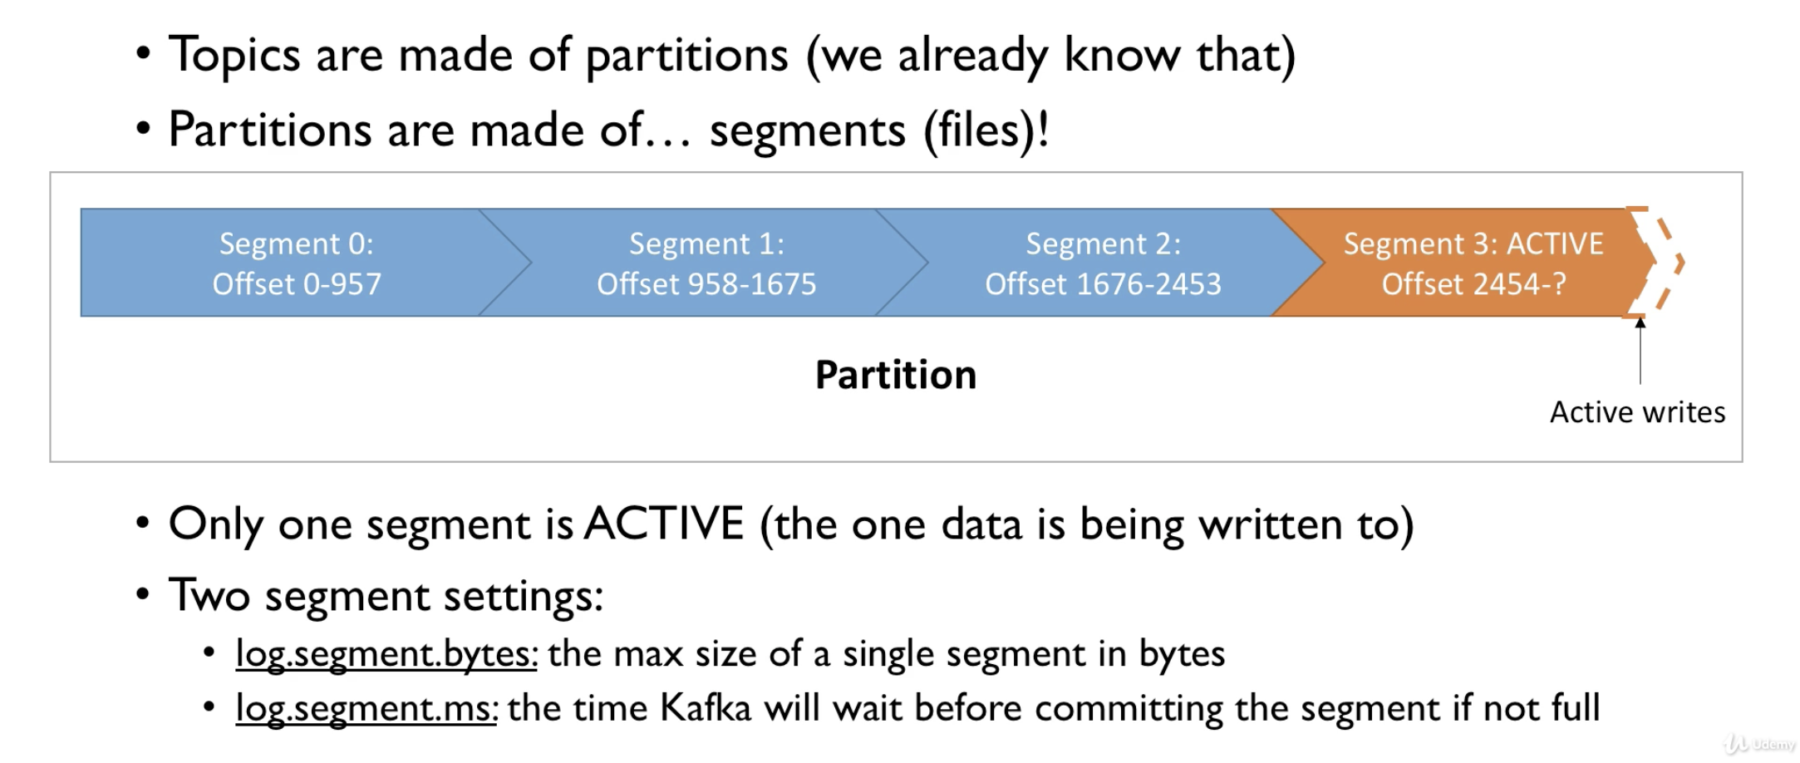

|  |
| --- |
| *\*\* Kafka is* ***not*** *good* ***for*** *random reads* ***and*** *random writes, it is good* ***for*** *sequential \*\** |

* Segments are represented with two indexes
* One is the position index which tells kafka where to read to find a message
* On is the timestamp index allows kafka to find a message with a timestamp
* Basically the indexes makes Kafka read messages in a constant time

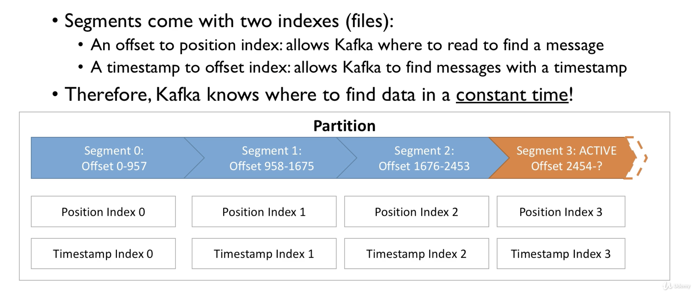

|  |
| --- |
| :> cd data/kafka  :> ls first-topic-0  00000000000000000000.index 00000000000000000000.log 00000000000000000000.timeindex leader-epoch-checkpoint |

Why should we care?

* Smaller value of log.segment.bytes (default 1GB) refers to
  + More segments per partition
  + Log compaction happens more often
  + BUT kafka has to keep more files opened (Error: too many files)
* log.segment.ms: (default is 1 week)
  + Lower indicates higher frequency of log compaction => frequent triggers
  + BUT we also get more files

### Log cleanup policies

* Kafka clusters run a clean up by default and make the data expire based on a policy
* This concept is called log cleanup policy

Policy 1 - log.cleanup.policy = delete

* Deletes the messages based on age of the data (default is 1 week)
* Deletes messages based on size (default is -1 which is infinite)

Policy 2 - log.cleanup.policy = compact (kafka default for topic __consumer_offsets)

* Deletes based on keys
* Deletes the old and duplicate keys once the active segment is committed
* Infinite time and space retention

|  |
| --- |
| :> kafka-topics.sh --zookeeper 127.0.0.1:2181 --describe --topic __consumer_offsets  Topic: __consumer_offsets PartitionCount: 50 ReplicationFactor: 1 Configs: compression.type=producer,cleanup.policy=compact,segment.bytes=104857600 Topic: __consumer_offsets Partition: 0 Leader: 0 Replicas: 0 Isr: 0 Topic: __consumer_offsets Partition: 1 Leader: 0 Replicas: 0 Isr: 0 Topic: __consumer_offsets Partition: 2 Leader: 0 Replicas: 0 Isr: 0 |

Why and when the log cleanup happen

Deleting data on Kafka allows us to

* Control the size of the data on the disk, delete obsolete data
* Limits the maintenance work on Kafka cluster

How often does the log cleanup happen

* Log cleanup happens on partition segments
* Smaller/large number of segments means that the log cleanup happen more often
* Log cleanup shouldn't happen too often as it consumes CPU and RAM resources
* Make sure that we have reasonable number of segments so that the cleanup doesn't happen too often
* log.cleaner.backoff.ms - the cleaner checks for work every 15 seconds (default)

### Log cleanup policy - Delete

log.retention.hours

* Number of hours to keep the data for
* The more is the number the more is the disk space it will occupy
* If we give a less number then, for any reason the users are down for a very long time, there will be a chance that the users lose the data
* Make sure that we select a proper number that is not too small and too large

log.retention.bytes

* Max bytes in size for each partition (default -1 for infinite)
* Useful to keep control on the size of the log under a threshold

Most common use cases

Case 1: one week of retention

* log,retention.hours = 168 log.retention.size = -1 (infinite size, default value)

Case 2: retention size bounded by 500MB

* log.retention.time 17520, log.retention.bytes = 524288000

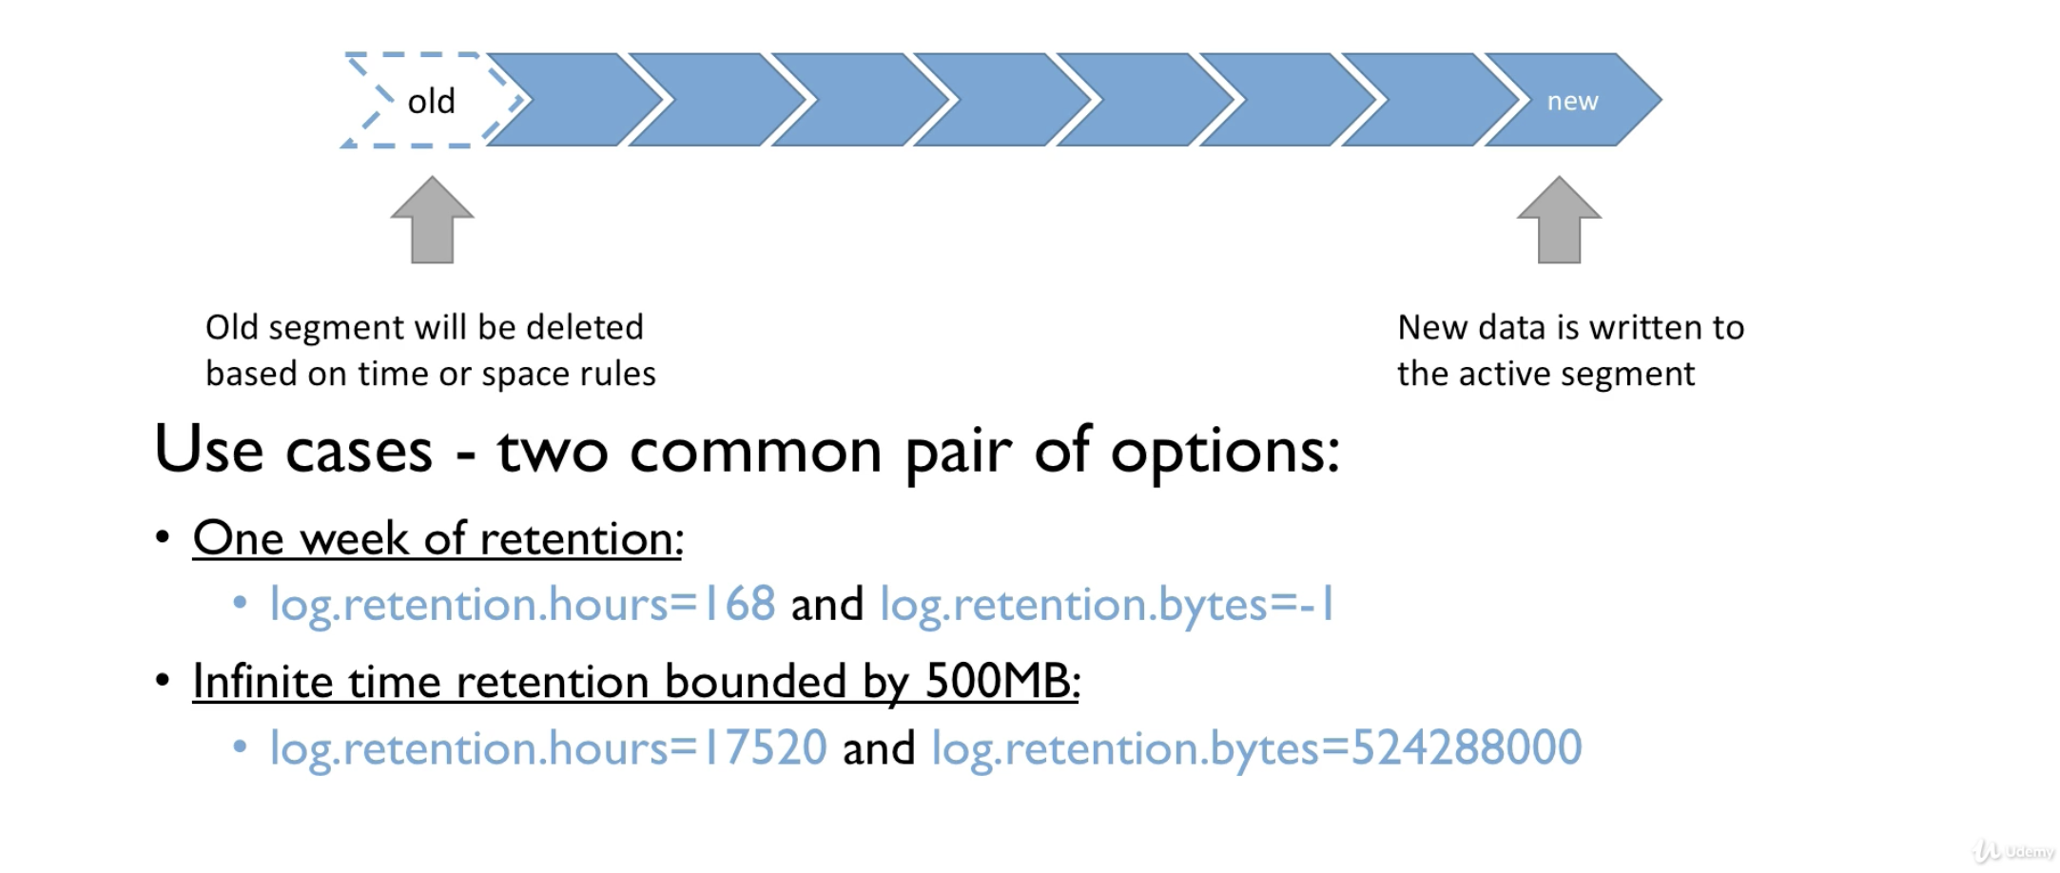

### Log compaction

* Ensures that the partition contains at least the last known value for a specific key within a partition.
* Very useful if we just require a SNAPSHOT instead of the full history like a data table in a database, where we can get the last value for each row
* The idea is we keep only the latest update for a key in our log - Means we keep only the most recent and most valuable information

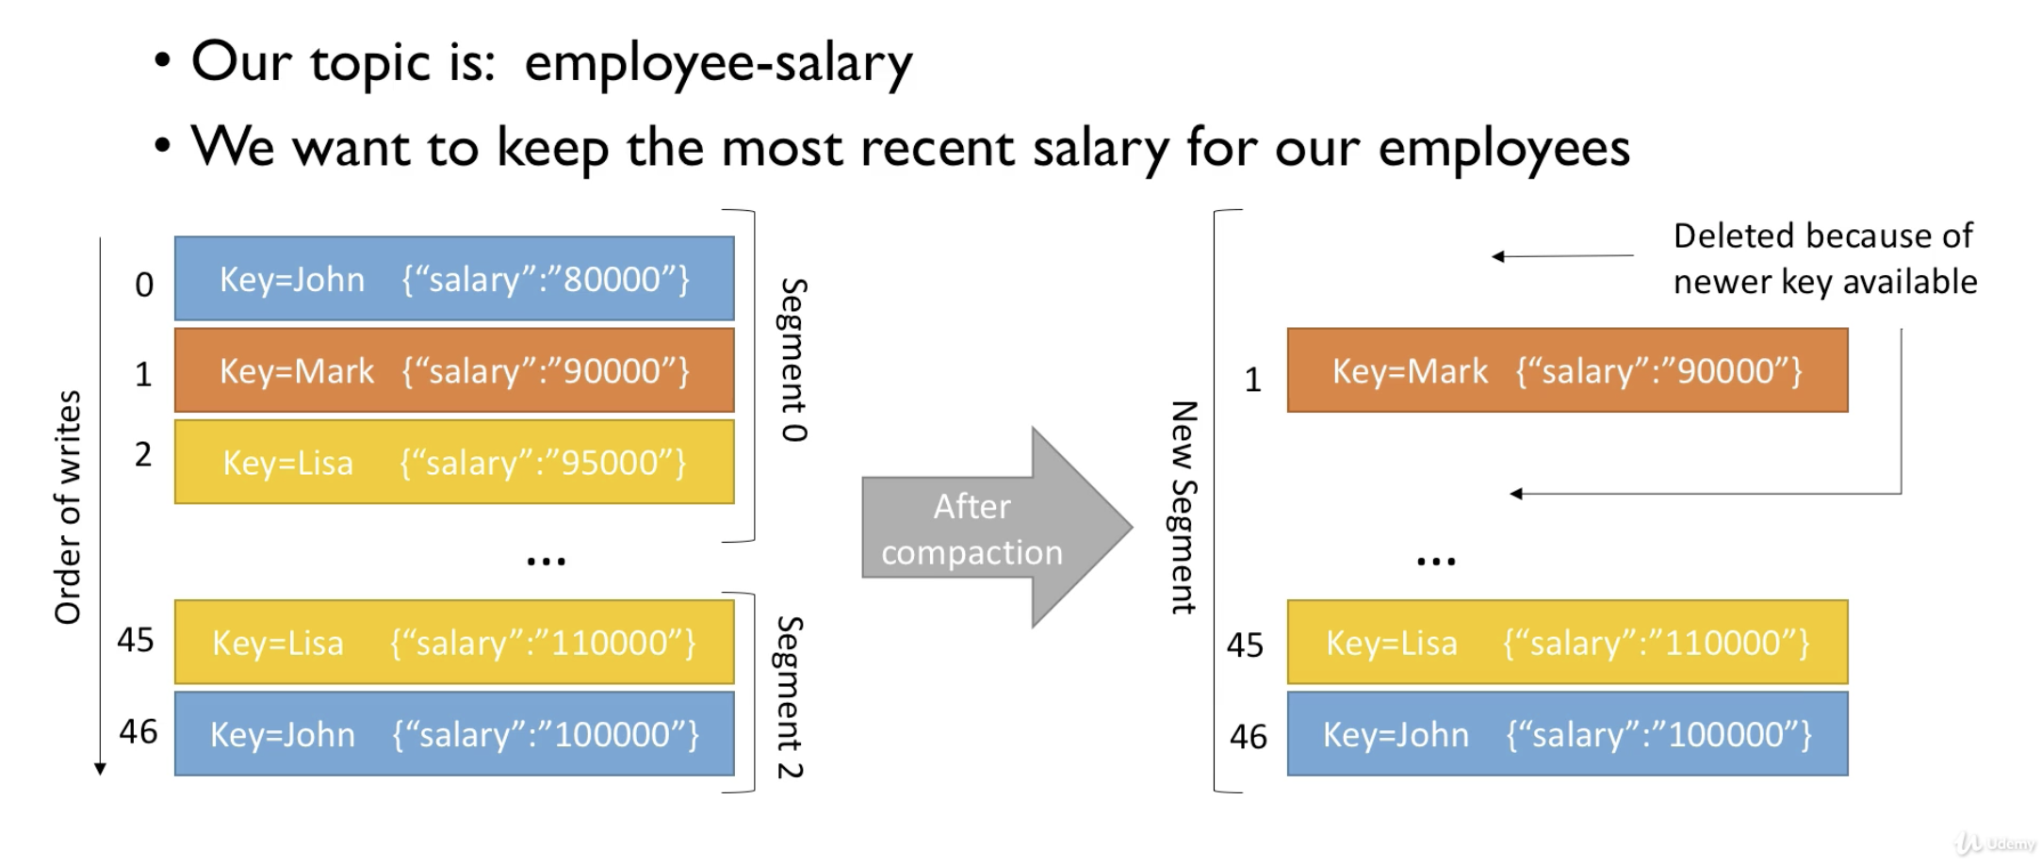

* In the above example, once the new data is entered into the segment 2, the old data holding the same keys John and Lisa will be deleted after the log compaction.
* As **a** result **of** this we will get **a** new **segment** **with** **the** latest/updated values. And **the** offsets won't change.

Guarantees of log compaction

* Any consumer reading from Kafka from the tail of the log will still see the messages sent to the topic
* Consumers still able to see the deleted messages for log.retention.ms (default is 24 hours)
* Ordering is still preserved, log compaction only removes the messages but doesn't affect their ordering
* Offsets of the messages are immutable, and do not change. If a message is deleted then then the offsets are skipped.

Myth busters of log compaction

* Log compaction doesn't prevent you from pushing the duplicate data
  + Deduplication happens only after the segment is committed.
  + Consumers can still access all the data from the tail as soon as the data arrives
* Log compaction prevent you from reading duplicate data from Kafka
  + Same points as above
* Log compaction can fail time to time
  + It is an optimization and sometimes the compaction thread might crash
  + We need to make sure to make sufficient amount of RAM for the compaction threads and it gets triggered
  + Restart Kafka if log compaction is broken

**You can't trigger log compaction happens in the background and we cannot trigger it via API as of now**

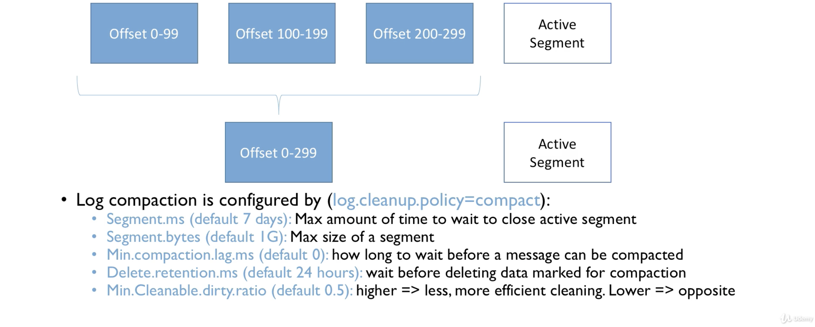

* Log compaction looks at all the segments, removes the unnecessary messages
* The active segment remains untouched
* It basically compacts the segments, meaning it makes only the useful data available and deletes the other data

### Log compaction practice

|  |
| --- |
| :> kafka-topics.sh --zookeeper 127.0.0.1:2181 --create --topic employee-salary --partitions 1 --replication-factor 1 --config cleanup.policy=compact --config min.cleanable.dirty.ratio=0.001 --config segment.ms=5000  Created topic employee-salary.  kafka-topics.sh --zookeeper 127.0.0.1:2181 --topic employee-salary --describe  Topic: employee-salary PartitionCount: 1 ReplicationFactor: 1 Configs: cleanup.policy=compact,segment.ms=5000,min.cleanable.dirty.ratio=0.001  Topic: employee-salary Partition: 0 Leader: 0 Replicas: 0 Isr: 0 |

|  |
| --- |
| :> kafka-console-consumer.sh --bootstrap-server 127.0.0.1:9092 --topic employee-salary --from-beginning --property print.key=true --property key.separator=, |

|  |
| --- |
| :> afka-console-producer.sh --bootstrap-server 127.0.0.1:9092 --topic employee-salary --property parse.key=true --property key.separator=,  >Mark,salary:30000  >Lucy,salary:40000  >Sheela,salary:50000  >Laila,salary:25000  Consumer output  Mark,salary:30000  Lucy,salary:40000  Sheela,salary:50000  Laila,salary:25000 |

|  |
| --- |
| :> cd data/kafka/ :> ls employee-salary-0 00000000000000000000.index 00000000000000000001.snapshot 00000000000000000003.log leader-epoch-checkpoint 00000000000000000000.log 00000000000000000002.snapshot 00000000000000000003.snapshot 00000000000000000000.timeindex 00000000000000000003.index 00000000000000000003.timeindex |

|  |
| --- |
| >Mark,salary:30000 >Lucy,salary:40000 >Sheela,salary:50000 >Laila,salary:25000 >Mark,salary:40000 >Sheela,salary:25000  Consumer  :> ^CProcessed a total of 4 messages  :> kafka-console-consumer.sh --bootstrap-server 127.0.0.1:9092 --topic employee-salary --from-beginning --property print.key=true --property key.separator=,  Mark,salary:30000  Lucy,salary:40000  Sheela,salary:50000  Laila,salary:25000  Mark,salary:40000  Sheela,salary:25000 |

|  |
| --- |
| :> ^CProcessed a total of 6 messages :> kafka-console-consumer.sh --bootstrap-server 127.0.0.1:9092 --topic employee-salary --from-beginning --**property** print.key=true --**property** key.separator=, Lucy,salary:40000 Sheela,salary:50000 Laila,salary:25000 Mark,salary:40000 Sheela,salary:25000 |

Here the old Mark data will be compacted and the latest data is applied to Mark

### Min Insync replicas reminder

* When we use acks=all, we need to use this setting in conjunction with min.insync.replicas
* min.insync.replicas setting is set at the broker or topic level
* When min.insync.replicas = 2 implies that the minimum of 2 ISRs should respond to the data availability once the data write has happened
* That means if replication.factor=3, min.insync.replicas=2 and acks=all, the system can tolerate at max of 1 broker going down, otherwise the producer receives an exception on .send() method.

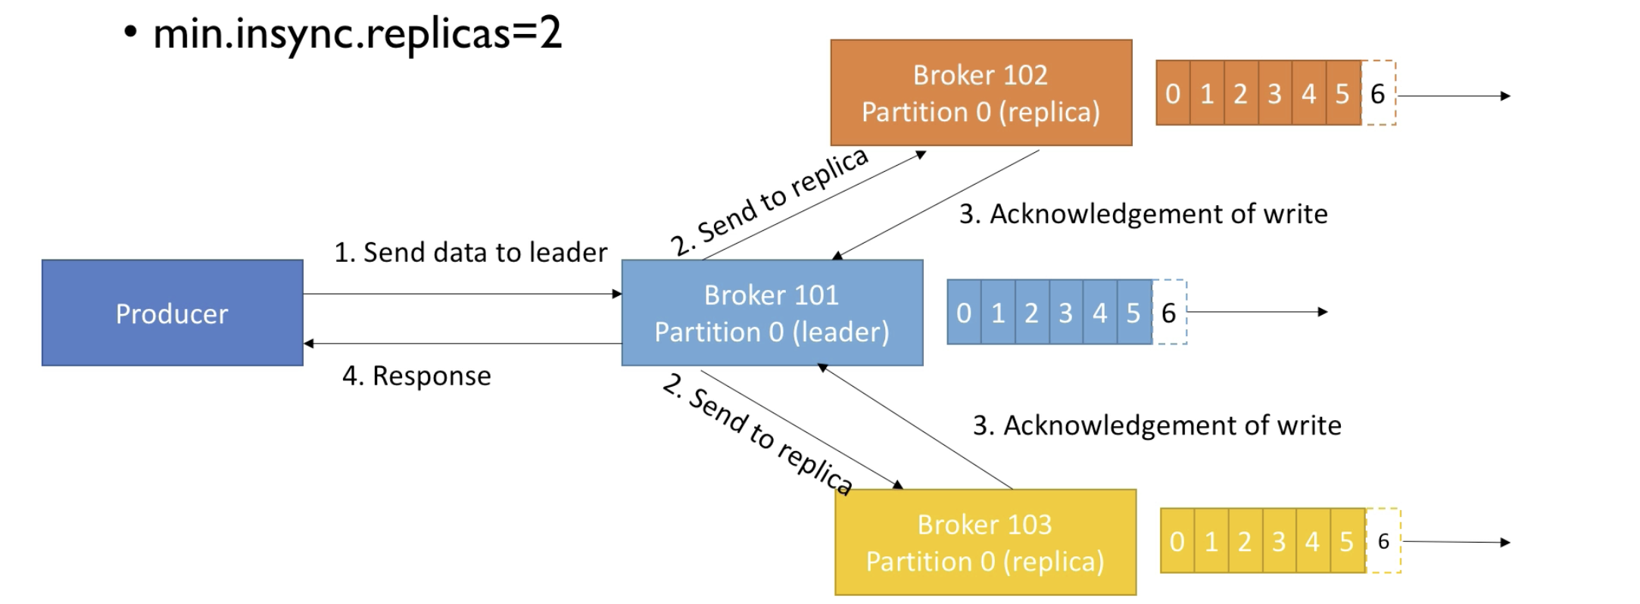

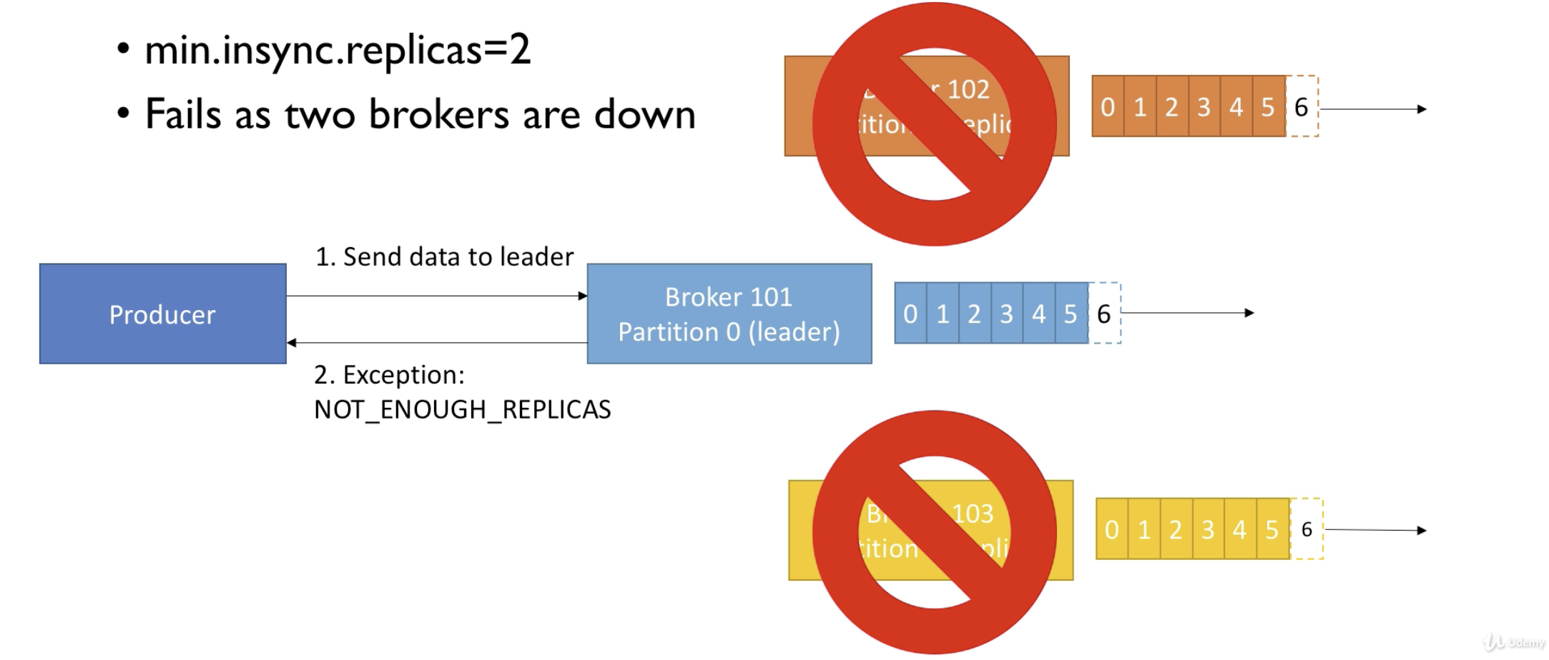

|  |
| --- |
| :> kafka-topics.sh --zookeeper 127.0.0.1:2181 --topic highly-durable --create --partitions 3 --replication-factor 1 |

|  |
| --- |
| :> kafka-configs.sh --zookeeper 127.0.0.1:2181 --entity-type topics --entity-name highly-durable --alter --add-config min.insync.replicas=2 |

### Unclean leader elections

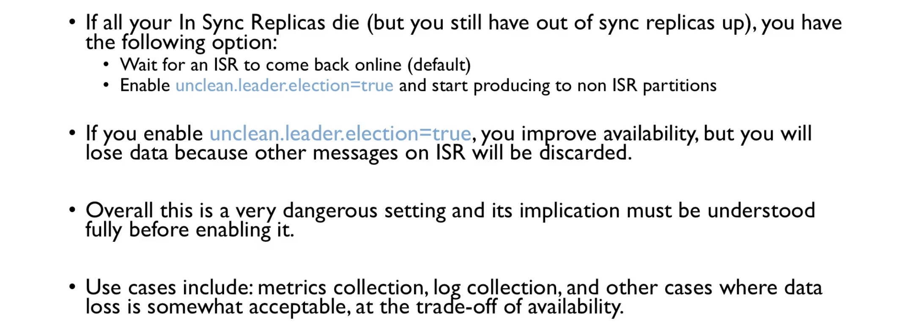

What next?

